EMI: Why Digital Devices Radiate

By Glen Dash, Ampyx LLC, GlenDash at alum.mit.edu
Copyright 1998, 2003, 2005 Ampyx LLC

The causes are more subtle, and the cures less obvious than most imagine.

We will begin with an experiment.

We built the circuit shown in Figure 2. A 6.25” by 4.5” (15.9 cm by 11.4 cm) printed circuit board was constructed with the topside of the board reserved for a V+ plane and the bottom side for a V- plane. A clock oscillator, an Epson SG51P, was placed to one side of the board, spaced 3.75” (9.5 cm) away from a 74HC02 device serving as a load. The power supply consisted of a 9-volt battery feeding a 7805 regulator whose output was loaded with a 10 microfarad tantalum capacitor. Placed beneath the clock oscillator and the 74HC02 device were .02 uF wafer type bypass capacitors from Circuit Components Inc., Part No. 293A14. The board was made out of a phenolic material and was .07” (1.8 mm) thick.

In order to connect the source to the load, a wire was used. It was placed adjacent to the underside of the board. The wire’s conductor was solid copper .03” (.76 mm) in diameter. Its insulation was .015” (.38 mm) thick. A 50 ohm carbon composition resistor was connected immediately to the output of the clock driver. A 50 picofarad capacitor was placed at the input of the 74HC02 device to simulate heavy loading. The clock oscillator had specs typical of a HC device. In order to simulate the effect of radiation off attached I/O, two telescoping antennas elements were attached to either side of the PCB and were electrically connected only to the V- plane.

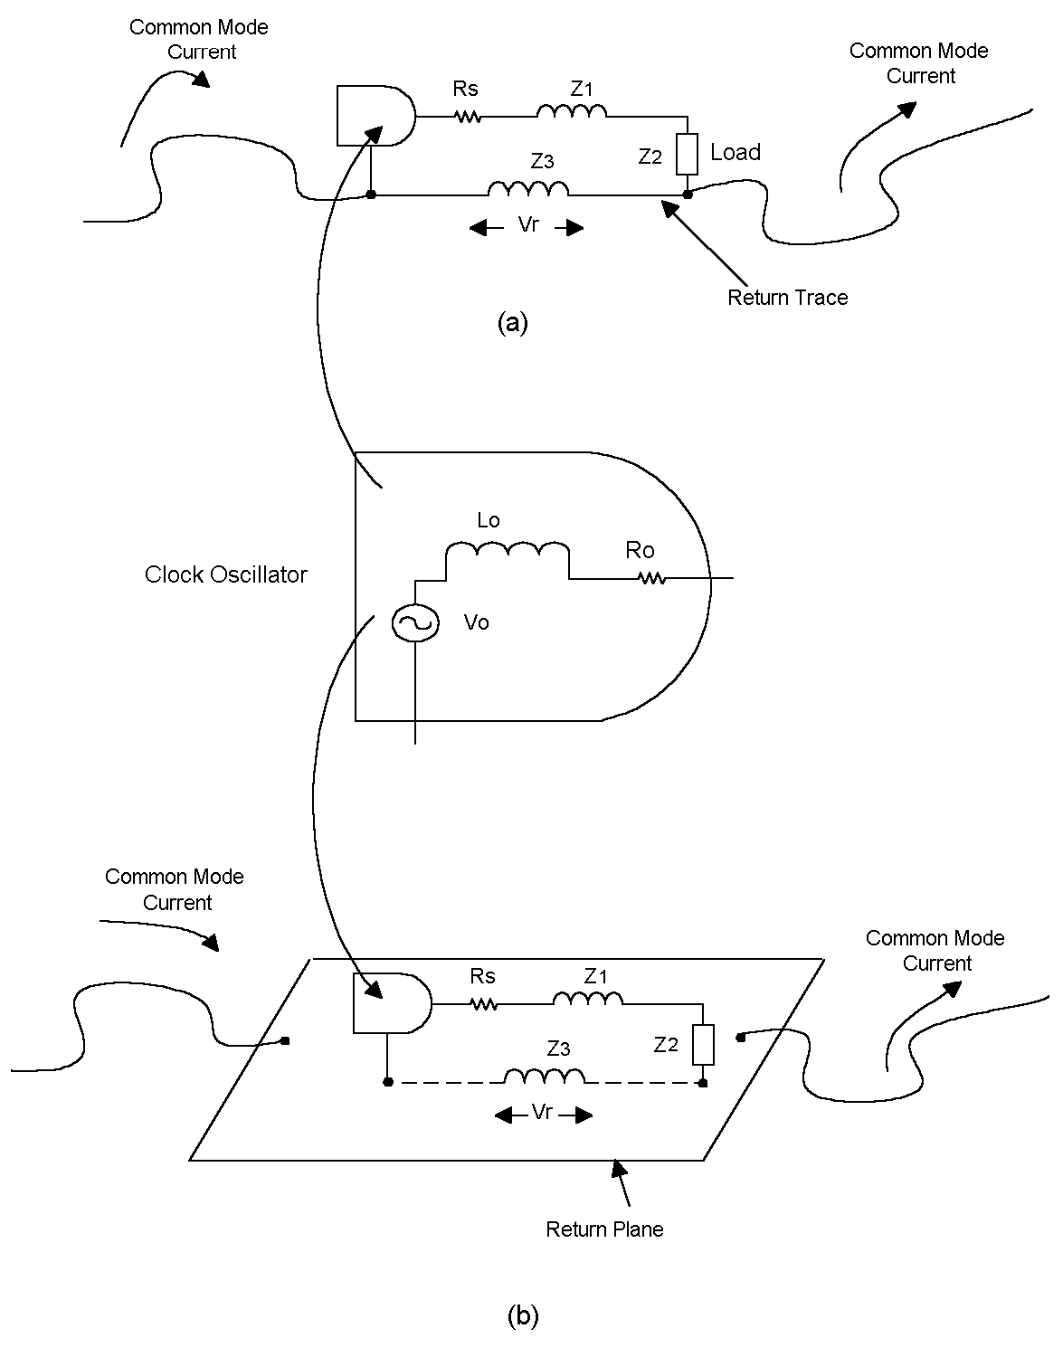
Figure 1: Here in the simplest of circuits, a clock oscillator drives a load with current returning either through a wire or trace as in (a) or through a return plane as in (b). Both designs can create EMI. Some inductance will exist in the return path causing any wires connected directly or incrementally to it to radiate. A plane has less inductance than a wire or trace, but significant emissions can arise from both designs.

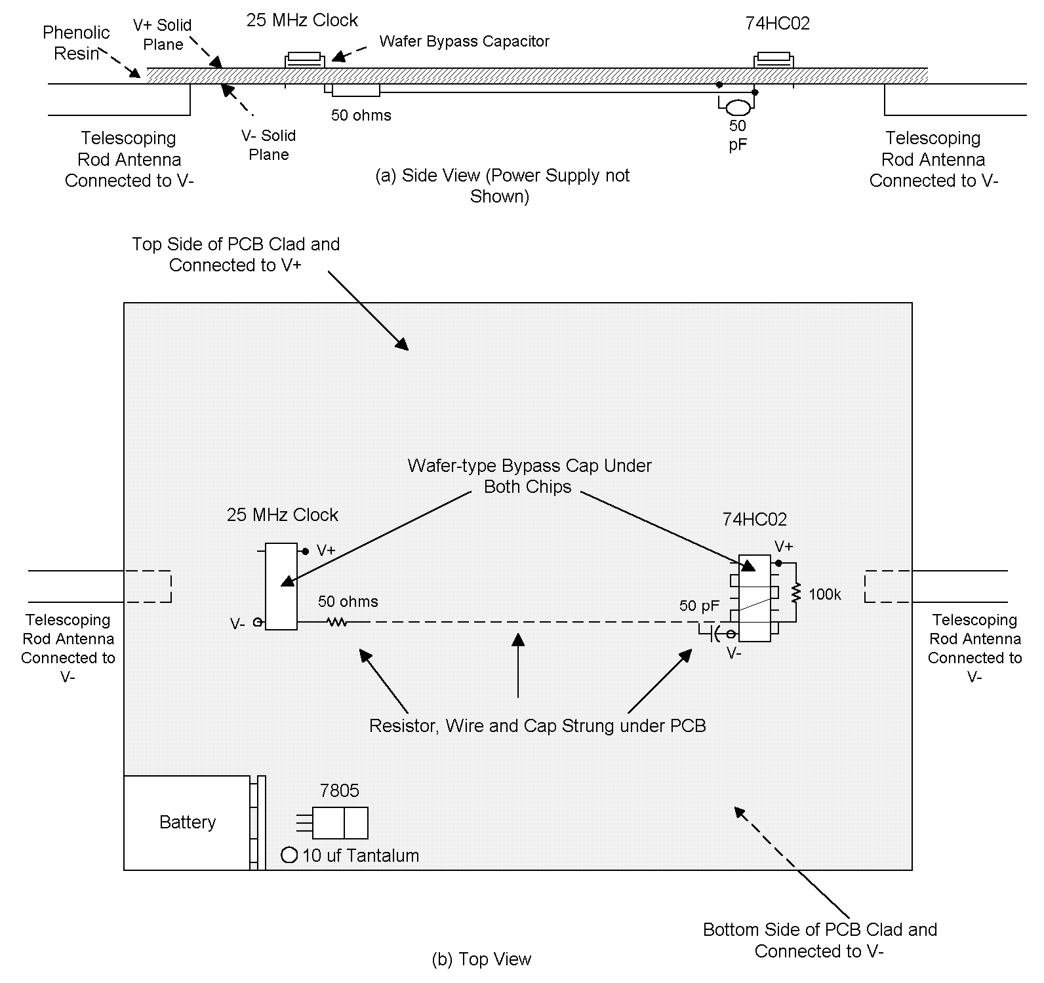

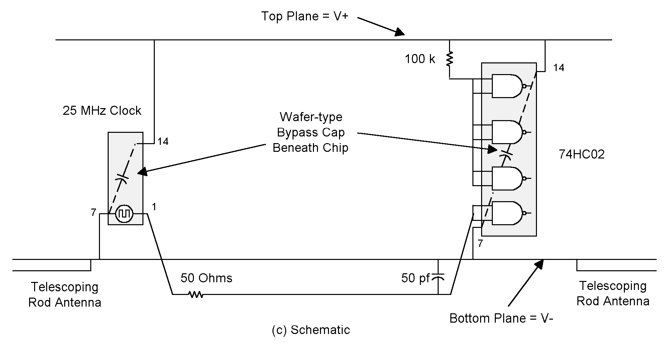
Figure 2: We assembled and tested this circuit to see if theory would correctly predict observed emissions.
Emissions tests were performed at an open field test site. The site had been previously checked against open area test site standards and had been accredited by NIST. Measurements were taken atop a .8 meter wooden turntable which was rotated to detect maximum emissions. As expected, when the attached telescoping antennas were tuned for resonance, maximum emissions at the resonant frequency were observed when the telescoping arms lay parallel to a horizontally polarized antenna. Measurements were performed at a distance of 10 meters and the antenna was raised and lowered to detect maximum emissions over a 1 to 4 meter range.

We began our study by focusing on one frequency, the fifth harmonic of the clock at 125 MHz. The telescoping elements were tuned to resonance at that frequency and left there for the duration of the test. The circuit shown in Figure 2 produced 39.4 dBuV/m of radiation at 10 meters.

Our next task was to explain why this circuit radiates, calculate the predicted radiation and see if it matched our measured results.

It is now well established one mechanism causing radiation at these frequencies is that illustrated in Figure 1. A clock or clock/driver combination serves as a source driving a distant load. The signal produced is a trapezoidal wave (square wave with finite rise and fall times) and the source has an internal resistance, R_{o}, and inductance, L_{o}. The load (Z₂ in Figure 1) is a logic gate, which, for MOS based technologies, can be modeled as a capacitance. A series resistance, R_{S} is sometimes inserted at the source end to suppress ringing.

Theory states that the “driven wire,” that is the wire connecting the source to the load can be characterized as an inductor. Similarly, the return trace (Figure 1a) or plane (Figure 1b) can also be characterized as an inductor at 125 MHz (Z₃). A return plane has a considerably lower inductance than a return trace.

If we know the current passing through the return plane or trace, then by using the inductance various models predict we can calculate a voltage drop across the return trace or plane. This voltage drop will drive any wires attached to the return path as if they were antennas. Basically, the return trace or plane serves as a low impedance voltage source driving attached wires. Any wires directly or incrementally connected to the return traces or plane will radiate. In a worst-case scenario, the wires attached to the return trace or plane can be stretched out to form a dipole resonant at one of the harmonics of the clock oscillator. That is what was done here.

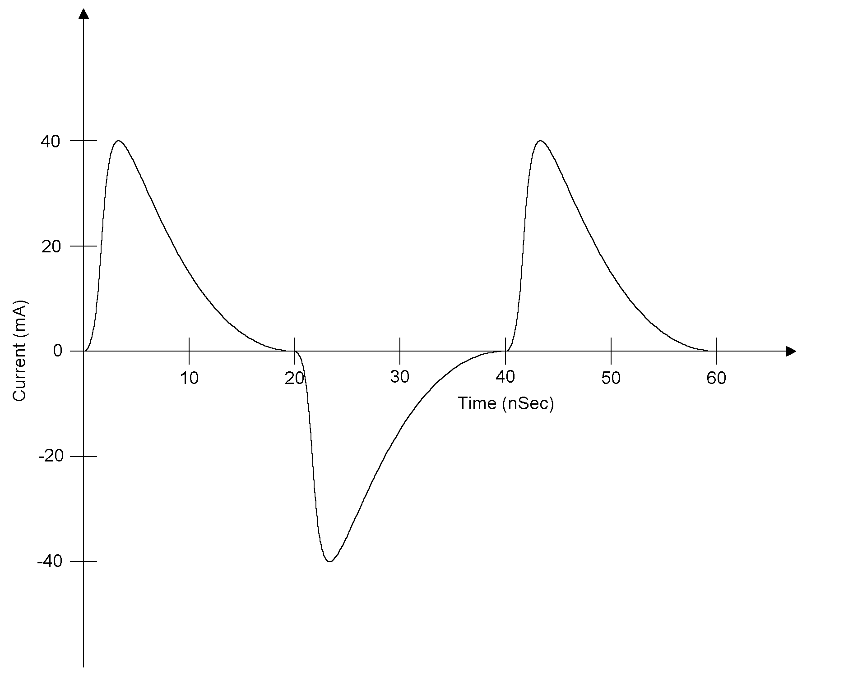
Figure 3: The current in the driven wire, and therefore the return, was measured using a Tektronix CT1 current probe.

A Tektronix CT1 current probe was used to measure the current through the driven wire. The current waveform is shown in Figure 3. The amplitude of the current was also measured by using a spectrum analyzer. At a frequency of 125 MHz the amplitude of the current measured was 2.8 milliamps RMS. (The current probe was removed during EMI testing.)

The inductance of the return plane, according to Kaden as reported by Leferink (Ref. 1), is:

$$\begin{aligned}L_{\text{return plane}}=\frac{μ_{0}l}{2π}\frac{d}{w}\end{aligned}≈\text{2 }(\frac{d}{w}$$
Where:
L _{return plane} = return plane inductance
w = width of the plane in meters
d = distance between the driven trace and the return plane in meters
l = length of the driven trace in meters, l >>d
μ₀ = permeability of free space = 4π x 10⁻⁷ Henries/meter

Hockanson, et al made a slightly different prediction (Ref. 2). It is:

$$L_{\text{return plane}}=\text{k }(\frac{d}{w}$$

The constant k is geometry dependent. It is a function of the current distribution in the return plane. Kaden’s formula assumes that the return current spreads out evenly across the return plane. But this is not so. It is now known that the current in the return plane concentrates beneath the driven trace. The constant k therefore can be difficult to predict. Estimates place k between 2 and 5.

We’ll use the upper limit of this range, k=5 to arrive at a worst-case prediction for the radiation. Inserting the values for the circuit in Figure 2 (d=.76 mm, w=114 mm, l=9.5 cm) yields an inductance value for the return plane of .033 nH/cm or .32 nH in total. At 125 MHz an impedance of .25j ohms would result due to this inductance. The voltage drop across the return can be readily computed from the measured current at 125 MHz (2.8 milliamps). The voltage across the return, the model predicts, is .07 Volts.

This voltage drives the attached telescoping antenna, the arms of which were adjusted to half wave resonance creating a half wave resonant dipole. We can calculate the predicted free space emissions from a half wave resonant dipole using the following formula (Ref. 3):

$$\begin{aligned}\begin{aligned}E(\text{V/m})=\text{ 5}\text{.}\text{5 }\frac{G_{\text{ant}}}{r}\frac{V_{r}}{\sqrt{Z_{\text{ant}}}}\end{aligned}E(\text{V/m})=(\frac{7}{\text{10}} \\ \frac{V_{r}}{\sqrt{\text{73}}}V_{r}\end{aligned}$$

Where:
E(V/m) = free space field strength
G _{ant} = gain of a resonant half wave dipole over isotropic = 2.1 dBi = 1.3
r = distance from the circuit to the measuring antenna in meters = 10 meters
V_{r} = the voltage dropped across the return plane = .07 Volts
Z _{ant} = impedance of the radiating antenna = 73 ohms for a half wave dipole.

Our model predicts free space radiation of 35.2 dBuV/m at 10 meters.

Testing over a ground plane affects the impedance of the radiating antenna somewhat and provides for ground reflection. As an approximation, we can assume that the net of these effects is to increase emissions by 5 dB at 125 MHz. Using this adjustment, our model predicts emissions of 40.2 dBuV/m, quite close to the measured value.

Our simple circuit of Figure 2 used solid power planes. Practical power planes, however, are not solid but are interrupted by holes and gaps. Models proposed by researchers predict that emissions will rise dramatically if the return plane is interrupted with a slit as shown in Figure 4. The slit cuts completely through the PCB, interrupting both the V+ and V- planes. It is .065” (1.65 mm) wide and extends from one edge of the board to a point 1” (2.54 cm) past the trace. The measured emissions at 125 MHz did rise dramatically, to 59.8 dBuV/m.

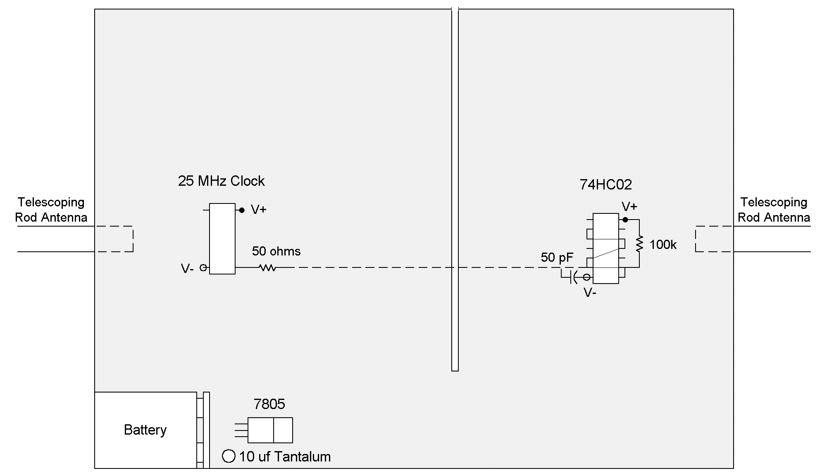
Figure 4: Slicing the return raises the return inductance resulting in increased radiation.

Hill, et al., (Ref. 4) models the increased inductance by analyzing the gap as a shorted transmission line. Dash, et al [5] calculates this inductance to be:

$$L_{\text{gap}}=\frac{\text{10}}{\text{2+}\text{ln}(\frac{w}{s})}\text{ nH/cm}$$

Where:
w = the width of the plane to the left and right of the slot in meters
s = the width of the slot itself in meters
w >> s and L _{gap} << λ

Applying this formula to our test circuit (s=1.65 mm, w=6.86 cm) and considering that L _{gap} =2.54 cm yields a predicted value of return plane inductance of 4.4 nH resulting in predicted emissions of 63.0 dBuV/m at 10 meters. This value is in reasonable agreement with the measured value.

Researchers also agree that if the return plane is interrupted by holes rather than a slit, the increased inductance caused by the presence of the holes will increase emissions only slightly. Figure 5 shows the circuit of Figure 2 with holes drilled through the plane, interrupting both the V+ and V- planes. Holes were placed .16” (4.1 mm) center to center and were .125” (3.2 mm) in diameter. No change in emissions was noted at 125 MHz due to the presence of the holes.

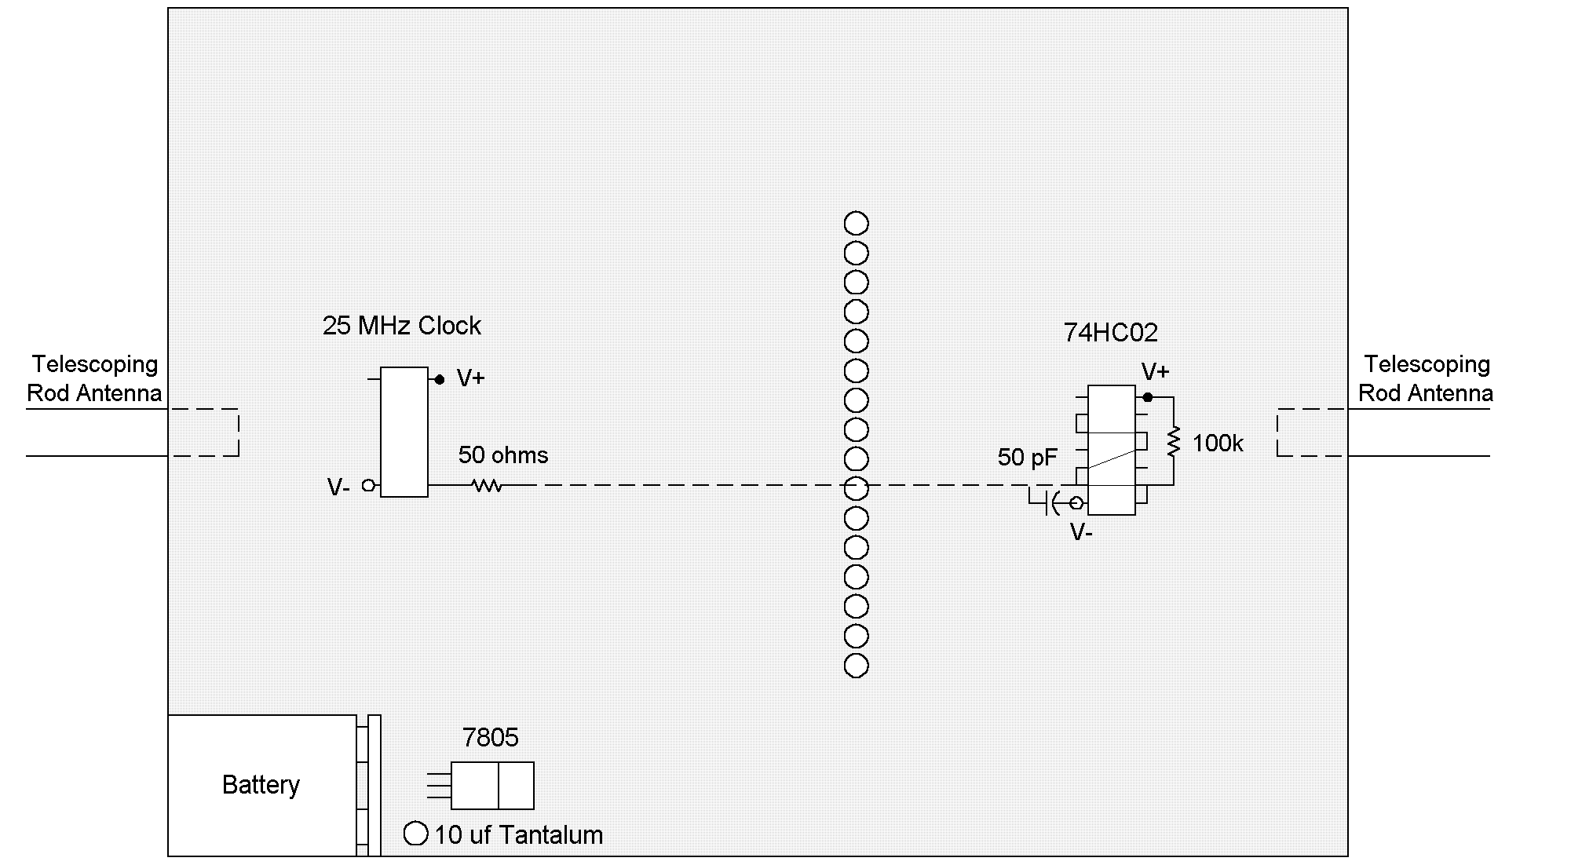
Figure 5

Next, we evaluated an unorthodox method for reducing emissions from an imperfect return plane (Ref. 6). This method uses a common mode choke located near the clock. In theory, the presence of the common mode choke should force current to return through the return wire, the one that passes through the common mode choke, instead of through the return plane. Even if the return plane was inductive because of the presence of an opening such as a slit, little voltage would be dropped across the return plane simply because the RF current does not pass through it.

We used the circuit of Figure 6. The return plane was gaped as in Figure 4. A twisted pair consisting of 24 AWG magnet wire was passed through two Fair-Rite 2643000801 No. 43 type ferrite beads 1 1/2 times and was then connected the clock and the load. The return wire was connected to the ground plane immediately adjacent to the clock and the load. Emissions fell dramatically at 125 MHz, to 38.7 dBuv/m at 10 meters.

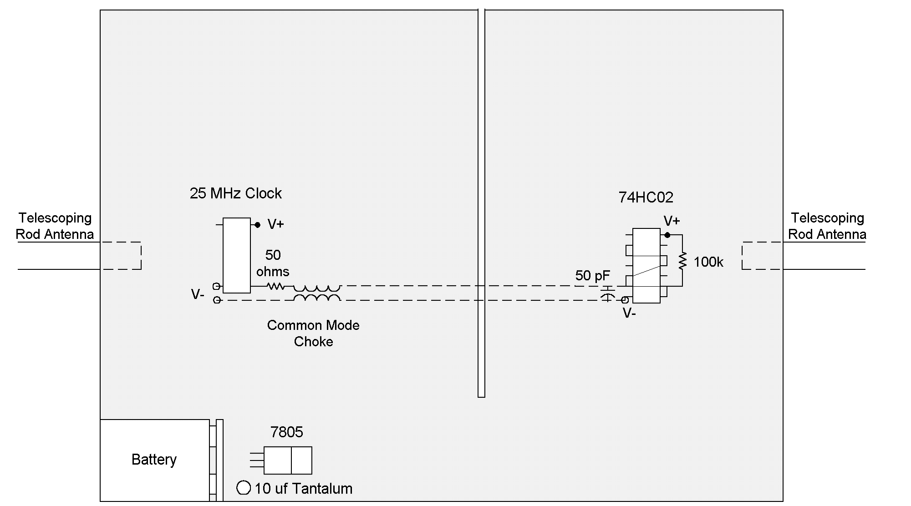
Figure 6: One unorthodox method of suppressing radiation is to use a common mode choke in the drive circuit.

Emissions were then measured using a circuit that employed both a common mode choke, as shown in Figure 6, and the solid ground plane of Figure 2. Emissions fell once again, this time to 32.7 dBuV/m. As a final test, the connection between the clock and the load was removed so that the clock oscillator could run by itself without any wires attached. At 125 MHz the clock oscillator, operating alone and fed power through solid V+ and V- planes, produced 29.7 dBuv/m of emissions, only 3 dB less than the emissions produced by the use of a combination of a common mode choke and a solid return plane. Data is summarized in Table 1.

Test Conditions | Figure | Measured Emissions  (dBuV/m at 10m) | Predicted Emissions  (dBuV/m at 10m)
Solid Return Plane | Figure 2 | 39.4 | 40.2
Slotted Return Plane | Figure 4 | 59.8 | 63.0
Holed Return Plane | Figure 5 | 40.2 | ~ 41
Slotted Return Plane with CM Choke | Figure 6 | 38.7 | --
Solid Return Plane with CM Choke | N/A | 32.7 | --
Clock Running Alone with No Wires Attached | N/A | 29.7 | --

Table 1: Radiation detected at 125 MHz is shown under varying conditions.

So far, so good. Theory works well at 125 MHz. But theory does not work well at the ninth harmonic, 225 MHz. (Table 2). In fact, what is remarkable about the 225 MHz data is that it was seemingly unaffected by anything that we did. The logical conclusion to be drawn was that emissions at the higher harmonics were not so much due to current on the driven wire but were due to some internal mechanism in the integrated circuits themselves.

Test Conditions | Figure | Measured Emissions  (dBuV/m at 10m)
Solid Return Plane | Figure 2 | 50.2
Slotted Return Plane | Figure 4 | 51.2
Holed Return Plane | Figure 5 | 50.1
Slotted Return Plane with CM Choke | Figure 6 | 49.6
Solid Return Plane with CM Choke | N/A | 50.1

Table 2: Radiation detected at 225 MHz under varying conditions is shown. Unlike the radiation detected at 125 MHz, the changing conditions did not affect the radiation at 225 MHz significantly.

The integrated circuits used were of the MOS family. Figure 7 shows the basic structure of a MOS device. P channel and N channel devices serve as switches alternately connecting the output to V+ and V-, depending on the input voltage. Very little current flows from V+ to V- when a gate is either in its high or low state. For example, when the input of a gate is in its high state, the N channel FET is turned on connecting the output to V-. The P channel device is in its off state and presents a very high impedance between V+ and the output. Therefore, little current flows between V+ and V-. The same situation is true in reverse when input is low and the output is high. In the transition region, however, current does flow from V+ to V-. This current is a function of input voltage, and is shown in Figure 7. It peaks somewhere in the middle of the input voltage range, and is known as “I _{dd} Delta,” “I _{dd} Noise” or sometimes as “shoot through” current.

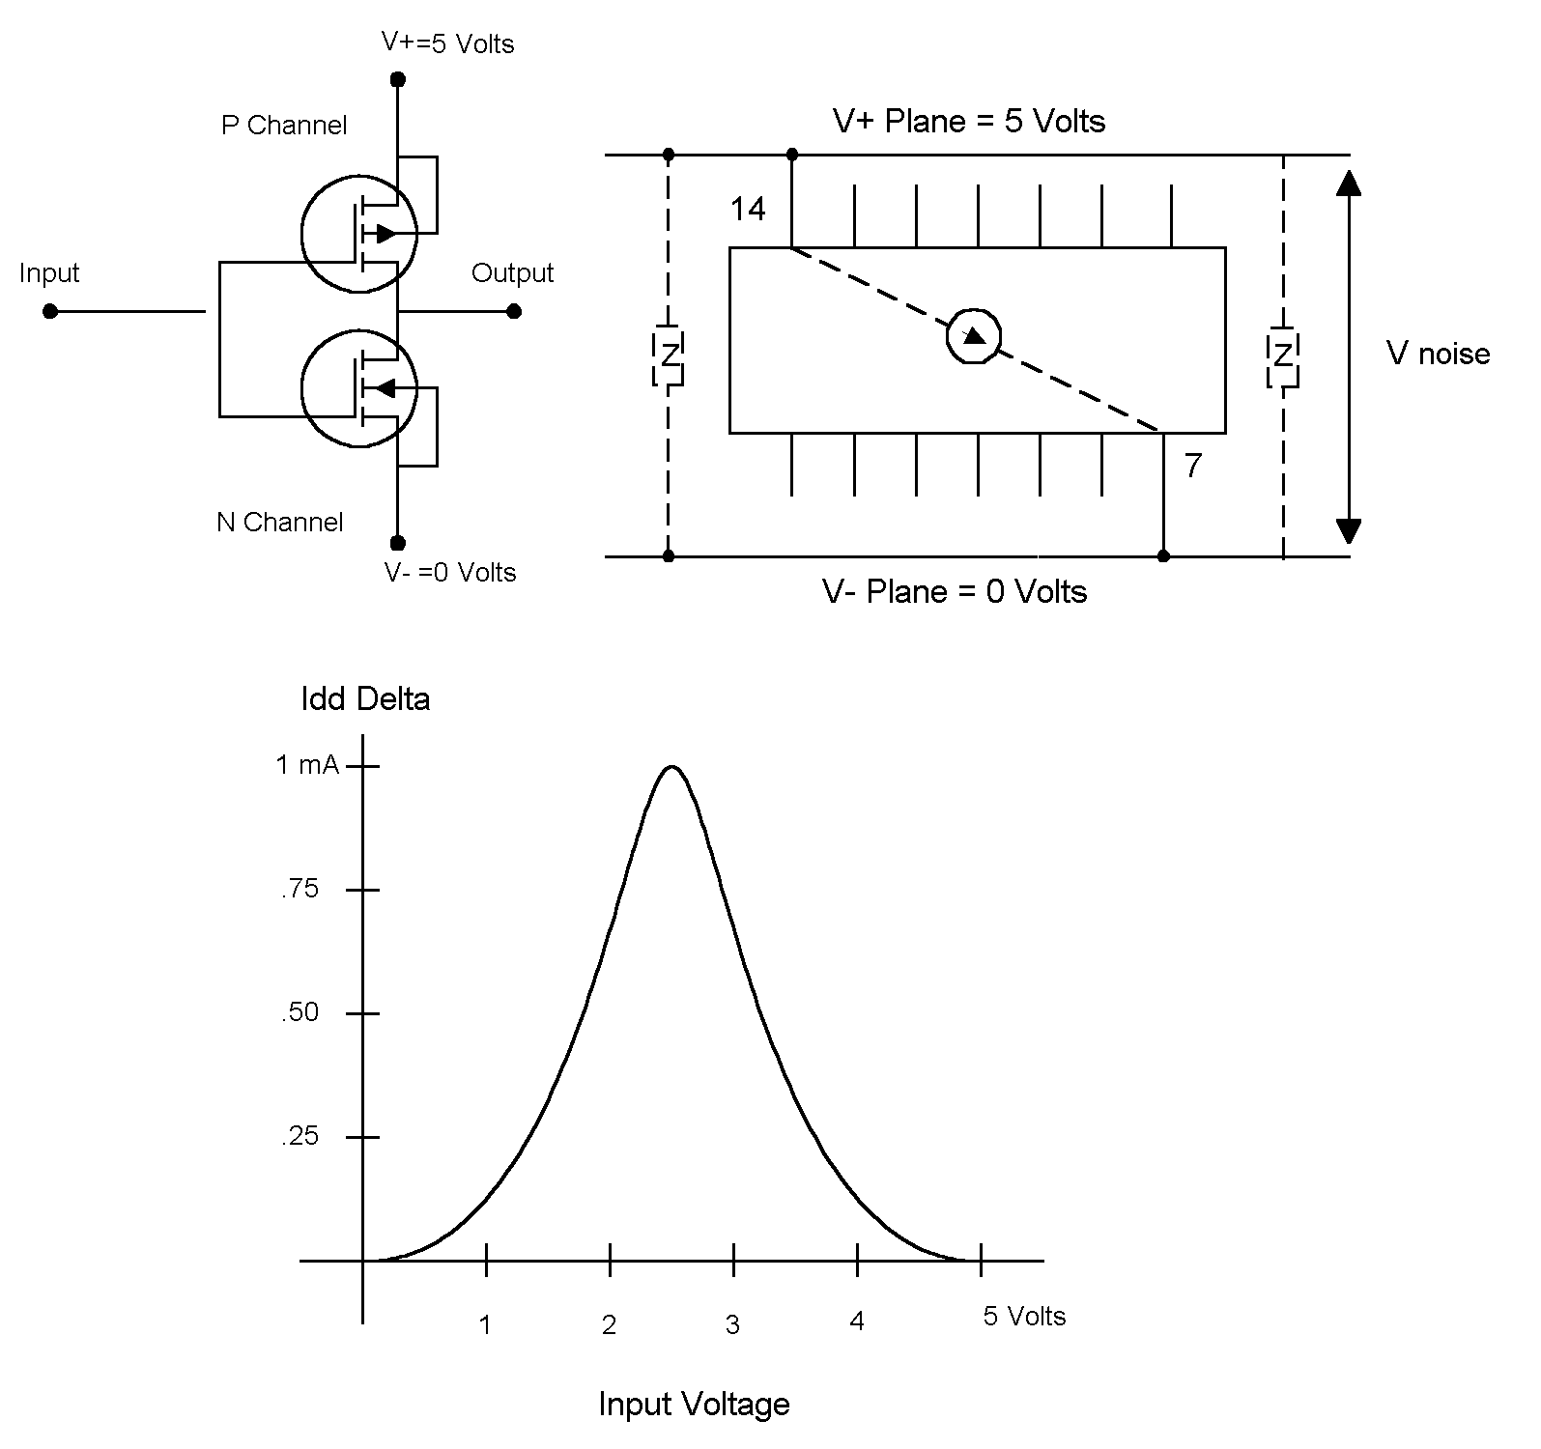
Figure 7: Variously called I_{dd} Delta, I_{dd} Noise or “Shoot Through” current, a spike in supply current drawn occurs as a MOS gate changes state.

The effect of I _{dd} Delta is to produce a very brief current pulse every time the gate changes state. The net result is a current pulse on the supply planes of approximately 1 milliamp peak and about 1 nanosecond in width each time a typical 74HC02 gate switches.

Unfortunately, the amount of radiation we can expect due to I _{dd} Delta can be difficult to predict. For one thing, manufacturers rarely cite I _{dd} Delta in their data sheets. For another, I _{dd} Delta is highly variable. Among other things it is a function of the supply voltage, varying as a function of V_{cc} to the 2.2 power. (Ref. 7).

Figure 8 shows how this current pulse turns into a voltage across the return plane. I _{dd} Noise current mostly passes through any bypass capacitor immediately adjacent to the integrated circuit. However, the impedance of that capacitor is finite, and some of the current is fed back through the supply planes. This creates a noise voltage due to the impedance of the return plane.
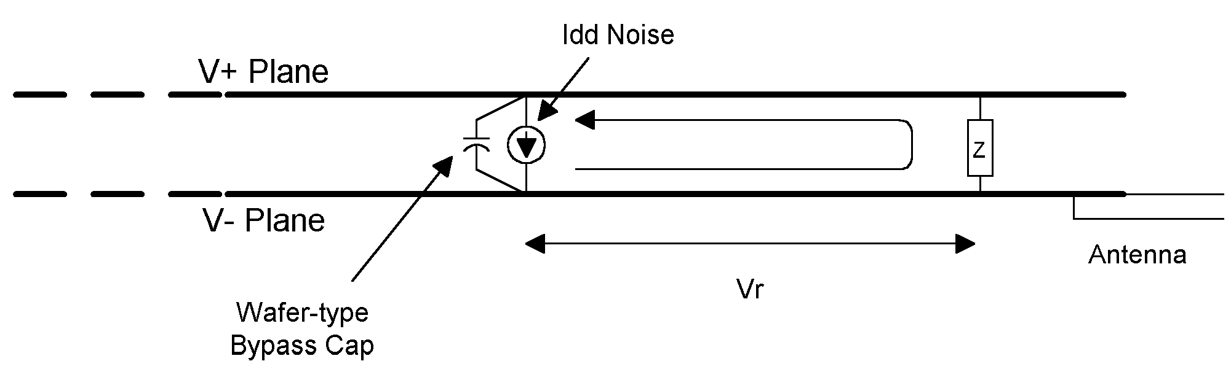
Figure 8: The spike in supply current caused by I_{dd} Delta creates a current flow through the return plane.

As mentioned, our test circuit already had wafer type capacitors placed immediately below the ICs. So as a further experiment, we isolated the V+ pin (pin 14 on both devices) from the V+ plane. A wire was connected as shown in Figure 9c. Although identical on a schematic, this configuration provided some filtering because of the wire’s inductance. Test results show a reduction of 9 dB at 225 MHz. The next step was to add a second bypass capacitor as shown in Figure 9b (a 1000 picofarad surface mount multilayer type) and to replace the wire with a surface mount device designed to increase series impedance over a wide frequency range. A TDK MMZ2012S301 was chosen which, according to the manufacturer’s data sheet, exhibits an impedance of greater than 300 ohms at the frequencies of interest. An additional reduction of more than 19 dB was noted.

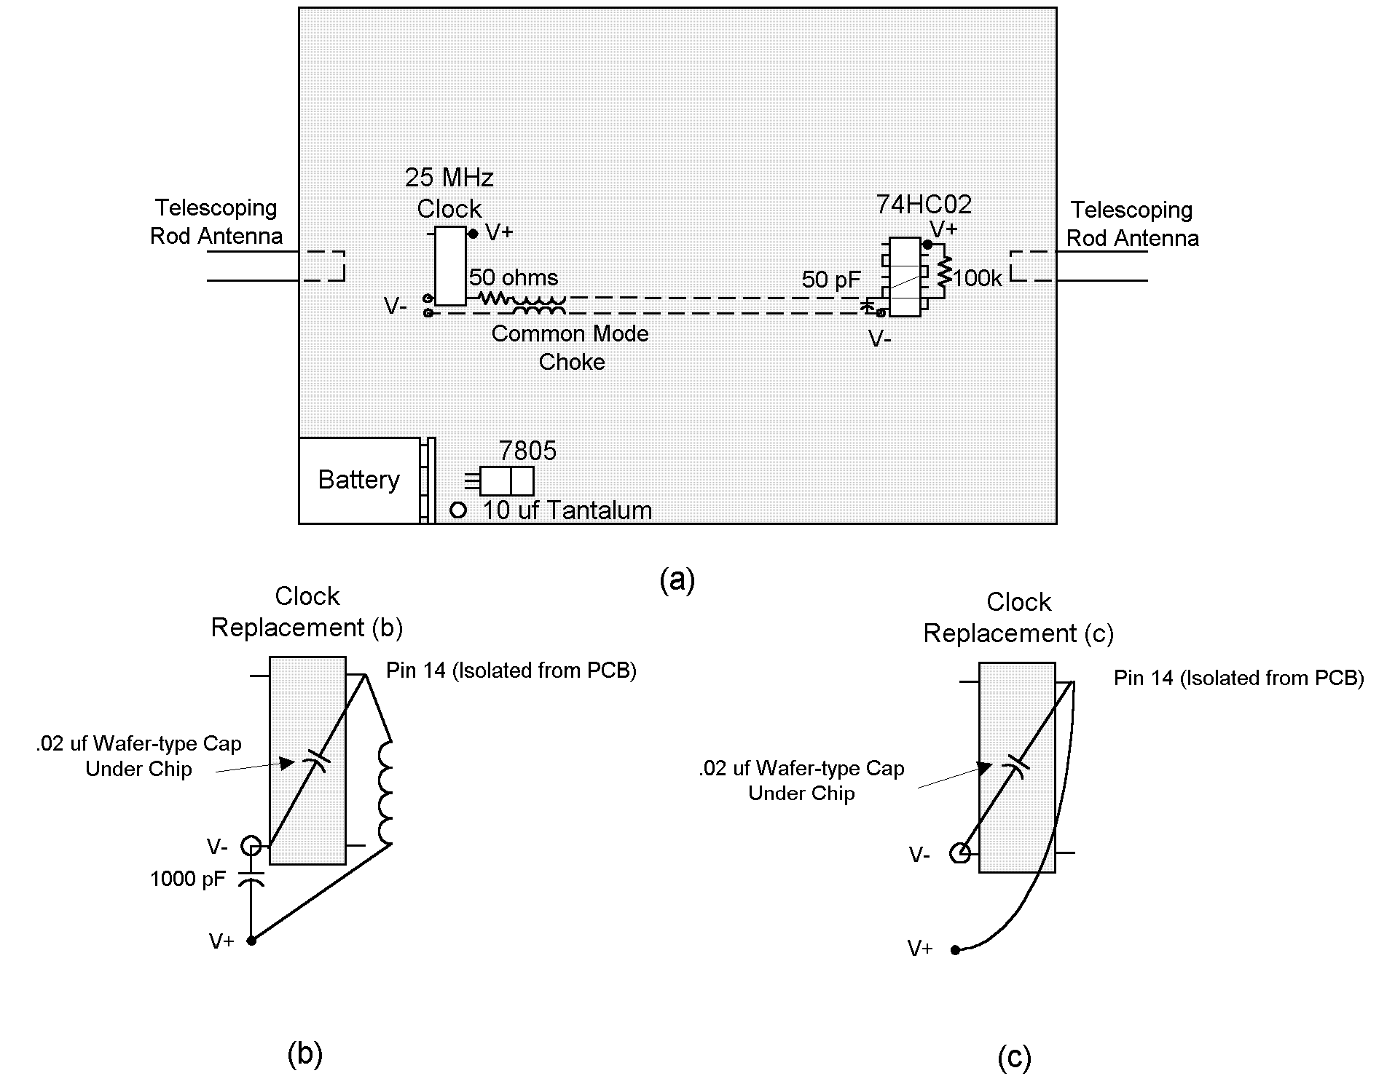
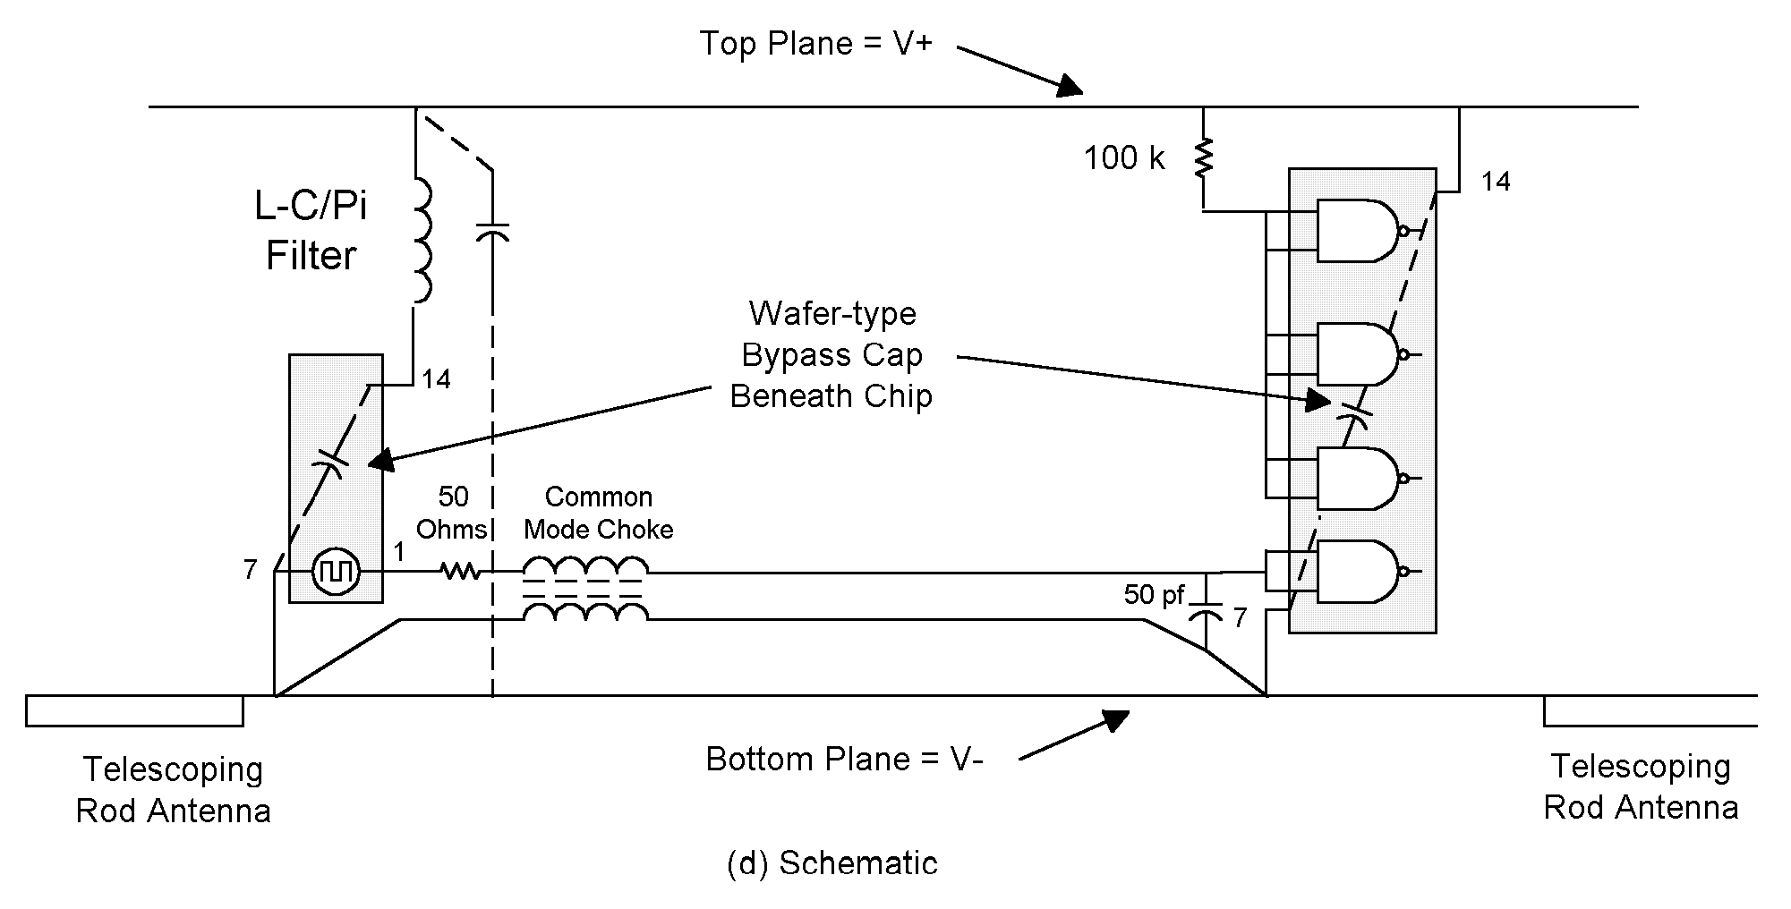
Figure 9: A small pi filter on the supply of the 25 MHz clock as shown in (b) dramatically reduced radiation at 225 MHz. Even a short length of wire as shown in (c) significantly reduced radiation by forming an LC filter. The filter works by reducing I_{dd} Delta.

Table 3 demonstrates the results of our efforts. Note that improvement was achieved without using any filtering near our “I/O” (telescoping elements) or shielding.

Frequency (MHz) | Circuit of Figure 4 | Circuit of Figure 9b | Reduction (dB)
75 | 41.3 | 27.3 | 14.0
125 | 59.8 | 31.2 | 28.6
175 | 53.4 | 34.3 | 19.1
225 | 51.2 | 33.6 | 17.6
275 | 33.8 | 27.8 | 6.0
325 | 48.4 | 22.7 | 25.7
375 | 48.4 | <20 | >28.4
425 | 39.4 | <20 | >19.4
475 | 37.3 | <20 | >17.3
525 | 31.7 | <20 | >11.7

Table 3: Reductions in Emissions (dB/uV at 10m)

References

1. F. Leferink, “Inductance Calculations: Methods And Equations,” 1995 IEEE International Symposium on Electromagnetic Compatibility, Page 16.

2. D. Hockanson, J. Drewniak, T. Hubing, T. Van Doren, F. Shu, C. Lam, L. Rubin, “Quantifying EMI Resulting from Finite-Impedance Reference Planes,” IEEE Transactions on Electromagnetic Compatibility, Nov. 1997, Page 286.

3. G. Dash et al, “Computational Methods Aid in Understanding Antennas,” Conformity Annual 2001, Pg. 126.

4. R. Hill, T. Van Doren, T. Hubing, J. Drewniak, and F. Gisin, “Common Mode Currents Induced On Wires Attached To Multilayered Printed Wire Boards With Segmented Ground Planes,” 1994 IEEE International Symposium on Electromagnetic Compatibility, Page 116.

5. G. Dash et al, “Designing for Compliance. We Put Theory to the Test,” Conformity, March 1998, Page 10.

6. F. J. Tilley, “Reducing Radiated Emissions on High Speed Signal Lines Using Common Mode Choke Coils,” IEEE Symposium on Electromagnetic Compatibility, 1995.

7. High Speed CMOS Designer’s Guide, Signetics/Philips, Feb. 1986, Page 2-18.

