Know The Theory of Partial Inductance to Control Emissions

By Glen Dash, Ampyx LLC, GlenDash at alum.mit.edu
Copyright 1999, 2005 Ampyx LLC

The theory of partial inductance is a powerful tool for understanding why digital circuits radiate and in designing strategies to mitigate this radiation. In fact, it can be fairly said that nothing is more central to understanding EMI phenomena than understanding of the theory of partial inductance.

We will begin with the classic definition of inductance. Inductance is defined as the ratio of magnetic flux that passes through a surface bounded by a closed loop to the magnitude of the current generating that flux. Mathematically:

$$\text{L=}\frac{ψ}{I}$$

Where:

L = Inductance in Henries
ψ = Magnetic flux through a surface bounded by a closed loop
I = Current generating ψ in Amps

The “surface bounded by a closed path” could be any surface, but often what is meant is the area enclosed by a planar wire loop. Strictly speaking, inductance is only defined for closed paths, that is complete loops. However, physicists have found it useful to assign a partial inductance to portions of a loop. The concept is illustrated in Figure 1. Current flowing in a loop creates a magnetic field passing through a surface bounded by the loop itself. That allows calculation of the loop’s inductance from Equation 1. In order to assign a partial inductance to a portion of the loop, we can divide the loop into segments and, with a fair degree of physical accuracy, state that each segment has its own partial inductance. Adding the partial inductances of the segments together equals the total inductance.

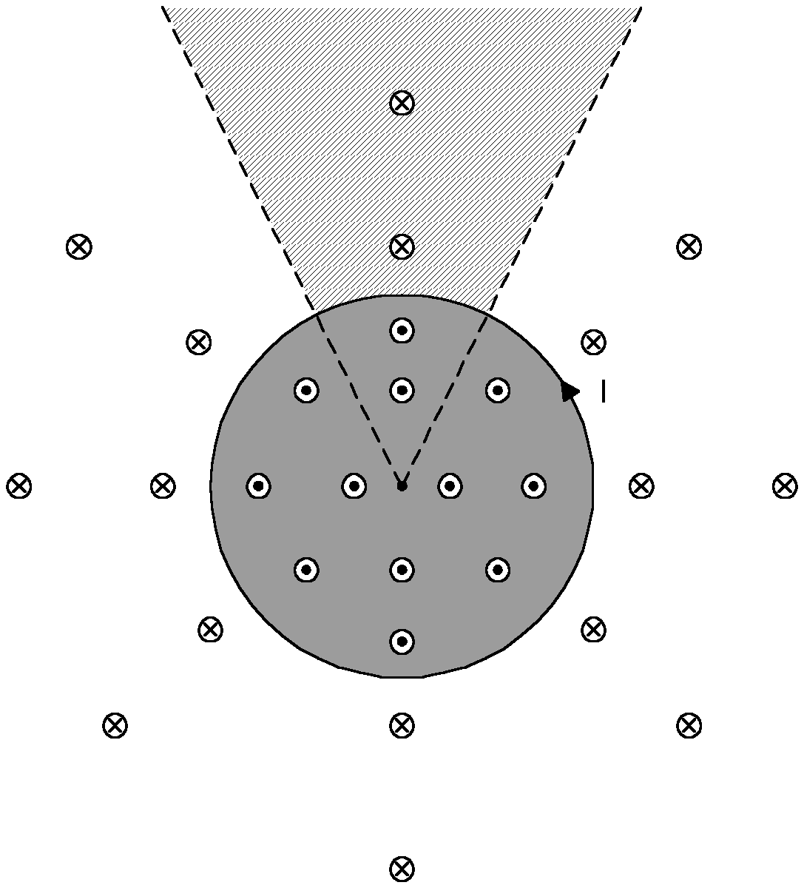
Figure 1: A loop of wire carrying current I has an inductance equal to the ratio of the magnetic flux through the loop divided by the current. Here, lines of flux are shown either as moving into the plane of the page (cross within a circle) or out of it (dot within a circle). A portion of the loop can be assigned a partial inductance by calculating the flux through the pie shaped area outside the loop.

To assign a partial inductance to a segment of a loop, the segment is identified and then an area, either inside or outside the loop, is assigned as shown in Figure 1. Measuring the total flux through either of these areas and dividing it by the current in the segment yields the partial inductance. Usually the area outside the loop is used.

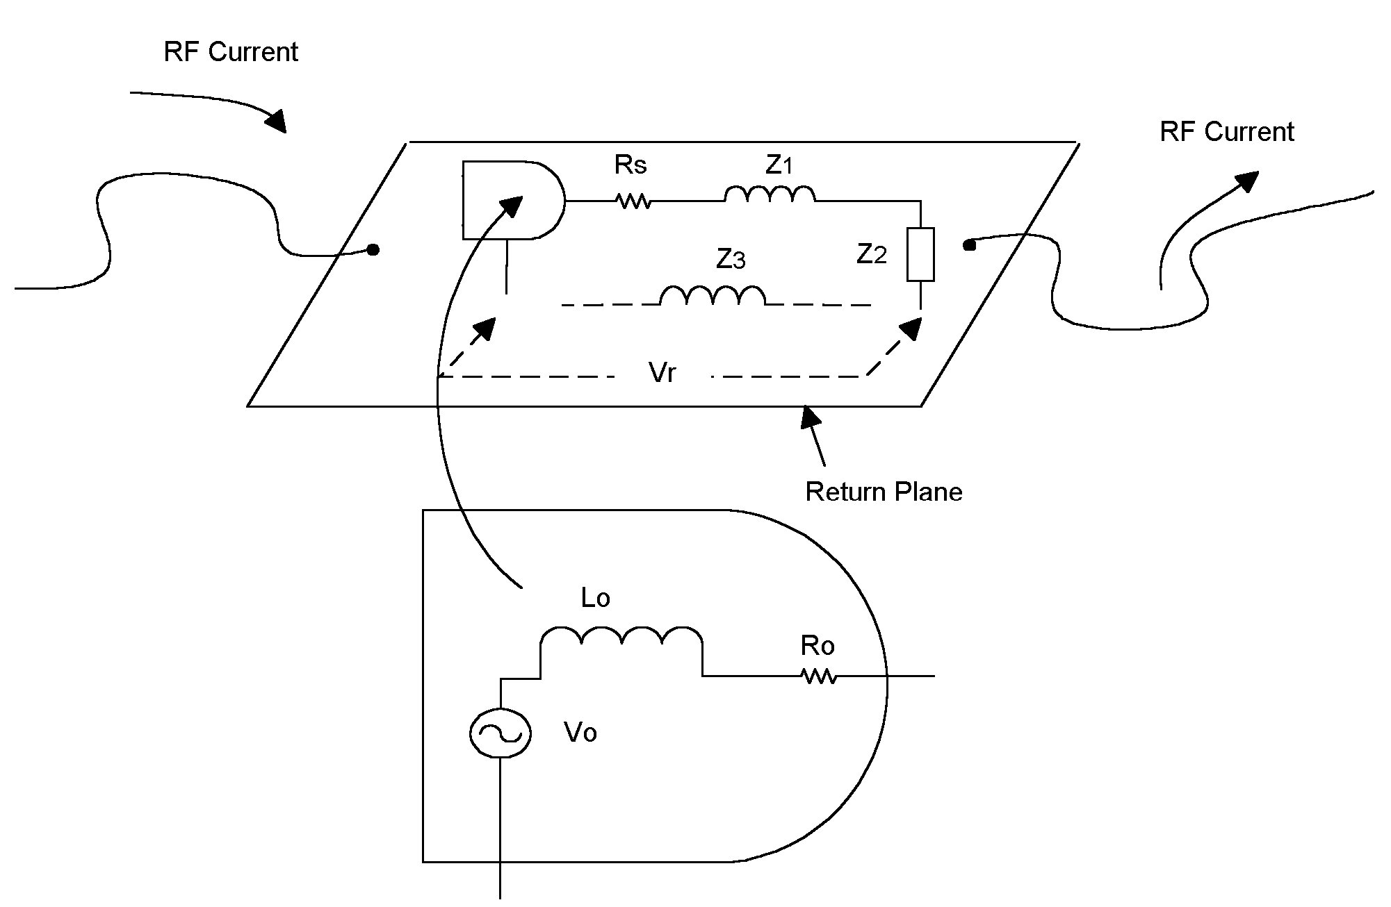
Figure 2: The return plane has a partial inductance and therefore will exhibit a voltage drop Vr across it. This voltage drop causes wires connected to the return to radiate.

The concept of partial inductance is useful for solving problems that would otherwise seem intractable. Take, for example, the calculation of the inductance of a single straight, infinitely long wire. In theory, only loops have inductance. Nonetheless, we have all experienced situations where a wire seems to have an inductance per unit length even where the current loop seems impossible to define. Using the concept of partial inductance, however, we calculate the drop expected per unit length of wire due to inductance (Figure 3). The flux through the area shown in Figure 3 -- which is defined as a surface of infinite length perpendicular to a selected segment of the wire -- divided by the current in that segment yields the partial inductance.

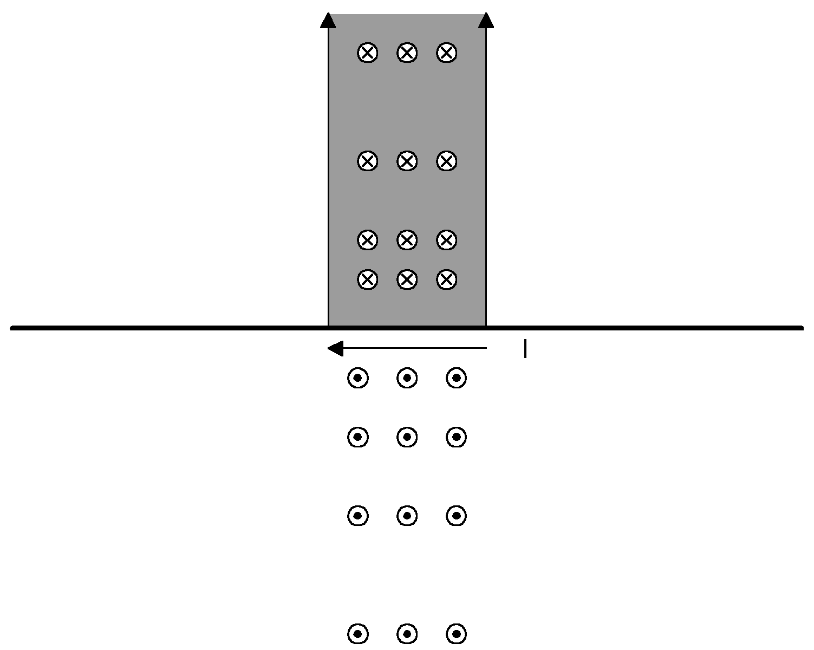
Figure 3: The partial inductance of a straight segment of wire can be calculated by taking the flux through the shaded area and dividing it by the current.

So far we have been talking about the inductance of a single wire isolated in space. Wires however, are rarely so isolated. Take, for example, the two parallel wires shown in Figure 4. Here, the partial inductance of a segment is due both to the flux generated by the current flowing in wire 1 and the flux generated by the current flowing in wire 2.

$$L_{\text{p tot}}=L_{\text{11}}{−L}_{\text{12}}$$

Where:

L_{p tot}= “Total” partial inductance of a segment of wire 1.

L₁₁ = Partial inductance of wire 1 due to the flux generated by the current on wire 1.
L₁₂ = Partial inductance of wire 1 due to the flux generated by the current on wire 2.

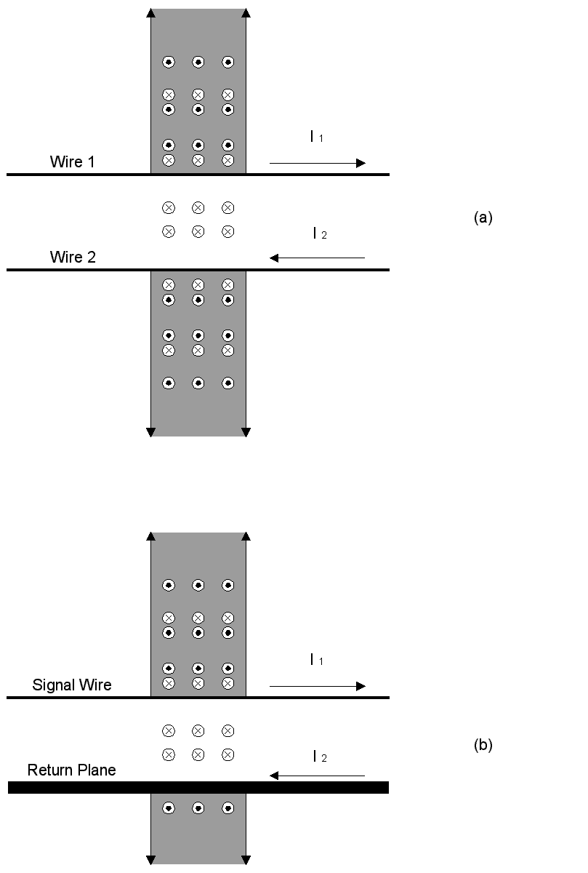
Figure 4: A pair of wires (a) carrying opposing currents will produce opposing fields in the shaded areas. Taking the net flux through the shaded area above wire 1 and dividing by the current on wire 1 allows us to compute the “total” partial inductance of that segment of wire 1. In the same manner, the partial inductance of a segment of a return plane can be calculated by taking the flux through the shaded area below the plane as in (b) and dividing by the current passing through the plane.

L₁₁ is known as the self partial inductance. The term L₁₂ is known as the mutual partial inductance. The total partial inductance of a segment, L_{p tot}, is the sum of the self and mutual inductances. L_{p tot} is sometimes known as the effective inductance, L _{eff}.

The sign on the right side of this equation is a function of the direction of the current in wire 2. If the current in wire 2 flows in the same direction as the current in wire 1 then the equation becomes:

$$L_{\text{p tot}}=L_{\text{11}}\text{+ }L_{\text{12}}$$

The effect of wire 2 is then to raise the inductance of wire 1.

For symmetrical structures such as the two wires of Figure 4(a), the calculation of partial inductance is straightforward. For structures that are not symmetrical, however, such as the classic case of a wire over a plane (Figure 4(b)), the calculations become considerably more complex. Nonetheless, some important insight can be gained by keeping these things in mind:

1. The total inductance of any loop can, by definition, be calculated by taking the flux through a surface bounded by the loop and dividing it by the current.

2. The partial inductance of a segment of a signal wire (Figure 4(b)) can be calculated by mapping a rectangular area outside the loop formed by the signal wire and the plane as shown. Calculating the flux in this area and dividing by the current yields the partial inductance of that segment.

3. The partial inductance of a segment of the return plane is calculated by identifying a rectangular area beneath the return plane and calculating the flux through it. That flux divided by the current yields the partial inductance of that segment of the plane.

The larger the return plane’s partial inductance, the greater the radiation that is likely to result. Consider the case of a digital clock driving a load (Figure 2). Any inductance in the return plane will cause a voltage drop across it. That voltage will cause wires attached to the return plane to radiate like an antenna. Neglecting resistances, the voltage drop is equal to:

$$V_{r}\text{=j}ωL_{p}I_{r}$$

Where:

V_{r} = Voltage dropped across the return plane
ω = Frequency in radians per second = 2πf
L_{p} = Partial inductance of the return plane
I_{r} = Current through the return plane

Controlling the partial inductance of the return plane is therefore of great importance in controlling emissions. Making the return plane infinitely wide will result in a return plane partial inductance of zero. An infinitely wide return plane will prevent any lines of magnetic flux from passing through it .

Note that the same logic applies to the case of the ideal shielded cable (Figure 5(a)). Here, all the lines of flux created by the center conductor are trapped within the shield. No lines of flux extend beyond the shield and therefore the partial inductance of the shield is zero. The center conductor, through the sum of its partial inductances, represents all the inductance of a circuit formed by the center conductor and the shield.

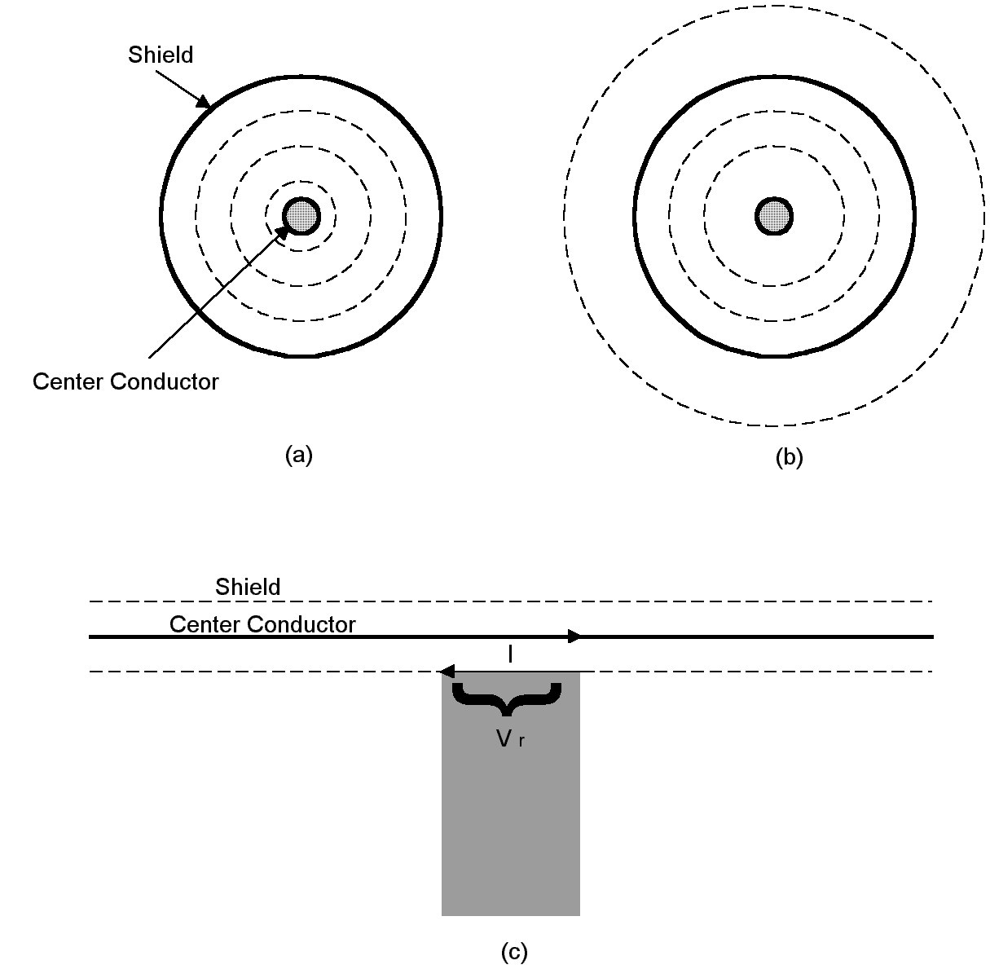
Figure 5: An ideal shielded cable (a) exhibits no return inductance. However, all practical shielded cables have some flux leakage (b). The flux around the shield causes it to exhibit an inductance and a voltage drop as shown in (c). This voltage drop can cause the shield to radiate.

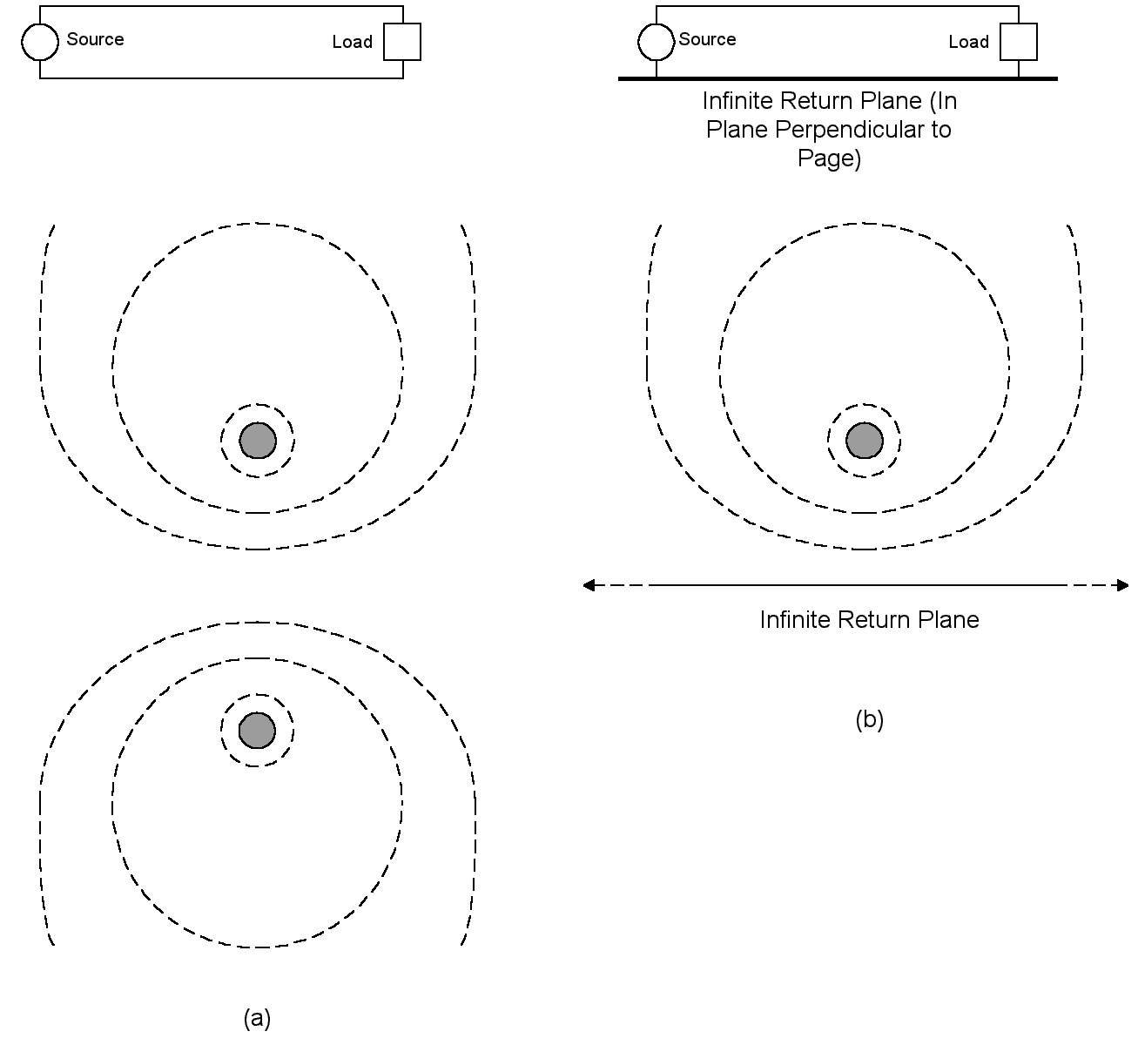
Figure 6: An open wire transmission line produces a classical dipole like magnetic flux pattern as shown in (a). The pattern produced by a wire over an infinite return plane (b) is the same (at least above the plane).

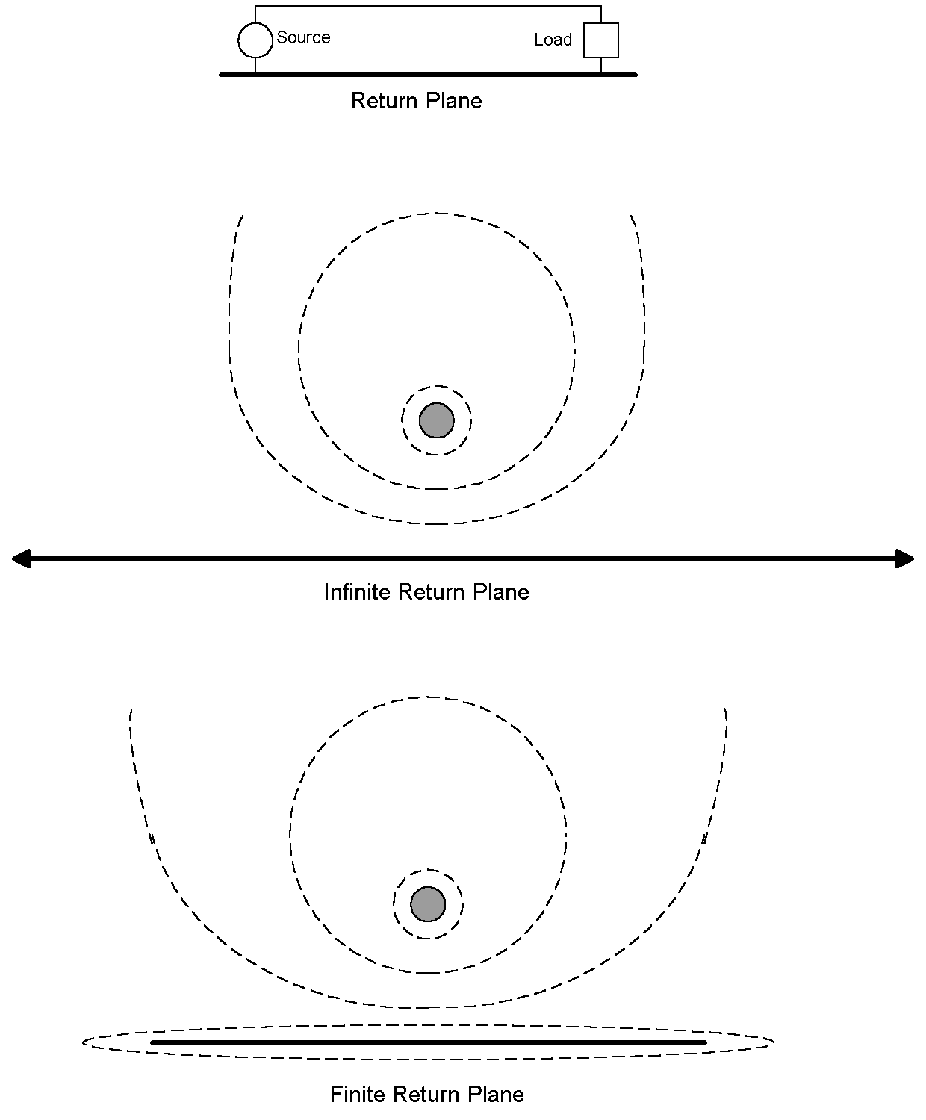
Figure 7: Real return planes are finite in size, so some flux leaks around the edges of the return plane, accounting for its partial inductance.

In the case of a shielded cable, any flux that is lost (that is, which circulates around the shield rather than within it) accounts for partial inductance of the shield and will result in a voltage drop across a portion of the shield. That voltage will drive the rest of the cable, and devices attached to it, as if they were antennas. The same concept of “lost flux” can be applied to the case of a wire over a plane. Flux that wraps around the plane is essentially lost and minimizing this lost flux is a key to minimizing the voltage drop across the plane (Figure 7).

In a 1995 paper (Ref. 2) Leferink tabulated the predicted partial inductances of the return conductors in various circuits (Figures 8 and 9 and Table 1). To make things manageable, Leferink had to make a number of assumptions. These were:

1. All of the marked dimensions In Figures 8 and 9 are considered to be small compared to the wavelength of interest.

2. The current distribution in the signal conductor (or to use Leferink’s terminology, the Flux Generating Conductor, FGC) is considered to be uniform.

3. The length of any transmission line formed is much greater than all the other dimensions.

4. The radius r where shown or the thickness t are considered to be equal for the signal conductor and the return conductor.

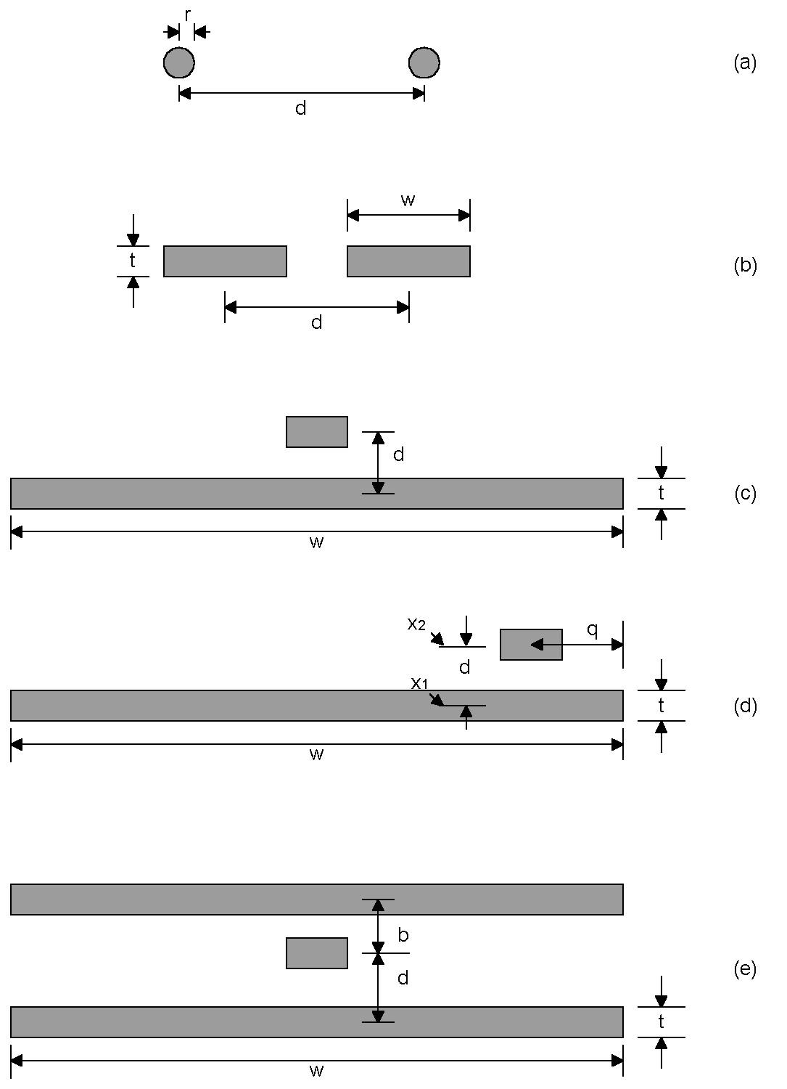

Figure 8: Some common geometries. The return partial inductance is tabulated for each in Table 1.

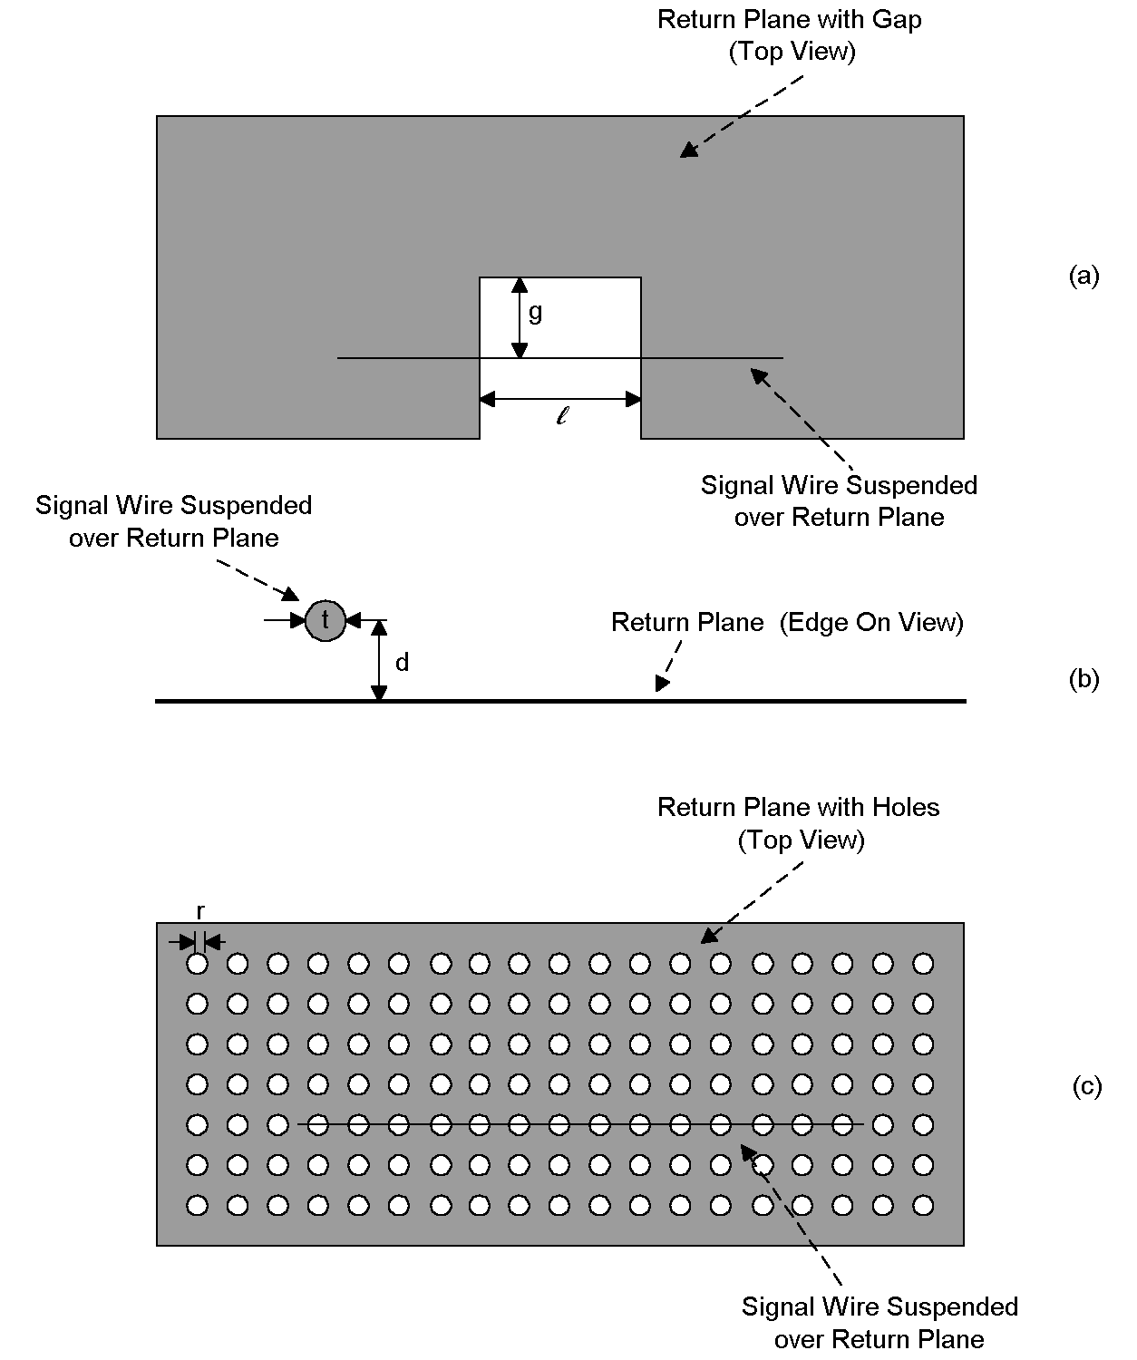
Figure 9: Gaps (a) and holes (c) can raise the return plane’s impedance. Figure 9(b) is a side view of the arrangement.

The formulas allow us to predict, to at least a first approximation, the partial inductance associated with some common geometries. Take, for example, a trace suspended above a plane (Figure 8c). The formulas predict that the effective inductance falls as the width of the plane is incresed. We also can calculate the effect of moving a signal conductor closer to the edge of a plane (Figure 8d). Here the formulas predict that the inductance of the return plane will rise as the signal conductor gets closer to the edge of the plane. However, this rise is small until the signal conductor gets quite close to the edge (Figure 10).

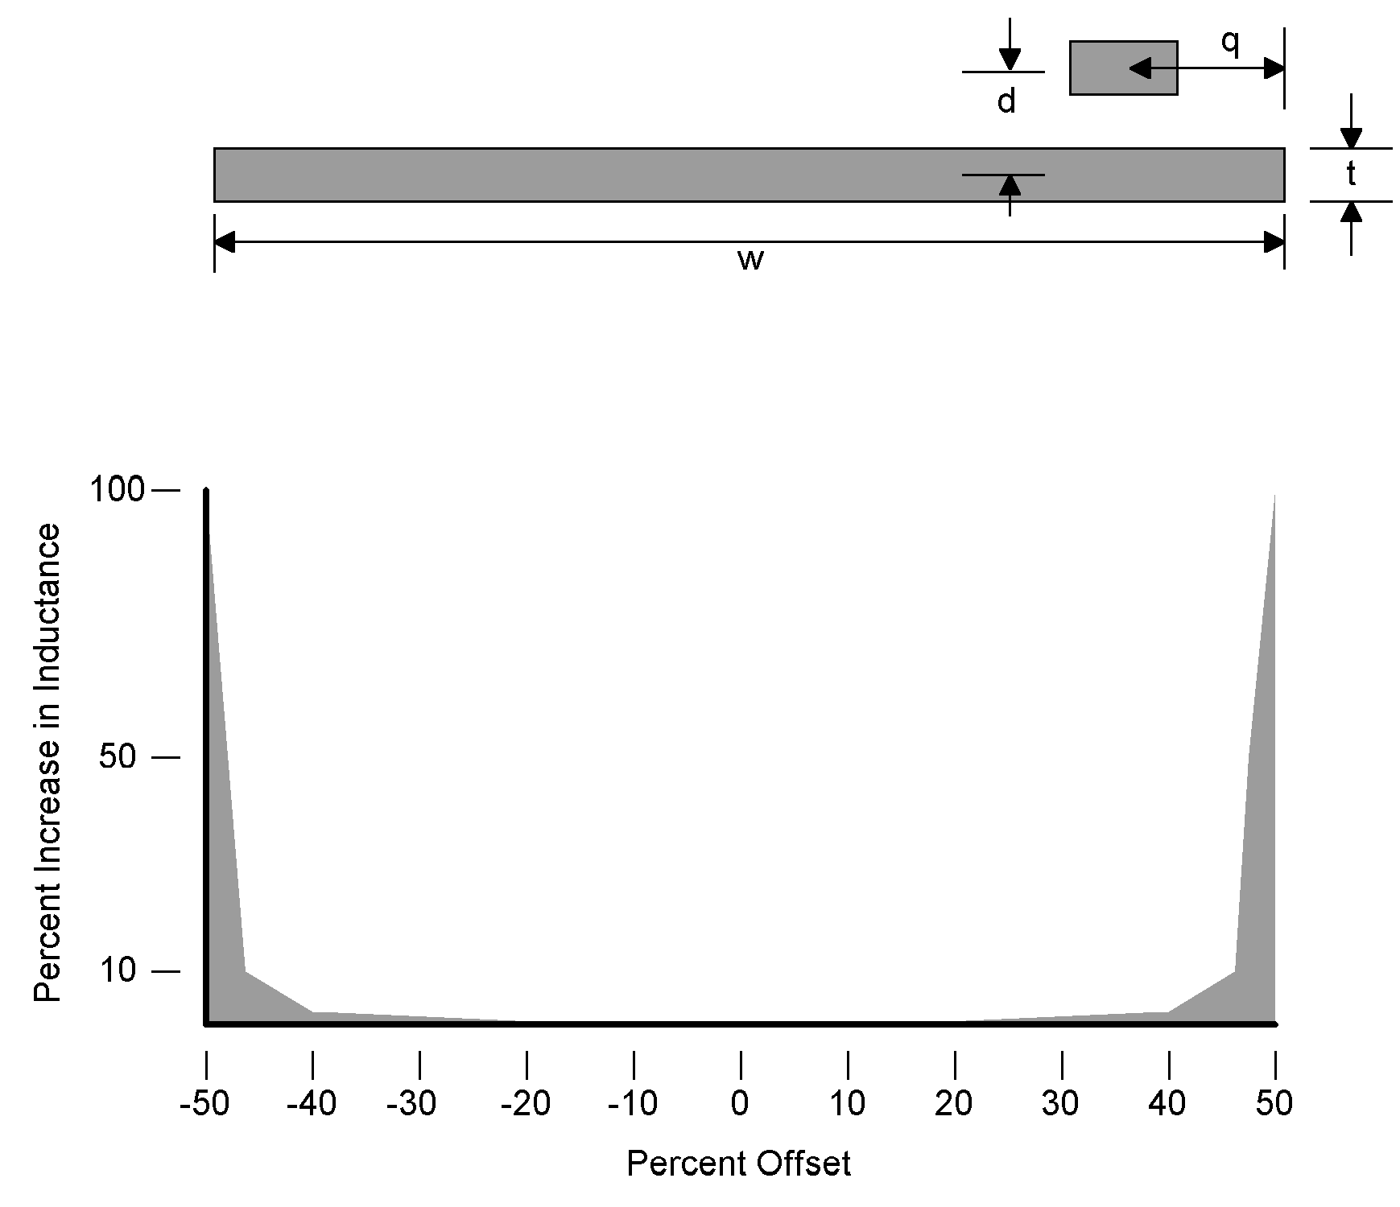
Figure 10: Moving a trace towards the edge of a return plane raises its inductance.

Finally, we can use the formulas to predict the increase in a return plane’s inductance due to holes or a gap in the return plane. For a gap whose dimensions are l=10mm, g=50mm and t=0.035mm, L_{gap}=14.5nH. For a plane studded with holes of r=1mm and d=1.6mm, each hole over which the signal wire passes will contribute 17 pH. Small holes in the return plane do not tend to increase inductance markedly, though gaps do.

References

- T. Hubing, T. Van Doren and J. Drewniak, “Identifying and Quantifying Printed Circuit Board Inductance,” IEEE Symposium on Electromagnetic Compatibility, 1994, Page 205.
- F. Leferink, “Inductance Calculations; Methods and Equations,” IEEE Symposium on Electromagnetic Compatibility, 1995, Page 16.
- F. Leferink, “Preventing Electromagnetic Interference from Integrated Circuits and Printed Circuit Boards using Computer Simulation,” Twente University of Technology, Rep. EL-BSC-92N138, 1992.
- F. Buesink, “Inductance of Striplines,” Internal Note to F. Leferink, Hollandse Signaalapparaten B. V.
- H. Kaden, Wirbelstroeme und Schirmung in der Nachrichtentechnik, Springer, Berlin, 1959.
- F. Leferink, M. van Doorn, “Inductance of Printed Circuit Board Ground Planes,” IEEE Symposium on Electromagnetic Compatibility, 1993, Page 327.
- D. Hockanson, J. Drewniak, T. Hubing, T. Van Doren, F. Shu, C. Lam, L. Rubin, “Quantifying EMI Resulting from Finite-Impedance Reference Planes,” IEEE Transactions on Electromagnetic Compatibility, Nov. 1997, Page 286.

TABLE 1
After Leferink (Reference 2)

Description of Circuit | Figure | Leff—Partial Inductance of Return | Notes
Ideal Shielded Cable | 5(a) | 0 | Ideal Case
Open Wire Transmission Line | 8(a) | $$\frac{μl}{2π}\text{ln}\left(\frac{d}{r}−1\right)$$ | Radii equal
Traces Side by Side | 8(b) | $$\frac{μl}{2π}\text{ln}\frac{\left(1−\frac{π}{2}\right)w+t+πd}{\left(1+\frac{π}{2}\right)w+t}$$ | Edge effects ignored
Microstrip | 8(c) | $$\frac{μl}{2π}\text{ln}\left(\frac{w+t+π\left(d−\frac{t}{2}\right)}{w+\left(1+\frac{π}{2}\right)t}\right)$$ | After Leferink (Ref. 6)
Microstrip | 8(c) | $$\frac{μl}{4π}\frac{\text{kd}}{w}\text{ 2}≤k≤\text{5 }$$ | After Hockanson (Ref. 7)
Offset Microstrip | 8(d) | $$\frac{μl}{2π}\left(\frac{1}{w}\right)\int_{x_{1}}^{x_{2}}{\left(\text{arctan}\frac{q}{x}+\text{arctan}\frac{w−q}{x}\right)}\text{dx}$$
Stripline | 8(e) | $$\frac{μl}{2π}\left\{\frac{d}{b}\left[\text{ln}\left(\frac{πd}{w}+1\right)−\text{ln}\left(\frac{πb+w}{πd+w}\right)\right]+\frac{b−d}{b}\left[\text{ln}\left(\frac{π\left(b−d\right)}{w}+1\right)−\text{ln}\left(\frac{πb+w}{π(b−d)+w}\right)\right]\right\}$$ | After Buesink. (Ref. 4)  t=0
Return Plane with Gap | 9(a), 9(b) | $$L_{\text{plane}}+\frac{μl}{2π}\text{ln}\frac{g}{t}$$ | g>d
Return Plane with Holes | 9(b), 9(c) | $$L_{\text{plane}}+v\left(\frac{{μr}^{3}}{3π^{2}d^{2}}\right)e^{−\left(\frac{t}{r}\right)}$$ | After Kaden (Ref. 5)  v = holes per unit length
Note: l in the equations above is the length of the return or a portion of the return. It does not appear in Figure 8. Inductances are in Henries. In terms of inductance per unit length, the term (μ/2π)=2nH/cm.

