Designing Log Periodic Antennas

By Glen Dash, Ampyx LLC, GlenDash at alum.mit.edu
Copyright 2000, 2005 Ampyx LLC

Lightweight and precise, the log periodic has become a favorite among EMC engineers.

In 1957, R.H. DuHamel and D.E. Isbell published the first work on what was to become known as the log periodic array. These remarkable antennas exhibit relatively uniform input impedances, VSWR, and radiation characteristics over a wide range of frequencies. The design is so simple that in retrospect it is remarkable that it was not invented earlier. In essence, log periodic arrays are a group of dipole antennas of varying sizes strung together and fed alternately through a common transmission line. Still, despite its simplicity, the log periodic antenna remains a subject of considerable study even today.

The log periodic antenna works the way one intuitively would expect. Its “active region,” -- that portion of the antenna which is actually radiating or receiving radiation efficiently -- shifts with frequency. The longest element is active at the antenna’s lowest usable frequency where it acts as a half wave dipole. As the frequency shifts upward, the active region shifts forward. The upper frequency limit of the antenna is a function of the shortest elements.

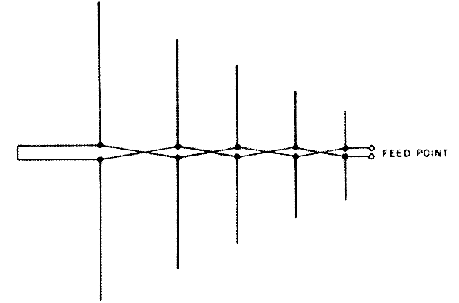
Figure 1. Basic arrangement of a Log Periodic Dipole Array (LPDA). From Ref. 1.

Log periodic designs vary, but the one most commonly used for EMC work is the Log Periodic Dipole Array (LPDA) of Figure 1 invented by D.E. Isbell of the University of Illinois. The LPDA we will discuss in this article covers a frequency range of 200 to 1000 MHz. We did not actually build it, but we did simulate its operation on a Method of Moments simulator.

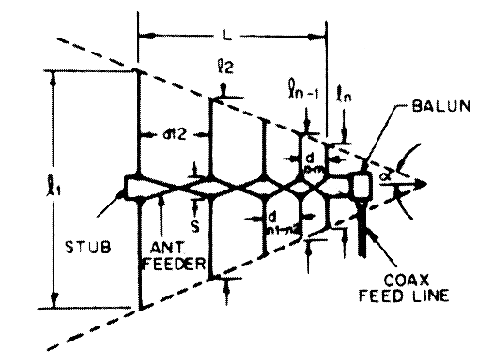
Figure 2: A closer look at the LPDA. Note that adjacent elements are fed out of phase.

The basic geometry is that shown in Figure 2.. Each element is shorter than the element to its left. Ratio of each element to each adjacent element is constant, and is referred to as tau (τ). The other critical dimension is the spacing between elements, designated “d” in Figure 2. Distance d_{1,2} for example, is the distance between the left most element and its nearest neighbor. The distance between two adjacent elements is equal to:

$$d_{1,2}=\frac{1}{2}\left[l_{1}−l_{2}\right]\text{cot}α$$

Two factors, tau (τ) and sigma (σ), are for the most part the only factors we need to consider. Tau, as mentioned, is the ratio of the length of one element to its next longest neighbor. Sigma is known as the “relative spacing constant” and along with τ determines the angle of the antenna’s apex, α.

$$\text{cot}α=\frac{4σ}{1−τ}$$

Tau and sigma can be selected by using Figure 3 (Ref. 1, 3). For EMC work, we would like to keep the antenna as compact as possible, and we can do so by selecting a low tau. We also would like to keep the gain fairly low so as to avoid too narrow a beam width. We will choose a sigma of .12 and a tau of .8, which should produce an antenna with a gain of approximately 6.5 db over isotropic.

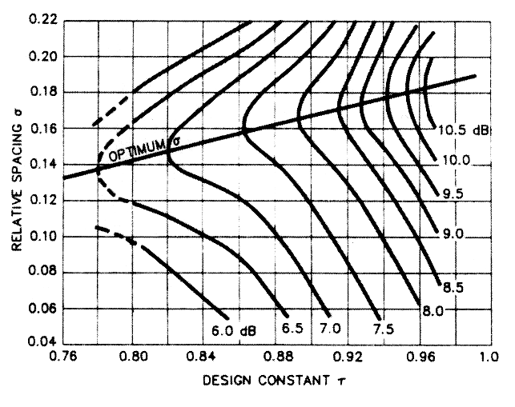
Figure 3: The parameters tau and sigma can be chosen from this graph. We chose a tau of .8 and a sigma of .12 for a predicted gain of 6.5 dBi. The line for optimum sigma is for those designers who want maximum gain. [Ref. 1, 3].

In operation, the LPDA works as follows. Referring to Figure 2, assume that we are operating at a frequency in which the third (middle) element is resonant. Elements 2 and 4 are slightly longer and shorter, respectively, than element 3. Their spacing, combined with the fact that the transmission line flips 180 degrees in phase between elements allows these two elements to be in phase and nearly (but not quite) resonant with element 3. Element 4, being slightly shorter that element 3 acts as a “director” shifting the radiation pattern slightly forward. Element 2, being slightly longer, acts as a “reflector” further shifting the pattern forward. The net result is an antenna with gain over a simple dipole. As the frequency shifts, the active region (those elements that are receiving or transmitting most of the power) shifts along the array.

Having chosen tau and sigma, we simply plug in the numbers. The result is Table 1.

Now comes the tricky part. We have to select the characteristic impedance of the transmission line that feeds the elements, a transmission line that also acts as the boom of the antenna. We will call this transmission line impedance Z_{b} (for boom) and Reference 1 tells us it should be:
$$\begin{aligned}Z_{b}=\frac{Z_{i^{2}}}{8σ^{'}Z_{d}}+Z_{i}\sqrt{\left({\left(\frac{Z_{i}}{8σ^{'}Z_{d}}\right)}^{2}+1\right)} \\ \text{Where:} \\ Z_{d}=\text{120}\left(\text{ln}\left(\frac{l_{n}}{d_{n}}\right)−2\text{.}\text{25}\right) \\ σ^{'}=\frac{σ}{\sqrt{τ}}\end{aligned}$$

This equation deserves some explanation. Z_{d} is the average characteristic impedance of a simple dipole antenna. As stated previously, Z_{b} is the characteristic impedance of the boom, itself a transmission line (referred to as the “antenna feeder” line in Figure 2). Z_{i} is the impedance of the antenna as seen from its input terminals. Those terminals are usually connected to some kind of balun which performs the balanced to unbalanced transformation and steps down the impedance Z_{i} to match the impedance of the signal source (when transmitting) or receiver input (when receiving). The impedance is of this line, referred to as the “coax feed” line in Figure 2, is usually 50 ohms and we will refer to it as Z₀.

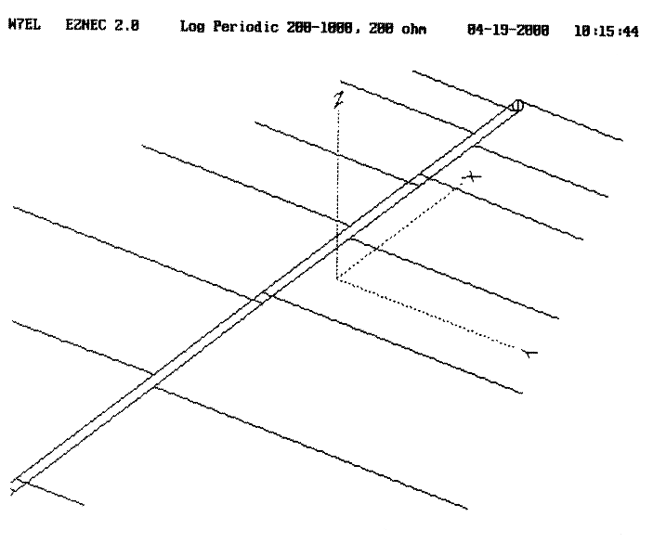
Figure 4: The antenna we have chosen to model uses two booms acting as a transmission line.

We have chosen to make the antenna elements from 1/4 inch rods. That makes the impedance Z_{d} of the longest element:

$$\begin{aligned}Z_{d}=\text{120}\left(\text{ln}\left(\frac{l_{n}}{d_{n}}\right)−2\text{.}\text{25}\right)=\text{120}\left(\text{ln}\left(\frac{\text{29}\text{.}\text{52}}{\text{.}\text{25}}\right)−2\text{.}\text{25}\right) \\ \text{302}\text{ ohms}\end{aligned}$$

Next we choose the spacing between the two booms. The booms will consist of one-quarter inch rods to which the left and right elements are alternately attached (Figure 4). Note that each element is fed 180 degrees out of phase with the elements adjacent to it. For reasons that will become apparent shortly, we will need to choose a relatively high impedance to feed the booms (Z_{i} ). We will choose 200 ohms. This impedance is four times the characteristic impedance of our coaxial line (Z₀ = 50 ohms) and is readily produced through the use of a balun with a 2:1 ratio of windings. The spacing between the two booms needs to be (after Ref. 1):

$$S=\left(\frac{\text{diam}}{2}\right)×{\text{10}}^{\left(\frac{Z_{i}}{\text{276}}\right)}=\text{.}\text{125}×{\text{10}}^{\left(\frac{\text{302}}{\text{276}}\right)}=2\text{.}5\text{ inches}$$
Where:

diam = diameter of each boom in inches.
S = center-to-center spacing between the booms in inches.

We will not be able to hold each element’s ratio of the length to diameter constant since metal stock is not available in all sizes. Instead we will choose diameters which attempt to preserve a length to diameter ratio of approximately 120 (Table 3).

The last design element we will have to design is the terminating stub shown in Figure 1. After Ref. 1, this should be λ_{max} / 8 or 7.4 inches long.

Next we will plug in these numbers into a Methods of Moments program. We will choose EZNEC, being mindful of some its limitations (Table 2). Log periodic antennas can be particularly challenging to model. Through the use of a “Guidelines Check” built into the software, allegiance to the limitations in Table 2 is automatically checked. After some compromises, we settle on the values listed in Table 3 and then press enter to start the simulation.

Figure 5(a) shows the predicted VSWR for our antenna over the frequency range of 200 to 1000 MHz. The VSWR is acceptable below 700 MHz but above that drifts upward. We can make a reasonable guess that the problem at the high end is due to the shortest elements being too long, and so we trim .5 inch off these and run the simulation again. Now the VSWR barely rises above the 1.5:1 range over the entire range of frequencies.

The radiation patterns and gain at 200, 500, 700 and 1000 MHz are shown both as elevation and azimuth patterns in Figure 6. The elevation pattern is the field produced in a plane that slices through the boom of the antenna and is perpendicular to the antenna elements. The azimuth pattern is the field strength in the plane that the antenna elements lie in. Both predict a forward gain that varies from 5 dBi to 7 dBi, reasonably close to our design target of 6.5 dBi.

Our antenna can now be built and should perform well. One drawback to the design, though, is the 200:50 balun that has to be used. Such baluns can introduce losses and may have difficulty in handling the high powers that are sometimes used for susceptibility testing. For this reason, some commercial designs aim at setting the characteristic impedance of the boom at something close to 50 ohms, 75 ohms being a typical target. (Setting the impedance of the boom elements at 50 ohms is not possible when round booms are in use.)

To get such a low impedance, we will have to use thick booms and antenna elements. For the purposes of our example, we will choose .75 inch diameter pipe. First we compute Z_{d} for .75 inch elements:

$$\begin{aligned}Z_{d}=\text{120}\left(\text{ln}\left(\frac{l_{n}}{d_{n}}\right)−2\text{.}\text{25}\right)=\text{120}\left(\text{ln}\left(\frac{\text{29}\text{.}\text{53}}{\text{.}\text{75}}\right)−2\text{.}\text{25}\right) \\ \text{169}\text{.}6\text{ ohms}\end{aligned}$$

Then we can calculate the boom center-to-center spacing:

$$S=\left(\frac{\text{diam}}{2}\right)×{\text{10}}^{\left(\frac{Z_{i}}{\text{276}}\right)}=\text{.}\text{375}×{\text{10}}^{\left(\frac{\text{169}\text{.}6}{\text{276}}\right)}=1\text{.}\text{544}\text{ inches}$$

Unfortunately, this log periodic antenna will have to be built to be tested. Its large elements and close spacings (.044 inches between booms) will cause it to exceed the parameters of Table 2. Yes, even in the 21st century there are some things best left to craftspeople.

Those craftspeople also know a few other tricks. One is to dispense with the 50:75 ohm balun and just suffer with a slightly higher VSWR. In order to allow for a balanced to unbalanced transformation, ferrite beads can be slipped over the 50 ohm coaxial cable, producing what is known as a W2DU balun (Ref. 1).

Log periodic antennas are rugged, simple and versatile. They will remain one of the best tools available to the EMC engineer for years to come.

Table 1

The antenna is fed through a 200:50 ohm balun.
Tau = .8 Sigma = .12. Gain = 6.5 dBi.

Alpha = 22.6 degrees. Cot α = 2.4
l₁ = 492/(200 MHz) = 2.46 feet = 29.52 inches.
l_{min} = 492/(1000 MHz) = .492 feet = 5.9 inches.

Element | Formula | Length (inches)
l₁ | (492/200) ft. | 29.52
l₂ | l₁τ | 23.64
l₃ | l₂τ | 18.84
l₄ | l₃τ | 15.11
l₅ | l₄τ | 12.09
l₆ | l₅τ | 9.67
l₇ | l₆τ | 7.74
l₈ | l₇τ | 6.19
l₉ | l₈τ | 4.95

Spacing Between Elements | Formula | Distance (inches)
d_{1,2} | .5(l₁ - l₂) cot α | 7.08
d_{2,3} | d_{1,2} τ | 5.64
d_{3,4} | d_{2,3} τ | 4.56
d_{4,5} | d_{3,4} τ | 3.60
d_{5,6} | d_{4,5} τ | 2.88
d_{6,7} | d_{5,6} τ | 2.28
d_{7,8} | d_{6,7} τ | 1.86
d_{8,9} | d_{7,8} τ | 1.49

Table 2

EZNEC warns us to observe the following limitations, least it produce untrustworthy answers:
Diameters of all wires should be < .02 λ.
Use at least 20 segments per each half wavelength.
Wire spacing should be > .0015 λ.
Transmission line spacings should be greater than several wire diameters.
Voltage sources feeding transmission lines should be on a wire 3 segments long and > .02 λ.
At their connection point, the ratio of any two wire diameters should be < 2:1.

Table 3: The parameters fed into EZNEC to simulate our antenna. The numbers are in inches.

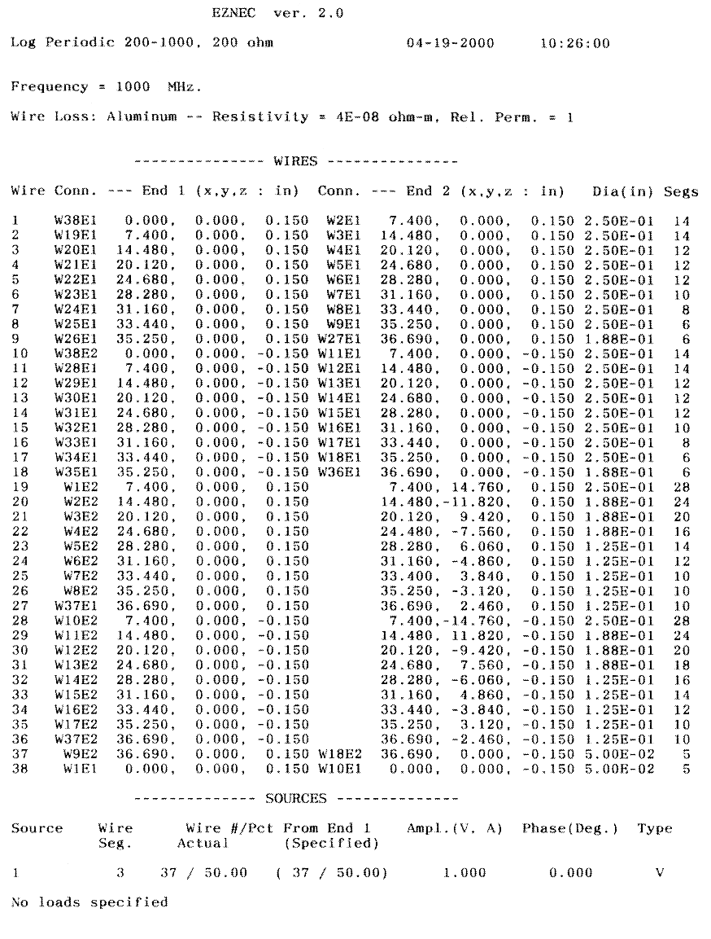
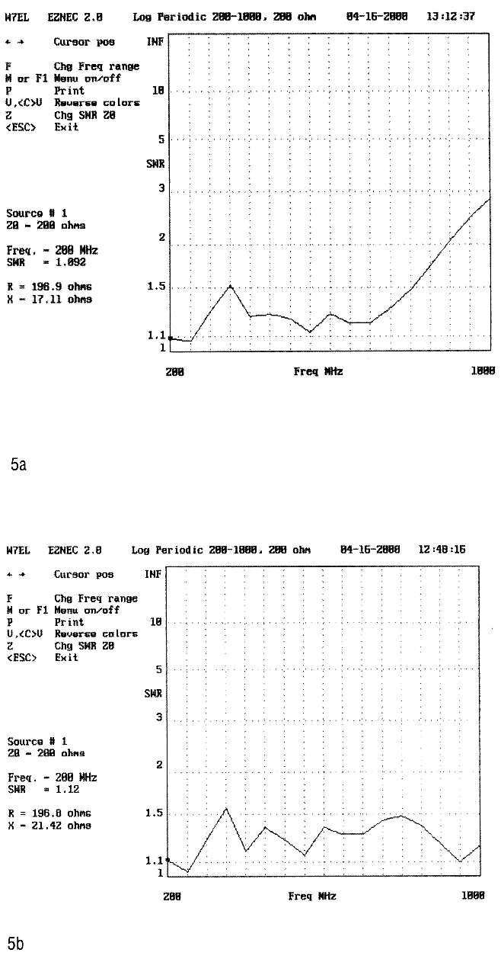
Figure 5: Figure 5a shows the predicted VSWR for the antenna described in Tables 1 and 3. Shortening the shortest elements of the array by .5 inch each yields the VSWR plot of Figure 5b.

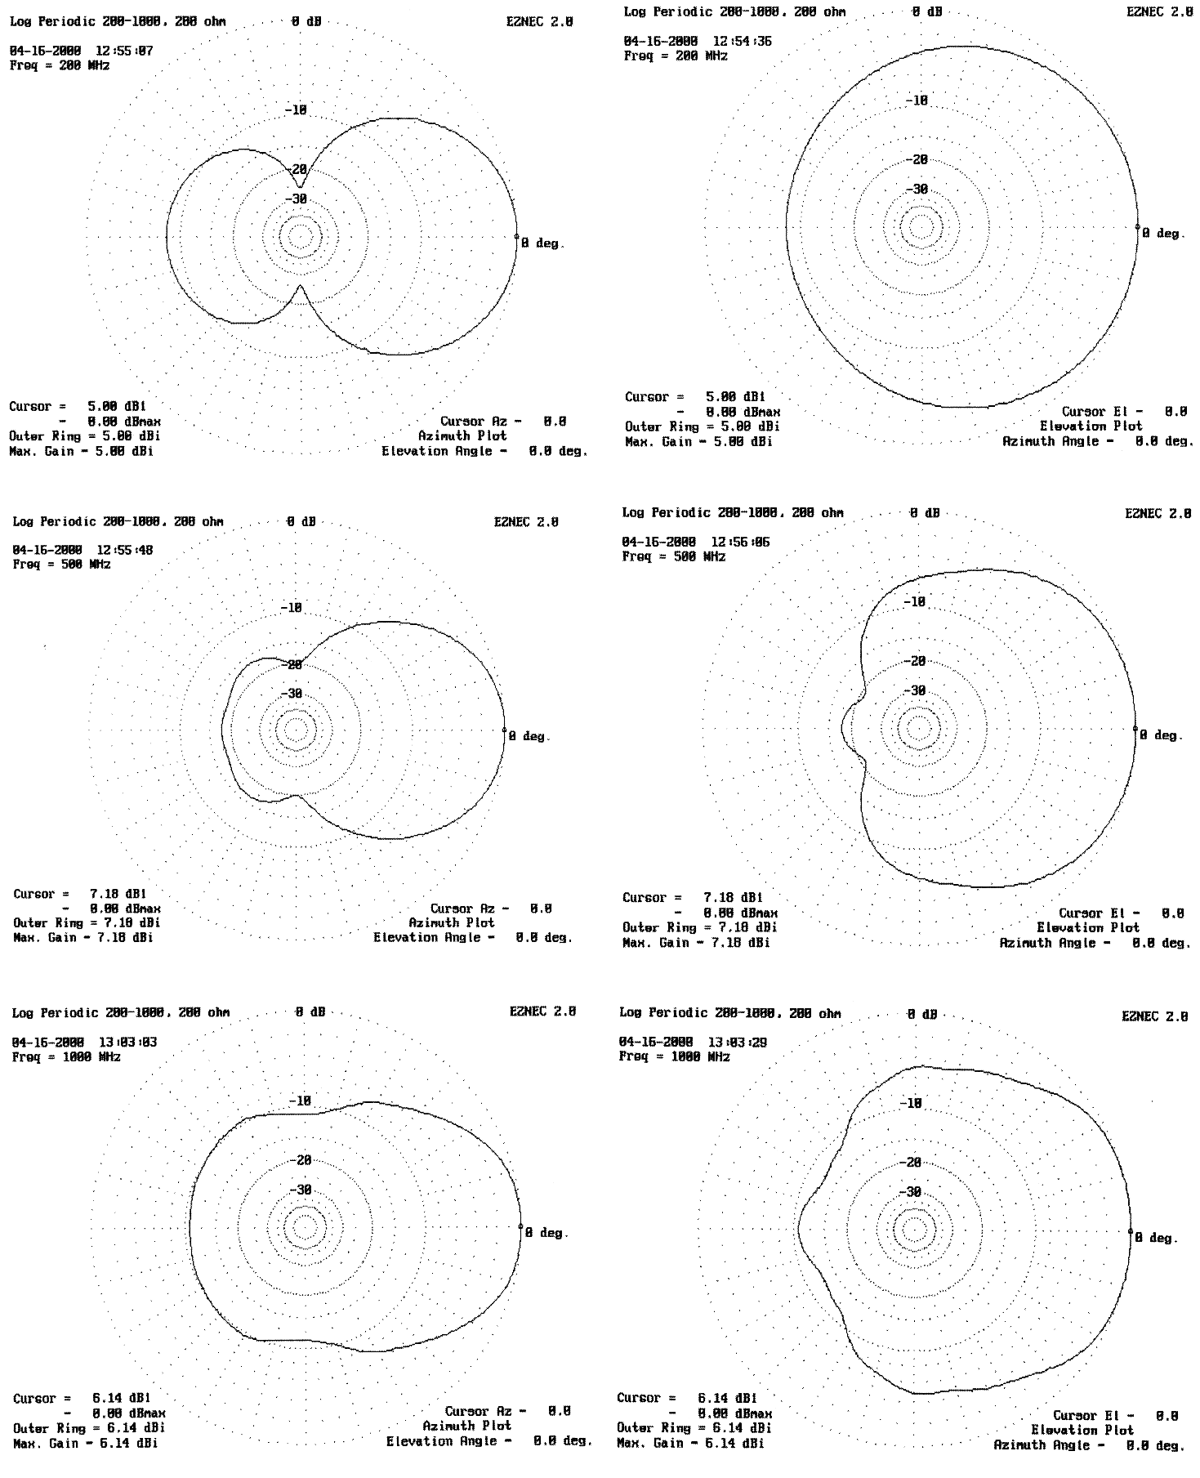
Figure 6: Azimuth and elevation plots for our modified antenna.
References

1. The ARRL Antenna Book, The American Radio Relay League, Newington, CT, 1991.

2. R. H. DuHamel and D. E. Isbell, “Broadband Logarithmically Periodic Antenna Structures,” 1957 IRE National Convention Record, Part 1.

3. R. L. Carrell, “The Design of Log-Periodic Dipole Antennas,” 1961 IRE International Convention Record, Part 1.

