Computational Magic and the EMC Engineer

By Glen Dash, Ampyx LLC, GlenDash at alum.mit.edu
Copyright 1999, 2005 Ampyx LLC

Using a computer to simulate EMC phenomena is a field full of promise.

In decades past, the EMC engineer had three basic methods for evaluating EM phenomenon: Maxwell’s Equations, circuit models and fieldwork. Maxwell’s Equations, solved for the boundary conditions and forcing functions at hand, serve as a practical tool only in relatively simple situations. Circuit models use simplifying assumptions to reduce radiated emissions problems to set of circuits. For example, to a first approximation an antenna can be modeled as a network of RLC circuits. Again, only relatively simple problems can be considered. Fieldwork provides real data, but is both expensive and time consuming. It is also subject to its own peculiar types of errors ranging from parasitics to broken cables.

The development of electromagnetic computational methods now provides us with another tool. In its current state of development, however, computational tools will not completely replace any of the methods above. Computer modeling of EM phenomenon in three dimensions requires a host of assumptions that make computational modeling a tricky business. To do it well, the engineer should not only have a working knowledge of Maxwell’s Equations, but should be familiar with the equally complex field of numerical analysis as well.

There are three different modeling techniques typically used for EMC modeling, the Finite Difference Time Domain (FDTD) method, the Methods of Moments (MOM) and the Finite Element Method (FEM). Of these, the first two find the broadest application in EMC, although all three methods have their following.

The method we will be studying in this article is the Method of Moments, the method employed by the Numerical Electromagnetic Code (NEC) developed by Lawrence Livermore Laboratory. To use the Method of Moments, the user typically converts a conductive structure into a series of wires, creating a “wire frame model.” These wires are then broken down into “segments,” each segment being short compared to the wavelength of interest. Each of these segments will carry some current, and the current on each segment will affect the current on every other. To compute the currents on each segment, a set of linear equations is created and solved by the computer. Once the current on each segment has been calculated, both near and far fields can be calculated by superposition.

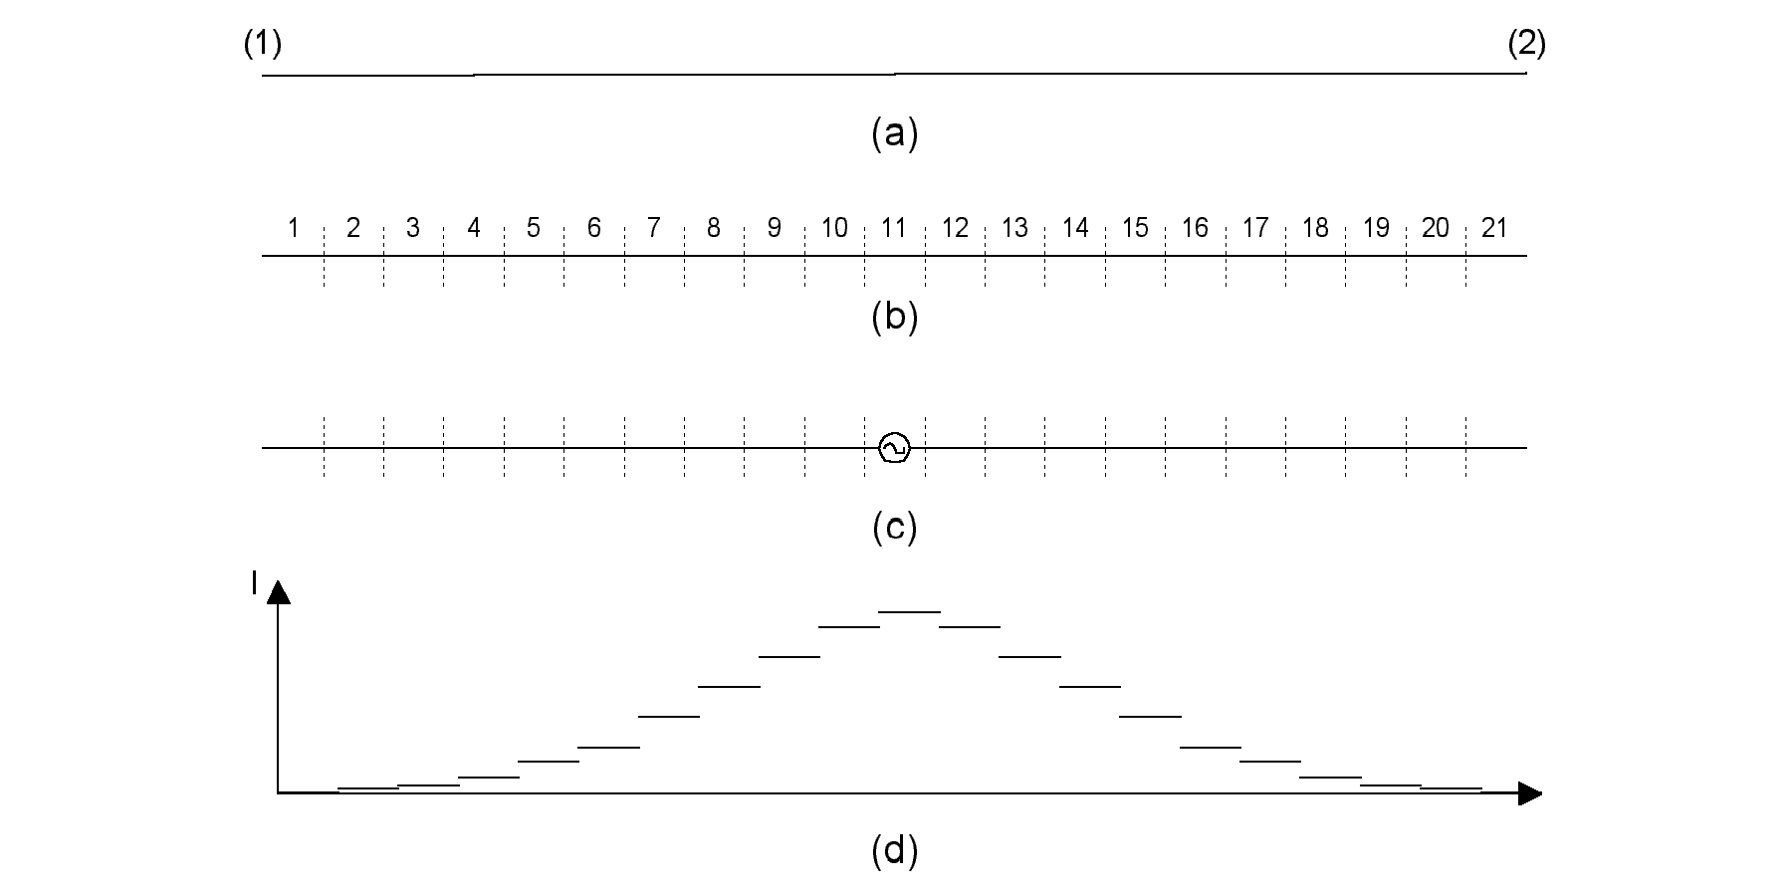
Figure 1: In order to model a dipole using the Method of Moments, a wire is first drawn from point 1 to 2 as in (a) above. In the case of a half wave resonant dipole, this wire is one half wavelength long. The wire is then divided into segments, each less than .1λ, as shown in (b). A voltage source can be placed in the middle of any segment, and here Segment 11 is chosen (c). The computer calculates the current on each segment, which for a resonant half wave dipole is shown in (d).

The Method of Moments has the advantage of being relatively simple to implement, at least compared to FDTD and FEM. Further, NEC computational engines are available in the public domain. It is excellent for modeling long thin wires such as the elements that make up most antennas. Because of that, it is the method of choice among radio amateurs. It is less well suited for modeling currents in two or three dimensions and not well suited at all for modeling the propagation of electromagnetic fields through different dielectrics. It is also a single frequency method. If you wish to calculate fields produced by a square wave source, for example, you will have to individually run simulations at the component frequencies of the square wave.

The FDTD method is one which is very well suited to the modeling of the propagation of electromagnetic fields through three dimensional volumes containing materials of differing permeability (μ), permittivity (ε), and conductivity (σ). In order to describe a volume, the volume itself and the entire space surrounding the device has to be “gridded,” that is broken into square or rectangular units for two dimensional modeling, or cubic structures for three dimensions. The longest sides of each of these “grid locations” must be short compared to the shortest wavelength of interest. Each grid location is then identified with its own permittivity, permeability, and conductivity. Initial conditions are set by either applying specific voltages or currents to given points, creating a localized set of electric and magnetic fields, or by specifying a localized set of fields directly. The finite time differential equations are then calculated in sequence and the fields propagated throughout the entire volume.

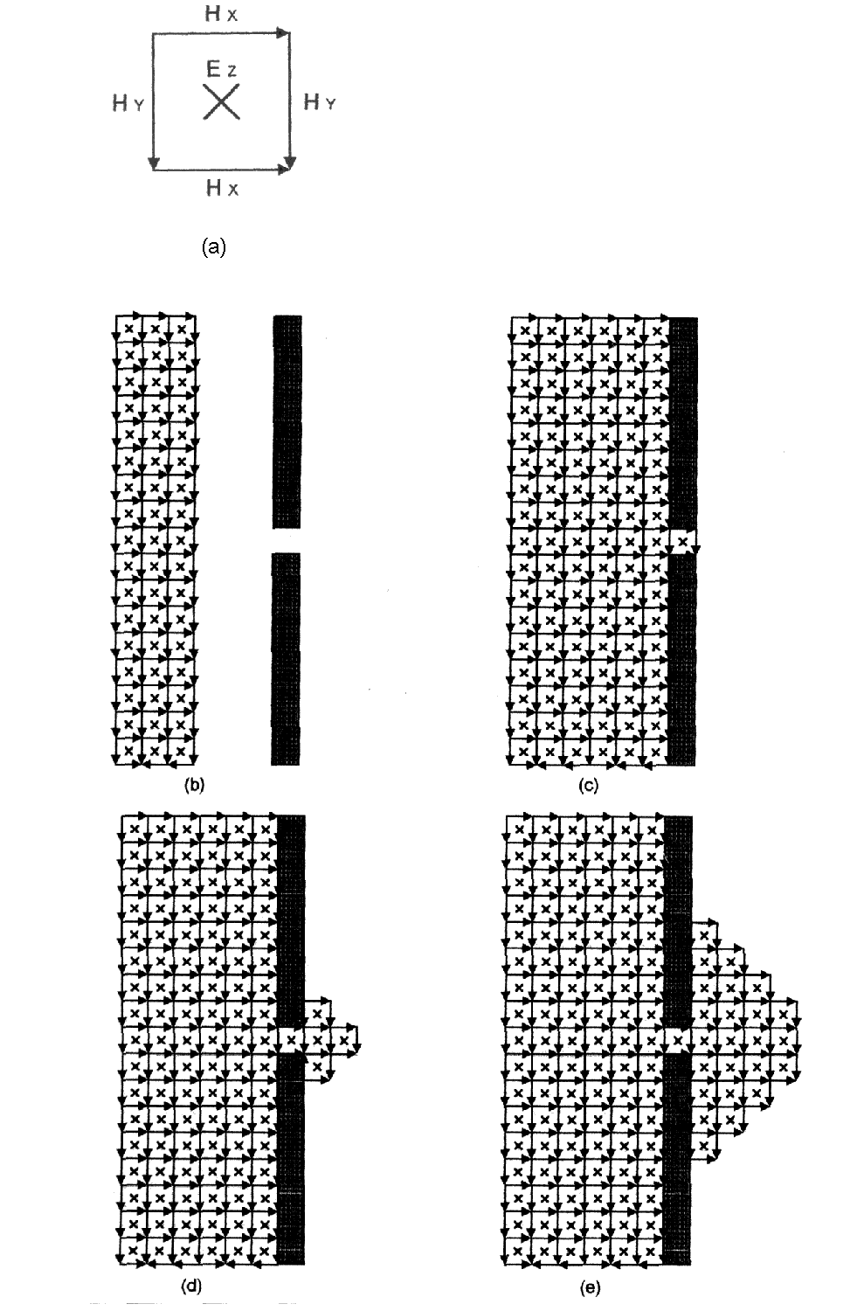
Figure 2 The FDTD method uses as its fundamental element a pixel or voxel consisting of orthogonal fields as shown in (a). The output is a simulation of propagating fields as they move through space. In (b) a plane wave approaches a perfectly conductive wall with an electrically small aperture in it. As the wave propagates through the aperture, part of it emerges with a circular wave front.

The FDTD method is a time domain technique and that has advantages and disadvantages. If what is desired is the field strength, voltage or current at a particular point in the volume at a particular frequency, then the solution produced at a particular grid location will have to be run through a Fourier transform. On the other hand, if what is desired is a time domain solution at a particular grid point, the FDTD technique may be a good choice.

The FDTD technique also differs from the Methods of Moments in that the entire space of interest needs to be gridded. If fields far away from the source of the radiation need to be calculated, a very large computational space will be needed. In order to produce a manageable simulation, “Absorbing Boundary Conditions” (ABC’s) are employed to limit the size of the computational field. Ideally, these ABC’s should be perfectly absorbing so that no radiation reflects back. In practice, creating ideal Absorbing Boundary Conditions can be difficult.

Many times the two techniques, FDTD and MOM, can be combined to take advantage of what each does best. For example, a small compact volume such as a computer with a shielded enclosure can be modeled using the FDTD technique. The FDTD method can be used to solve for currents on the shield’s surface. Once known, a wire frame model of the shield can then be created. Any attached I/O cables can be simulated by attaching wires to the shield. Fields at any particular point, near or far, can then be efficiently calculated using the Method of Moments.

The Finite Element Model finds lesser application in the EMC arena. Like FDTD, it is a volume based technique, but like the MOM it solves for fields at a particular frequency. The space is segmented into triangular or tetrahedral shapes, creating the finite mesh. Numerical techniques are used to solve Maxwell’s Equations in the frequency domain within each of the segments. As with the FDTD method, FEM techniques require the entire computational volume to be modeled and the method requires the use of Absorbent Boundary Conditions.

In this article, we are going to try our hand at the Method of Moments. To do that, we will utilize a program popular with amateur radio operators known as EZNEC available from Reference 2. While this program will not serve as a panacea for EMC related problems, it has two advantages: First, it is well written and documented, and its author, Roy Lewallen, has worked diligently on improving the program for years. Second, it is inexpensive. Because it is designed for amateur radio use and not for EMC, it has some shortcomings that we will return to, but as a tool to introduce engineers to computational techniques it is quite excellent.

To understand how EZNEC works, we start with a single wire segment. Each segment produces an electromagnetic field at every other point in space.

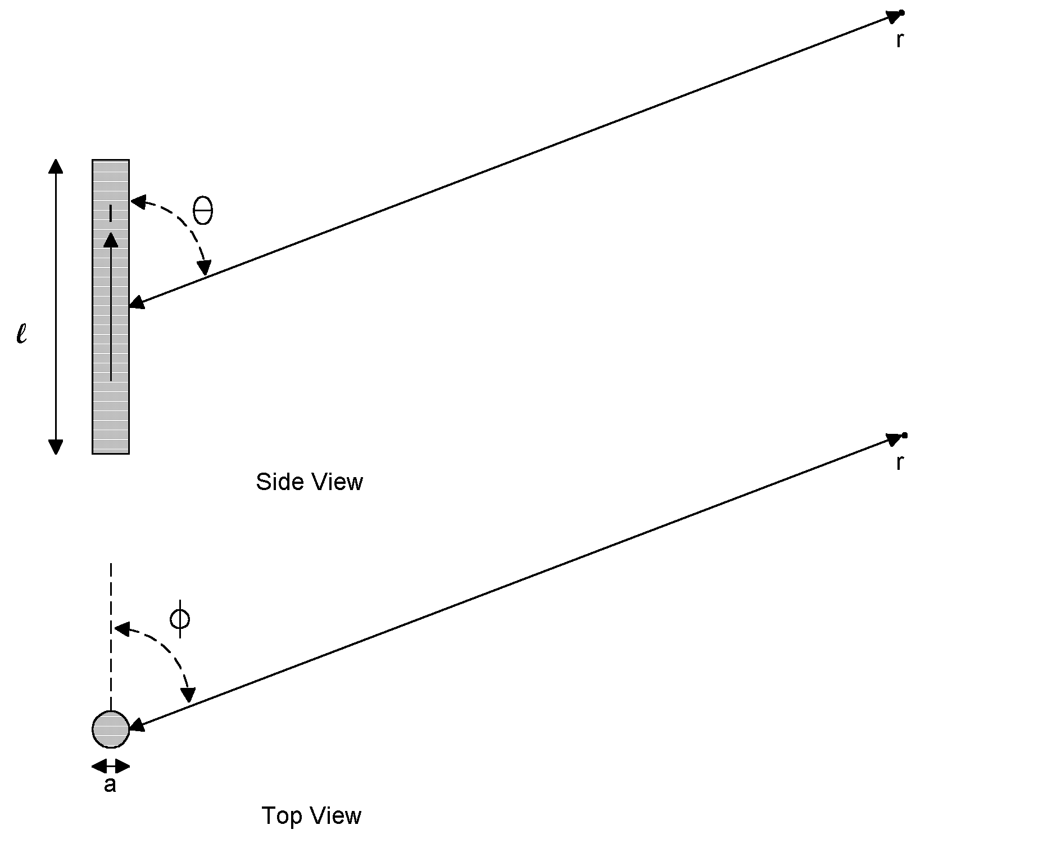
Figure 3: We will use these coordinates to solve for the field from each wire segment.

If we assume that the segment is (a) less than .1λ in length at the highest frequency of interest and (b) has a ratio of diameter to length of less than .1, then Maxwell’s Equations can be readily solved, allowing us to relate the current on the segment to the electric field some distance away. The fields will be:

$$\begin{aligned}H_{φ}=\frac{1}{4π}I^{}ℓ\text{sin}θ\left(\frac{jω}{\text{cr}}+\frac{1}{r^{2}}\right) \\ E_{r}=\frac{1}{2πε_{0}}I^{}ℓ\text{cos}θ\left(\frac{1}{{\text{cr}}^{2}}+\frac{1}{jωr^{3}}\right) \\ E_{θ}=\frac{1}{4πε_{0}}I^{}ℓ\text{sin}θ\left(\frac{jω}{c^{2}r}+\frac{1}{{\text{cr}}^{2}}+\frac{1}{jωr^{3}}\right)\end{aligned}$$

Where:

θ, r = Coordinates: θ in radians, r in meters
I* = “Retarded” current in amperes = I₀e^{jωt-βr}
I₀ = Current on the segment at time t=0
l = Length of segment in meters
ω = Frequency in radians per second = 2πf
t = Time in seconds
β = Phase Constant = 2π/λ
ε₀ = Permittivity in air (dielectric constant)
c = Speed of light in meters/second

Therefore, if we know the currents on all of our segments, we can calculate the field anywhere we want by superposition. Unfortunately, the fields produced by each segment affect the currents on all the others, so we have a problem that has to be solved using linear equation techniques. The linear equations can be described in the form below where we have N segments:

$$\begin{aligned}Z_{\text{11}}I_{1}+Z_{\text{12}}I_{2}\text{+ }\text{.}\text{.}\text{.}Z_{\text{1N}}I_{N}{\text{=E}}_{1}{Δz}_{1}=V_{1} \\ Z_{\text{21}}I_{1}+Z_{\text{22}}I_{2}\text{+ }\text{.}\text{.}\text{.}Z_{\text{2N}}I_{N}{\text{=E}}_{2}{Δz}_{2}=V_{2} \\ \\ \\ \\ Z_{\text{N1}}I_{1}+Z_{\text{N2}}I_{2}\text{+ }\text{.}\text{.}\text{.}Z_{\text{NN}}I_{N}{\text{=E}}_{N}{Δz}_{N}=V_{N}\end{aligned}$$

Here, I_{n} is the current on segment n and E_{n} is the electric field induced on each segment. Since field times distance equals voltage, the voltage on each segment, V_{n} is the field times the length of the segment, Δz_{n} . The parallel to Ohm’s Law is intentional and, in fact, the parameter Z_{nm} is the “mutual impedance” linking segments.

As EZNEC begins computation, it will calculate these impedances first. Once the impedances are solved for, currents can be computed at each segment. Once that is known, both near and far fields can be computed.

We will start our own experiments by modeling a simple dipole antenna. Our antenna is shown in Figure 1. It is resonant at 125 MHz and driven by a one-volt source. In order to model this, we set our input parameters as follows:

- We will use one wire, which we divide into 21 segments.
- In the center segment, segment 11, we place a one-volt source. EZNEC allows us to place any given voltage or current source at any location on any segment. Functionally, it is in series with the segment. Essentially, the program allows us to break any segment at any point and insert a source at that point.
- Although EZNEC allows us to model antennas over ground planes, to keep things simple we will place our antenna in free space.

Once the model is set up, hitting “return” sets the program in motion, and in a few moments it has calculated the impedances, currents and fields.

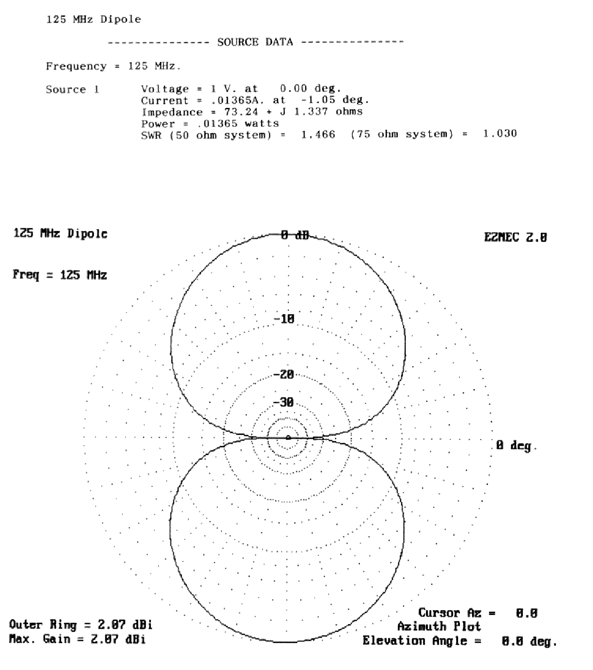
Figure 4: EZNEC’s output for the simulated dipole in Figure 1 matches well what theory predicts.

Being designed for amateur radio, EZNEC presents its output in terms of “field strength in decibels over isotropic” (dBi) and in terms of power drawn from the source. In this case the gain was 2.1 dB over isotropic and power, .0137 watts. The following can be used to convert these results into field strength at 3 meters:

$$E(\text{V/m})\text{=1}\text{.}\text{83}\sqrt{P_{t}}{\text{10}}^{\left(\frac{G(\text{dBi})}{\text{20}}\right)}$$
Where:

E(V/m) = Field strength at 3 meters in volts per meter.
P_{t} = Power supplied by the source to the antenna in watts
G(dBi)= Gain over an isotropic antenna

The resulting calculated field strength of our simple dipole is .272 volts per meter. This is very close to what theory predicts.

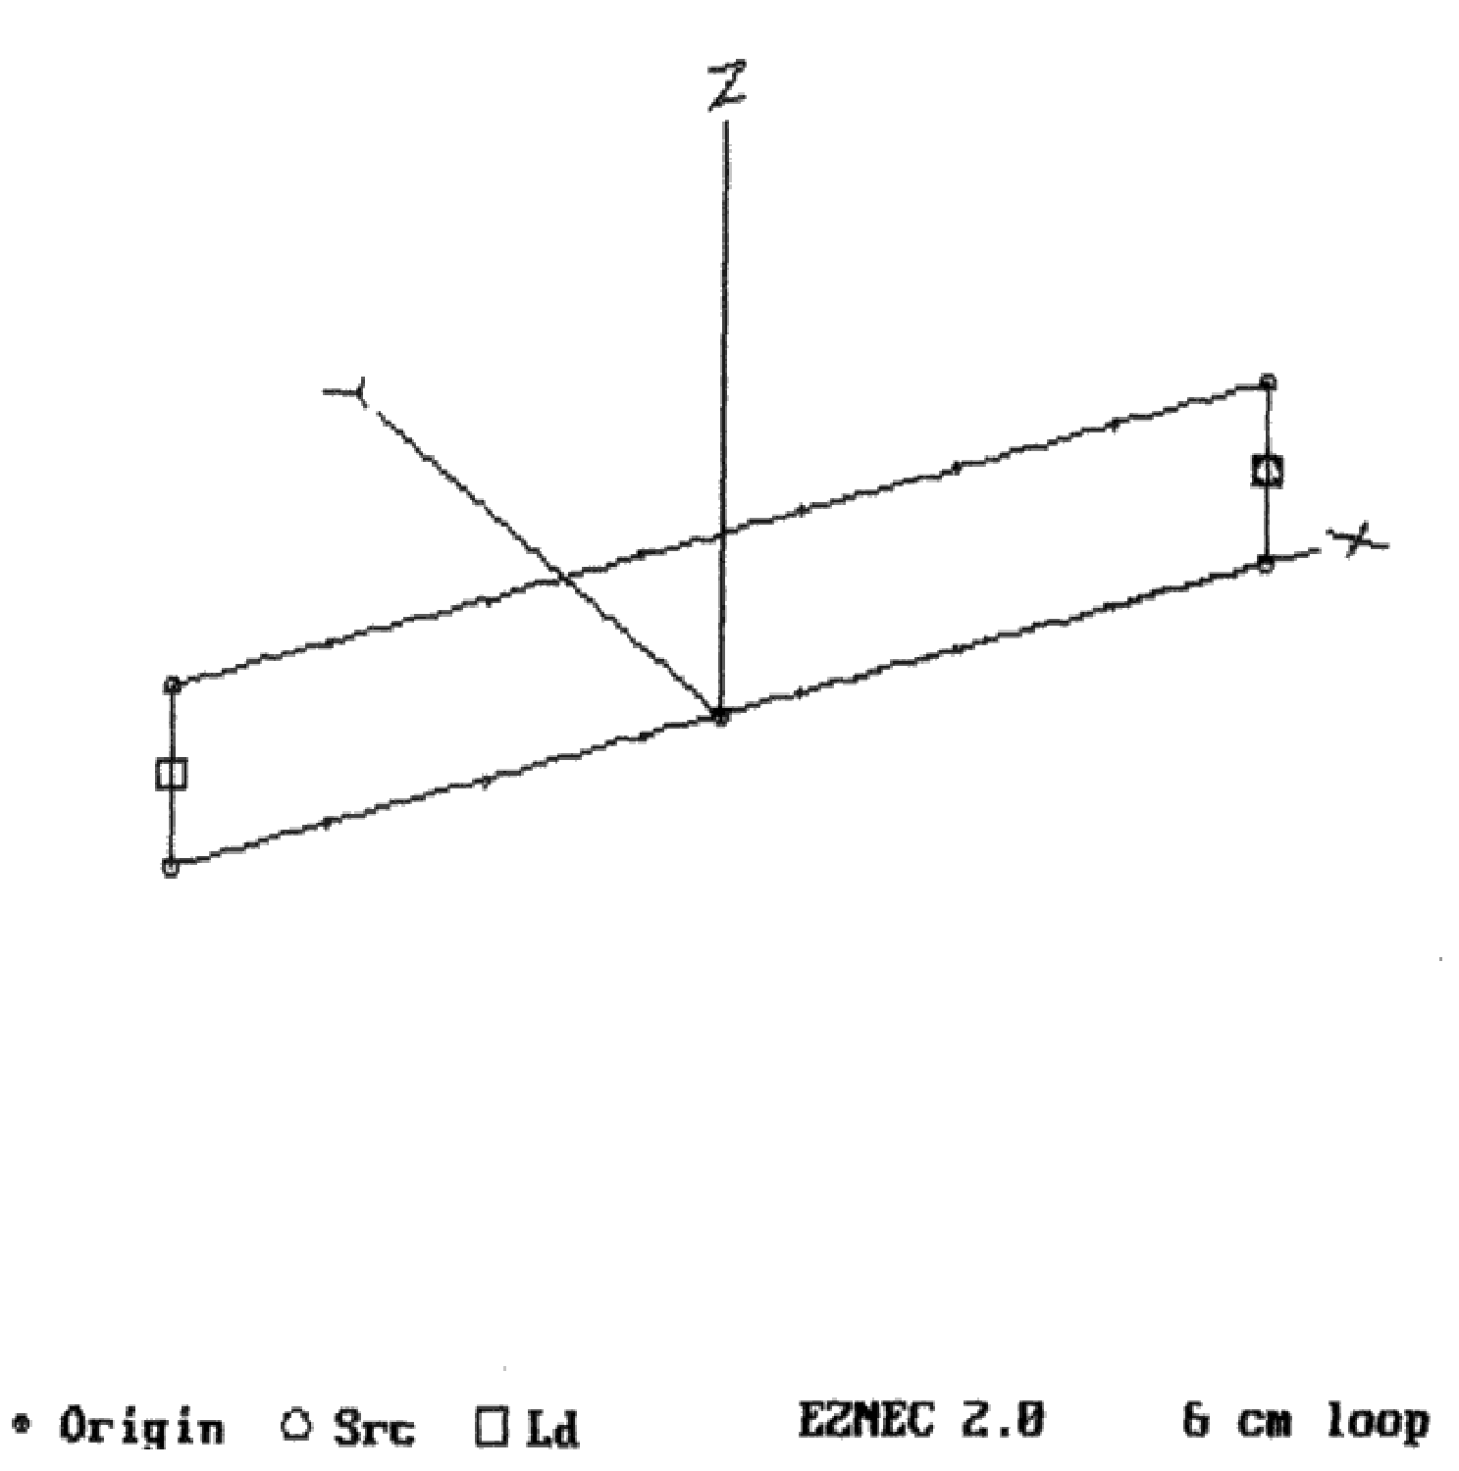
Figure 5: A small loop, modeled as shown, does not produce much radiation.

We will find it useful to remember that one volt into a half wave resonant dipole produces a field strength at 3 meters of .272 V/m in free space. This is true at any frequency. More generally:

$$\text{E=}\text{.}\text{272}{\text{ V}}_{\text{Ant}}$$

Where:

E = Field strength in free space at 3 meters
V _{Ant} = Voltage directly across a half wave resonant dipole

Next we model the radiation from a small loop. The loop is shown in Figure 5. A one-volt source with a 50 ohm output impedance drives a 50 ohm load. Two conductors, each .5 mm in diameter are separated by .5 cm. For modeling purposes we choose to divide each wire into seven segments. EZNEC predicts field strength of 352 μV per meter at 3 meters. The Method of Moment also readily calculates impedances seen by the source and the load. The one-volt source in this case “sees” an impedance of 101.8 + j83.64 ohms, which is pretty close to what we would expect. The real part of the impedance is a function mostly of the 50-ohm source impedance and 50-ohm load impedance. The inductive component, j83.64, is due to the loop.

We now combine our dipole antenna of Figure 1 with our loop of Figure 5 creating what is shown in Figure 6. EZNEC predicts a field strength of 71,000 μV/meter at 3 meters.

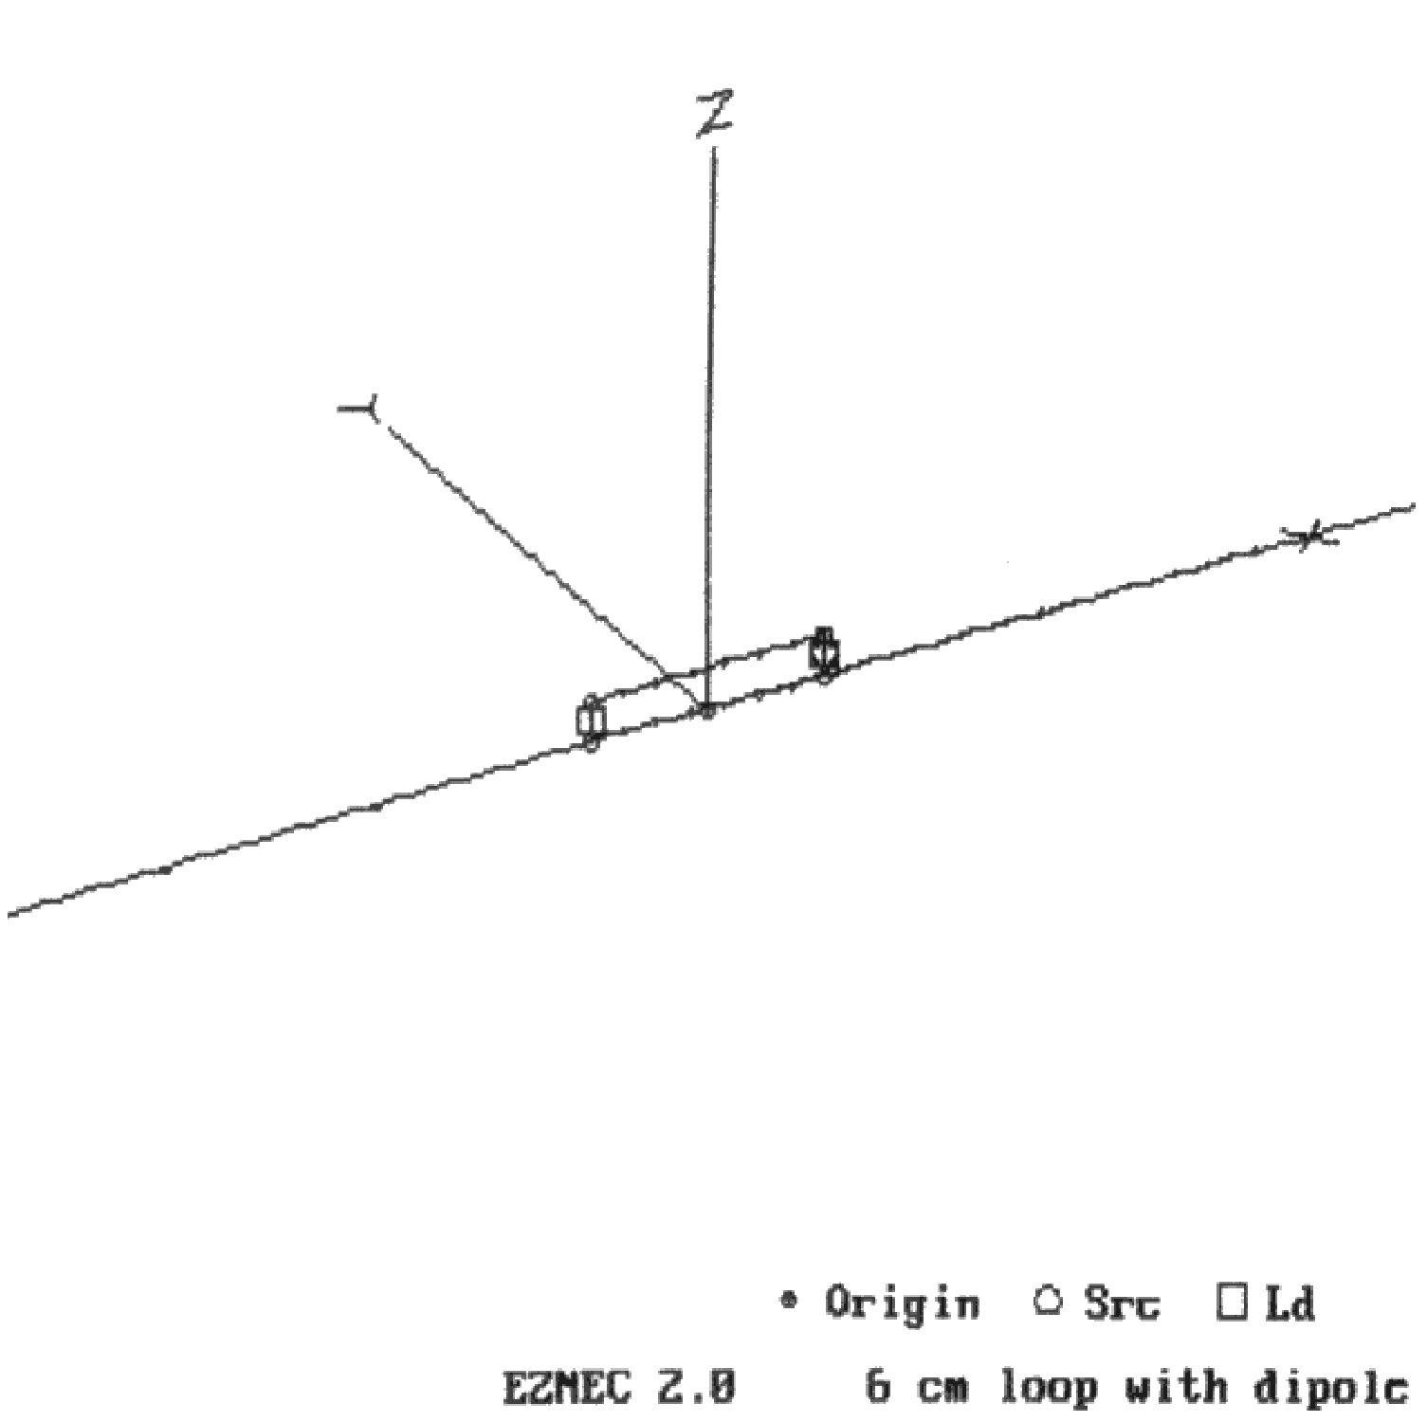

Figure 6: Adding long wires to the loop of Figure 5 increases radiation markedly.

That is a lot higher than the field strength of the loop in Figure 5. A small loop, by itself, does not radiate very much. Add wires to it and the radiation can go up spectacularly. That is consistent with what has been observed when testing computers. A small computing device may not radiate much until its I/O cables are attached.

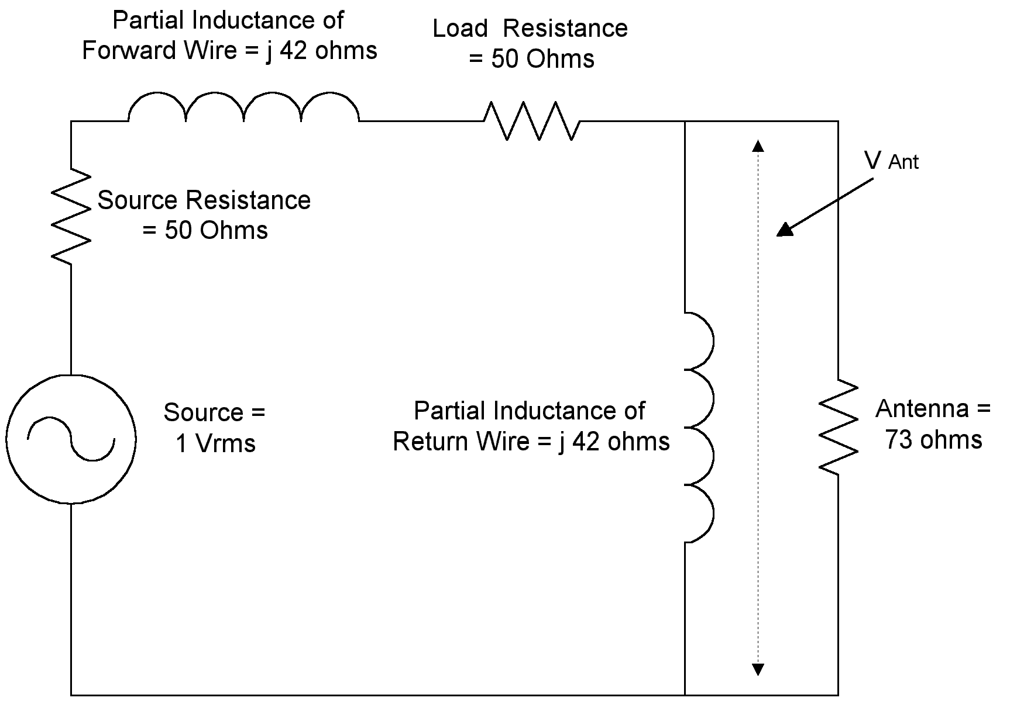

Figure 7: The loop-and-dipole combination of Figure 6 can be modeled using this circuit representation.

One quickly learns, however, not to trust all such computations implicitly, at least not without running some check on the results. To do that, we will use the circuit model shown in Figure 7. We have a one-volt source with a 50-ohm source impedance driving a 50 ohm load. An inductor of impedance j42 is in series with the 50-ohm load. This represents the inductance of the forward, or driven wire, which should be equal to about half of the total calculated inductance of the loop. The voltage across the antenna elements is the voltage dropped across a second inductor (Z=j42) which simulates the return trace. A 73-ohm resistance simulates the antenna itself, a half wave dipole at resonance. We calculate the predicted radiated energy at 3 meters in free space as follows:
$$\begin{aligned}V_{\text{Ant}}=\frac{\frac{j\text{42}⋅\text{73}}{j\text{42}+\text{73}}}{\text{100}\text{+j}\text{42}+\frac{j\text{42}⋅\text{73}}{j\text{42}+\text{73}}}\text{=j}\frac{\text{3066}}{j\text{10332}+\text{5536}} \\ \\ |V_{\text{Ant}}|=\text{.}\text{262}\text{Volts} \\ \text{E=}\left(\text{.}\text{272}\right)\left(\text{.}\text{262}\right)≃\text{71},\text{000}\frac{μV}{m}\end{aligned}$$

Our circuit model predicts radiation approximately equal to that predicted by EZNEC.

We will now try to tackle a very common problem in EMI prediction. A wire is placed over a return plane, which we simulate with a wire mesh as shown in Figure 8. The return plane itself is 10 cm x 10 cm. The driven wire, placed centrally over the return plane, is 6 cm long and consists of .5 mm diameter copper wire that is suspended .5 cm above the return plane. The source is modeled as a 1-volt source with a 50-ohm source impedance. The load impedance is also 50 ohms. In order to simulate I/O cables, 2 wires are attached creating a resonant dipole at 125 MHz. In this test, we will not only use squares to simulate the return plane but will provide some diagonal connections as well, knowing that some currents would prefer to go in these directions.

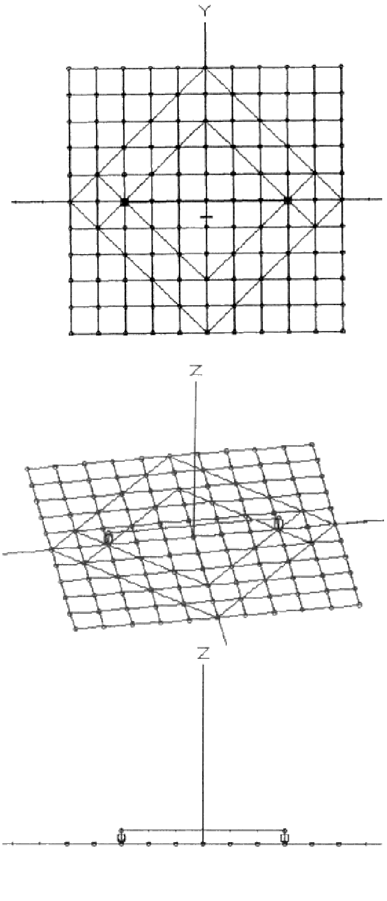
Figure 8: To simulate the radiation from a driven wire over a return plane this wire frame model was created and run in EZNEC. Shown are overhead, oblique and side views of the wire frame model.

Assuming that the wire frame model of our return plane acts as a true return plane, EZNEC should come up with a value for the field strength close to what theory would predict. Approximately 10 mA of current will pass through the circuit. This current will create a voltage drop across the return plane owing to the return plane’s inductance. While this inductance is small, it is not insignificant. Its value has been estimated to be (Ref 5):

$$\text{L=k}\frac{d}{w}\text{nH/cm}$$

Where:

k = A constant estimated to be between 2 and 5
d = Height of the driven trace above the return plane in cm
w = Width of the return plane in cm

Using this formula, we predict a voltage drop of between .0042 and .105 volts across the return plane. This voltage will drive the wires attached to the return plane like they were antennas. Using the formulas above, we predict a field strength of between and 1140 and 2850 uV/m at 3 meters.

We will assign one segment to each wire in the return plane, and divide the wire suspended over the return plane into six segments. The wires simulating I/O cables are divided into 58 segments each. EZNEC predicts emissions of 4570 uV/m. That is higher than theory would predict and leaves us with a problem common to the use of computational techniques. Is the theory wrong or is our computational model inadequate?

In such situations, it is often easiest just to increase the number of wires and segments as a test. We did so, producing the wire frame model of the return plane shown in Figure 9. There are many more diagonal elements, and we have chosen to increase the number of segments close to the centerline of the return plane (notice the hash marks in Figure 9). EZNEC now predicts radiated emissions of 2410 uV/m, a value which falls right within the range theory would predict.

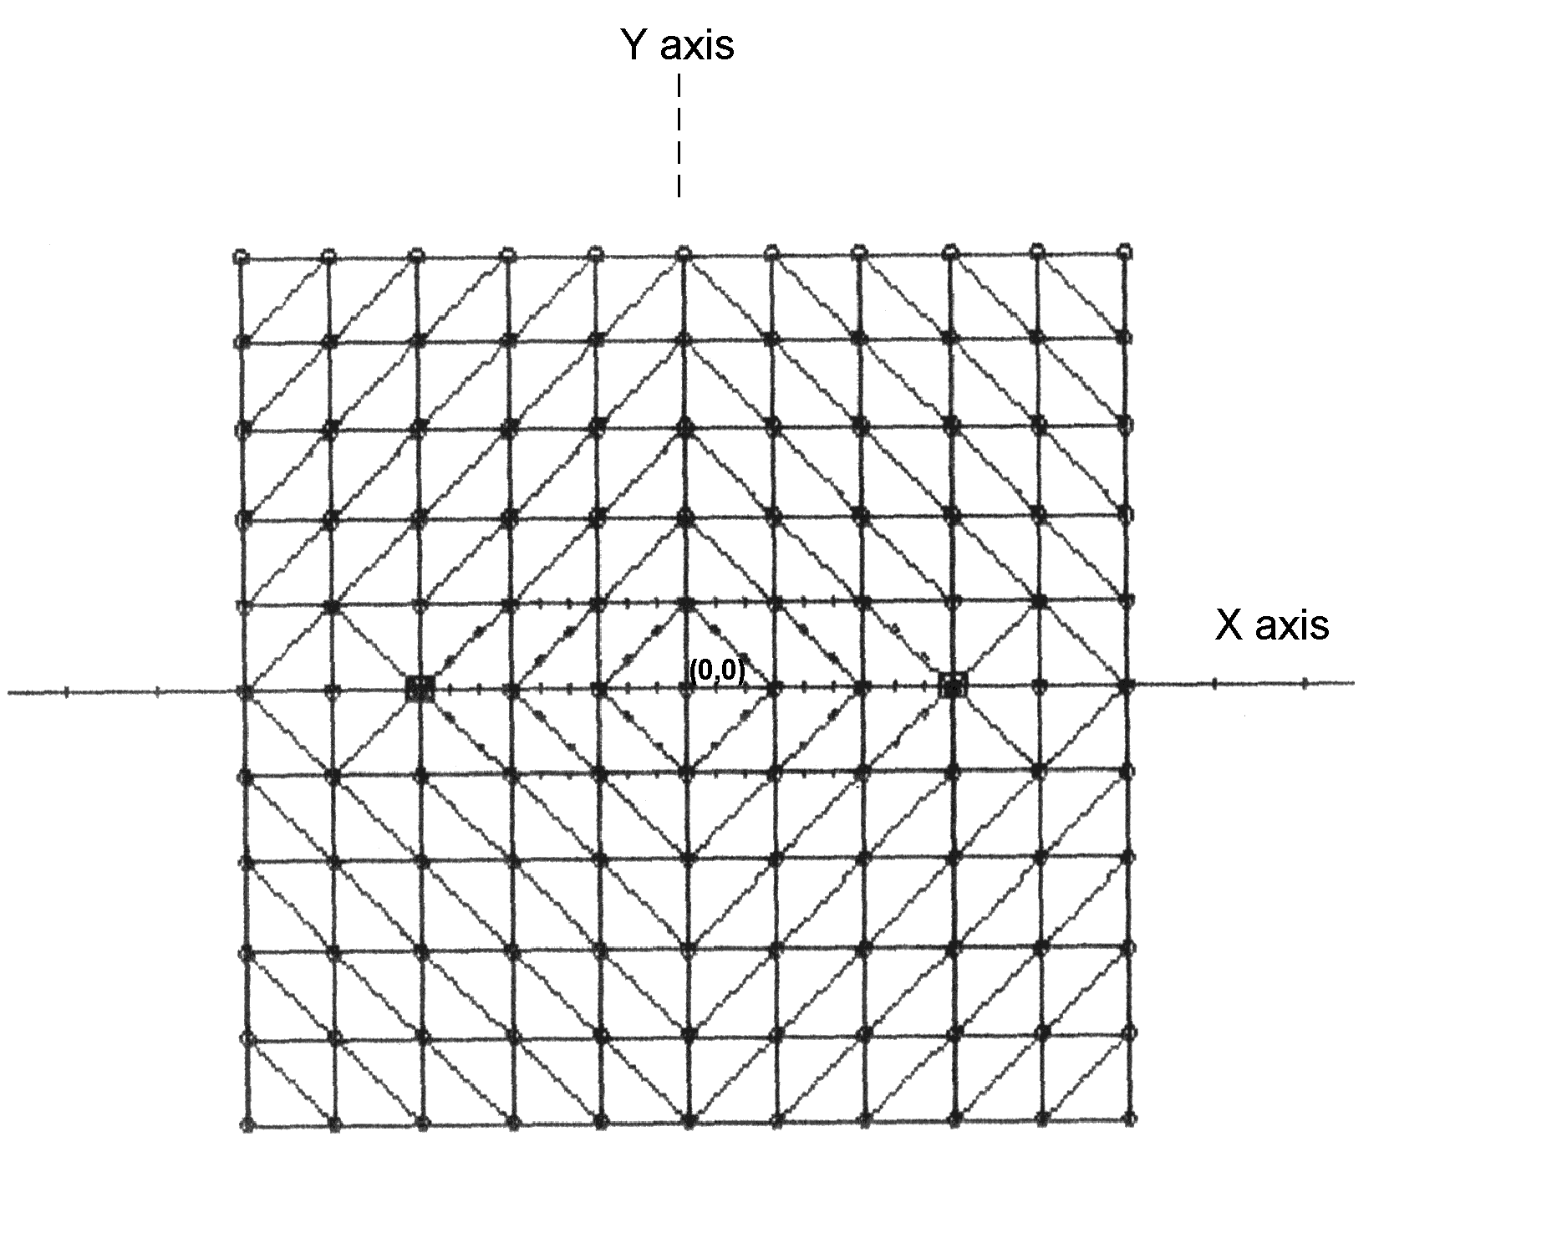
Figure 9: The wire frame model shown here better models a real world return plane.

EZNEC also allows us to take a look at the currents along the centerline (Y axis) of the return plane. These should move only in the X direction and are plotted in Figure 10. While the magnitudes seem to be what we would expect (most of the current is concentrated near the centerline due to the effect of mutual inductance), the phase swings wildly near the center. That is not what our intuition would predict. Again we are faced with the problem of determining what is wrong, our intuition or the wire frame model. We suspect that it is the wire frame model. Rather than running diagonal wires, it may have been better to simulate a return plane by using small squares near the X-axis and larger squares further away. (EZNEC’s limitation of 500 segments prevents us from using small squares throughout). We’ll save that prediction for future research.

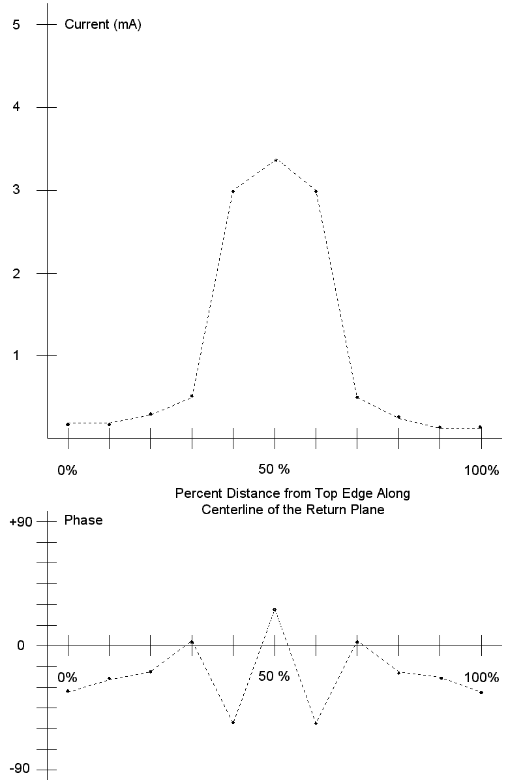
Figure 10: The current distribution along the Y-axis of the return plane of Figure 9 is shown for X=0 (midline of the plane). By symmetry, the current along this line should move in the X direction only.

EZNEC also allows us to change the dimensions of our test circuit readily, much more readily in fact than we could in the laboratory. We change the height of the trace over the return plane from .5 cm to 1 cm and then to 2 cm. The results are plotted in Figure 11. The field strength increases as the wire is raised as theory would predict. The three predicted field strengths run along a straight line, indicating that the field strength increases linearly with an increasing ratio of height to width. That is also what theory would predict. Note, however, that the predicted emissions do not go to zero as the height of the trace goes to zero. Rather, a residual impedance, which we calculate to be approximately .08 ohms, seems to remain where none should. While part of that impedance may be due to skin resistance of the wire (calculated to be about .02 ohms) the remaining .06 ohms is, we think, due to a residual error in the model. After all, a wire frame model is just that, a model, and can never perfectly simulate a solid return plane.

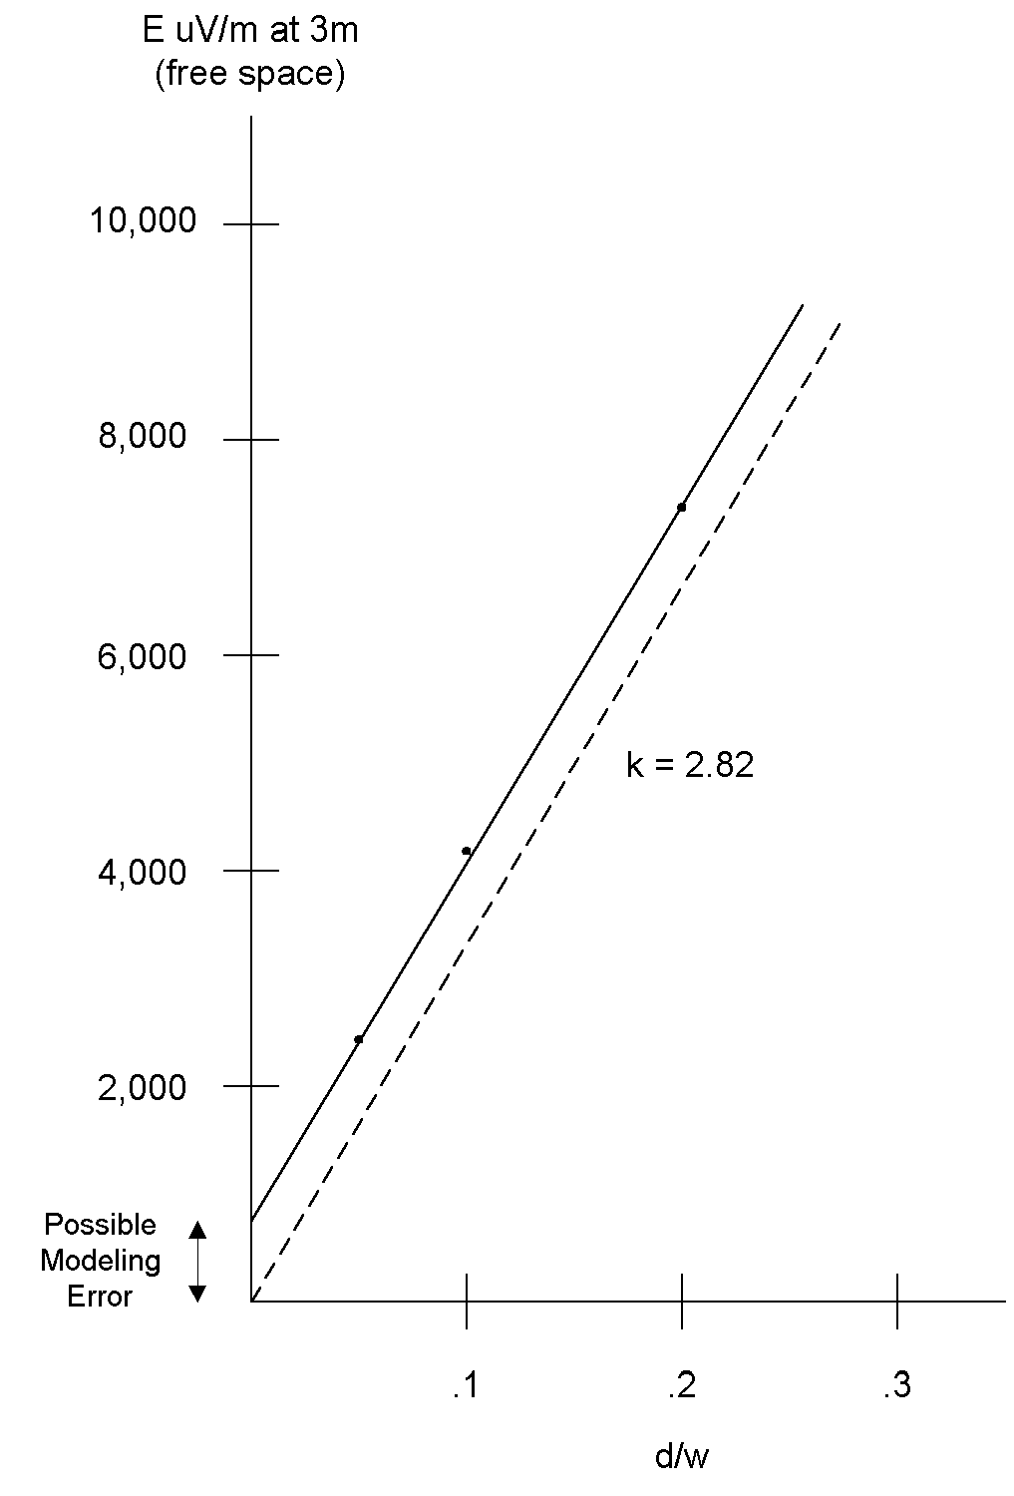
Figure 11: As theory predicts, emissions are a linear function of the ratio of the height of a driven wire over a return plane (d) to the width of the plane (w). A residual impedance is present for d/w=0, which could be due to modeling error. If it is eliminated graphically, the line shifts as shown. Empirically, k is equal 2.82 (=2√2).

If we ignore this residual impedance, the line shifts to the position shown by the dotted line in Figure 11. These empirical results can then be used to calculate the constant k in Equation 6. It equals 2.82. That is an interesting number, since 2.82=2√2.

As useful and affordable as EZNEC is, a Method of Moments simulator for EMC use should have, in addition to the features of EZNEC, the following:

1) It should have a full color display capability for currents on each segment. Abrupt changes in the magnitude or phases of currents between segments can signal modeling problems.

2) It should have the ability to model return planes easily. In EZNEC return planes have to be laboriously built out of individual wires. Some Method of Moment simulators can do this automatically using either wire squares or simulated “patches” of conductive material.

3) Calculation of field strength should be performed automatically for any given distance. Distances of particular importance are 3, 10 and 30 meters. Also useful would be a feature which would calculate the maximum field strength as the receiving antenna was raised and lowered over a prescribed distance such as 1 to 4 meters and a feature that would automatically calculate maximum field strength along such a traverse both in vertical and horizontal polarizations.

4) EZNEC does an excellent job of displaying the wire frame model and allowing it to be rotated in 3 dimensions. It would be nice, however, if the wires were numbered so that problem wires could be identified more readily.

The Method of Moments is a powerful technique for calculating emissions from structures such as antennas, and, if used with care, can model other structures such as return planes and even shielded cases. As such, it will find wide application in the emerging field of EMC control through computational methods. It complements well the FDTD method which is better at predicting fields within confined volumes when those fields are perturbed by elements having varying conductivities and dielectric constants.

References

1. B. Archambeault, O. Ramahi and C. Brench, EMI/EMC Computational Modeling Handbook, Kluwer Academic Publishers, Norwell, MA 02061 (1998).

2. EZNEC is available from Roy Lewallen, W7EL, P.O. Box 6658, Beaverton, OR 97007, email: w7el@teleport.com.

3. R. Harrington, Field Computation by Moment Methods, Robert E. Krieger Press, Malabar, FL (1987).

4. R. Booton Jr., Computational Methods for Electromagnetics and Microwaves, John Wiley and Sons, New York, NY (1992).

5. D. Hockanson, J. Drewniak, T. Hubing, T. Van Doren, F. Shu, C. Lam, L. Rubin, “Quantifying EMI Resulting from Finite-Impedance Reference Planes,” IEEE Transactions on Electromagnetic Compatibility, Nov. 1997, Page 286.

For those interested in the methods used to compute impedances, a terse introduction can be found in Chapter 6 of Reference 1. For a more detailed discussion, see References 3 and 4.

