A Dash of Maxwell’s

A Maxwell’s Equations Primer

Chapter V – Radiation from a Small Wire Element

By Glen Dash, Ampyx LLC, GlenDash at alum.mit.edu
Copyright 2000, 2005 Ampyx LLC

In our last chapter, we derived our third form of Maxwell’s Equations, which we called the computational form:

$$\begin{aligned}\text{E=-}(∇V+\frac{\text{dA}}{\text{dt}}) (a) \\ \text{B=}∇×\text{A } (b) \\ \text{V=}\frac{1}{4\text{πε}}\sum_{n=0}^{n=N}{\frac{ρ_{n}}{r_{n}}}{\text{ v}}_{n} (c) \\ \text{A=}\frac{μ}{4π}\sum_{n=0}^{n=N}{\frac{J_{n}}{r_{n}}} ℓ_{n}{\text{ a}}_{n} (d)\end{aligned}$$

Where:

E = Electric field in V/m
B = Magnetic flux density, B=μH

H = Magnetic field in Amps/m

V = Voltage
A = Vector potential
ρ_{n} = Charge density in Coulombs/m³ of a particular charge element, n
r_{n} = Distance from a given charge or current element, n, to the location of interest
v_{n} = Volume of a particular charge element, n
l_{n} = Length of a particular current element, n
a_{n} = Area of a particular current element, n
J_{n} = Total current density (both conductive and displacement) in amps/ m² of a particular current element, n
ε, μ = Permittivity and permeability respectively

The magic of these equations lies in their suitability for computational use. To solve Maxwell’s Equations for a given assemblage of wires and sources, all we need to know is the distribution of current and charge. Equations 1(c) and 1(d) allow us to compute the voltages and vector potential over a volume of interest. Equations 1(a) and 1(b) then allow us to compute the free space electric and magnetic fields at any point in that volume by simple summation.

It is time to put these equations to work by computing the radiation from a simple structure, a short wire element. We choose for our element the one shown in Figure 1. It is a short piece of wire with the following properties:

$$\begin{aligned}ℓ\text{<<}λ \\ d\text{<<}ℓ \\ I=I_{0}\text{cos}(ωt)=\text{Re}[I_{0}e^{jωt}] \\ I,\text{at any given instant},\text{is constant along the length of the element}\end{aligned}$$
Where:
l = length of wire in meters
ω = frequency in radians = 2πf
λ = wavelength in meters
d = diameter of wire in meters
I = current on the wire in amps

Note that this wire element has constant current along its entire finite length. Since the current has to go somewhere two plates are provided, one at each end. They form a capacitor and serve as reservoirs of charge.

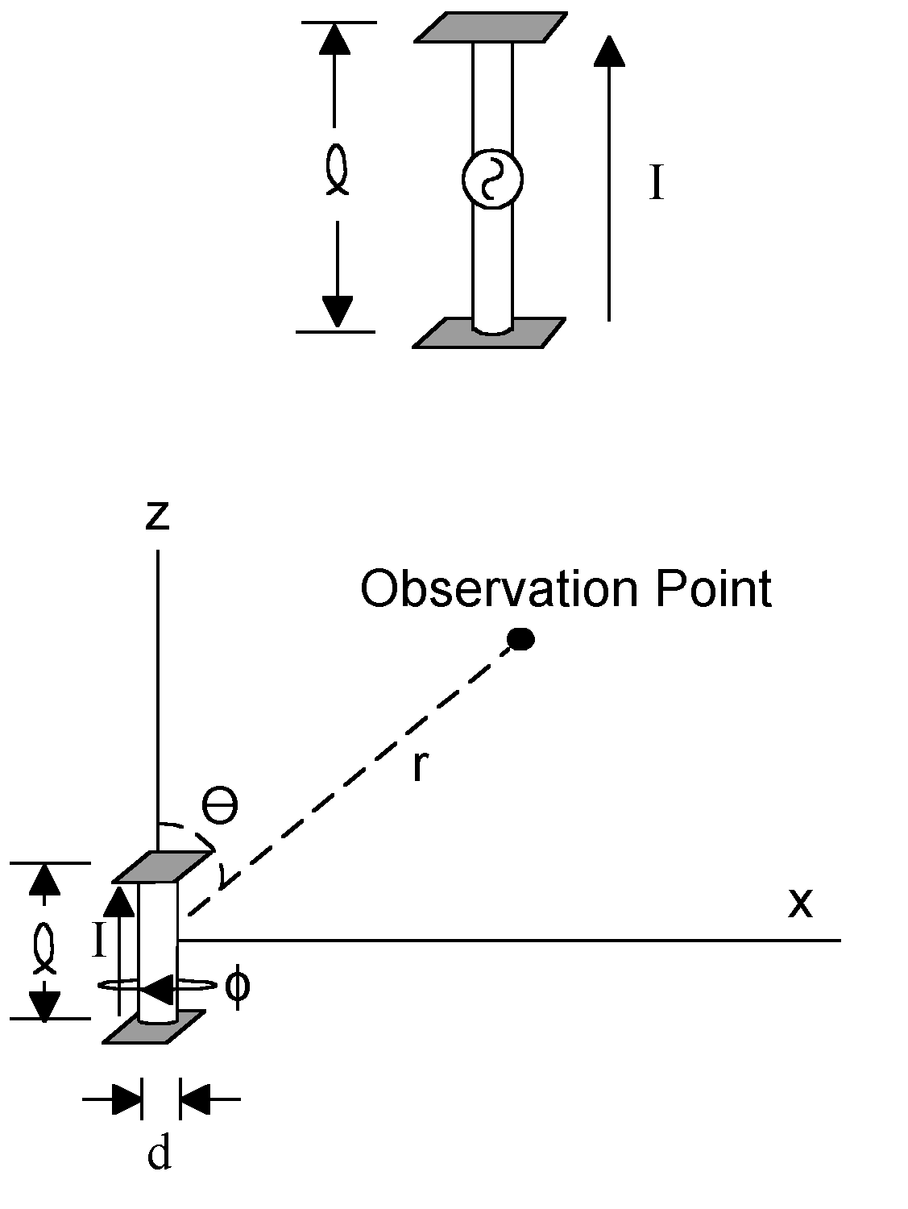
Figure 1: A small wire element carries a current I. Our task is to derive the magnetic and electric fields at any given observation point. The length of the wire element is l. We will be using two coordinate systems, Cartesian (x,y,z) and spherical (r, θ, φ ).

We will start our analysis by computing the vector potential A. A is always aligned with the currents that produce it. Since we only have currents in the z direction, A will only point in the z direction. A is simply:

$$\begin{aligned}A_{z}=\frac{μ_{0}}{4π}\underset{\text{n=1}}{\overset{N}{\sum{}}}\frac{J_{n}}{r_{n}}a_{n}ℓJ_{n}a_{n}{\text{=I}}_{n} \\ n=\text{N=1} \\ A_{z}=\frac{μ_{0}(I)(ℓ)}{4πr}\end{aligned}$$

Where:
J_{n} = current density on a wire element in amps/meter²
a_{n} = area of wire element n in meter²
I_{n} = current on a wire element in amps

However, these results are not complete. We have to account for the fact that the vector potential propagates as a wave through space. Since our hypothetical wire element is suspended in free space, this wave propagates away from the wire element with the speed of light, c. To account for this propagation, we adjust the solution in by adding a phase term:

$$I=I_{0}\text{cos}(ωt−\text{ωτ})$$
Where:
τ = Time to the observation point in seconds
ω = Frequency in radians per second
ωτ = Total phase change in radians

The term ωτ accounts for the fact that the vector potential at the observation point is a function of something that happened earlier, namely the current at the source at time t-τ . The time it takes for the field to propagate to the observation point is equal to the distance r divided by the speed of light: τ= r/c. Therefore:

$$\begin{aligned}I=\text{Re}\left(I_{0}e^{j(ωt−\text{ωτ})}\right) \\ \text{Noting that: }τ=\frac{r}{c}\text{ and }ω=2π\text{f, }\text{ωτ}=\frac{2π\text{fr}}{c} \\ \text{And since: f}λ=\text{c and }β=\frac{2π}{λ}\text{, }\text{ωτ}=βr \\ I=I^{}=\text{Re}[I_{0}e^{jωt−βr}]=\text{Re}[I_{0}e^{jωt}e^{\text{-j}βr}] \\ A_{z}=\frac{μ_{0}I^{}ℓ}{4πr}\end{aligned}$$

I* is known as the “retarded current”. The use of retarded currents and retarded potentials are common in electromagnetics. As above, their purpose is to account for the finite propagation speed of electromagnetic waves as they move through space.

In the case of our wire element, the vector potential A is plotted in Figure 2.

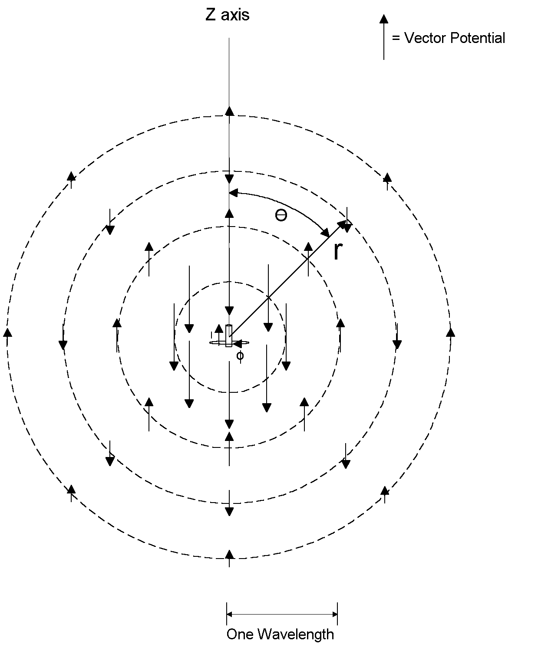
Figure 2: The vector potential A is plotted. The small current element creates a vector potential which falls off linearly with distance. It reverses in phase every half wavelength as it propagates outward.

From our solution for the vector potential A we can compute the magnetic flux density B using Equation 1(b). Note that the magnetic flux density, and hence the magnetic field, is a function only of A, and hence only a function of the currents. Computing the curl is somewhat complex mathematically, but we can get an intuitive feel from Figure 3. As previously described chapters, we can use an imaginary paddlewheel-type device to test for the existence of curl in a field. At Point 1 in Figure 3, the vector potential to the right of the axis of the paddlewheel is greater than that to the left and in an opposing direction. This causes the paddlewheel to turn, demonstrating that there is curl at that point. The curl of a vector field is a vector in itself whose direction is determined by the right hand rule. The fingers of the right hand point in the direction of the paddlewheel spin and the thumb gives us the direction of the curl. The curl of the vector potential at point 1, which is equal to the magnetic flux density, points toward the reader (outward from the page). At Point 2, the opposite is true. At Point 3, the paddlewheel does not spin. There is no curl at all.

With a little bit of imagination we can discern that:

- There is no curl in the z direction.
- The curl of the vector potential points only in the φ direction.
- Even in the φ direction, there is no curl along the z axis.

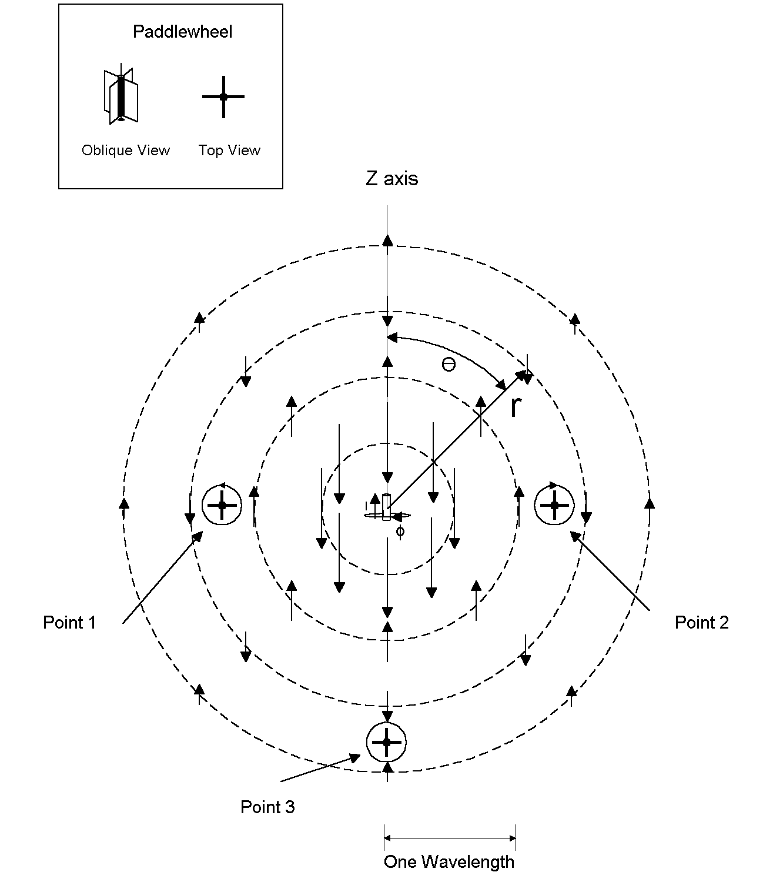
Figure 3: The vector potential A is used to calculate the magnetic flux density, B, and the magnetic field, H. The magnetic flux density is equal to the curl of the vector potential. We can get an intuitive feel for the magnitude and direction of the curl by using an imaginary paddlewheel, shown in the upper left hand corner. Inserted into the field, it will spin if the vectors on one side of the paddlewheel are different than on the other. At Point 1, there is curl in the counterclockwise direction and at Point 2, the clockwise direction. There is no curl at Point 3. The direction of the magnetic field is determined by the right hand rule. The fingers of the right hand point in the direction of the curl. Therefore, the magnetic field at Point 1 points outward and at Point 2, inward.

Having calculated the vector potential and studied in at least an intuitive way the form of the magnetic field, our next step is to compute the scalar potential V. To do this, we need to know the distribution of the charge at any given point in time. The charge is related to the current on the wire by:

$$\begin{aligned}\text{I=}\frac{\text{dq}}{\text{dt}} \\ \text{q=}\int{\text{Idt+C}}\end{aligned}$$

We can ignore the constant C (static charge) and compute q as follows:

$$\begin{aligned}\text{I=}\text{Re}[I_{0}e^{jωt}] \\ q=\int{\text{Idt}}=\text{Re}[\frac{I_{0}}{jω}e^{jωt}] \\ \text{q=}\frac{I_{0}}{ω}\text{sin}(ωt)\end{aligned}$$

For brevity, in the analysis that follows we will assume that the last mathematical step is always to take the real part of the solution, and simple state that:

$$q=\frac{I_{0}}{jω}e^{jωt}$$

We assumed above that the current I was constant over the length of the wire, but we do not make the same assumption for the charge q. Rather, we assume just the opposite, that the charge q tends to be concentrated on the plates at the ends of the wire.

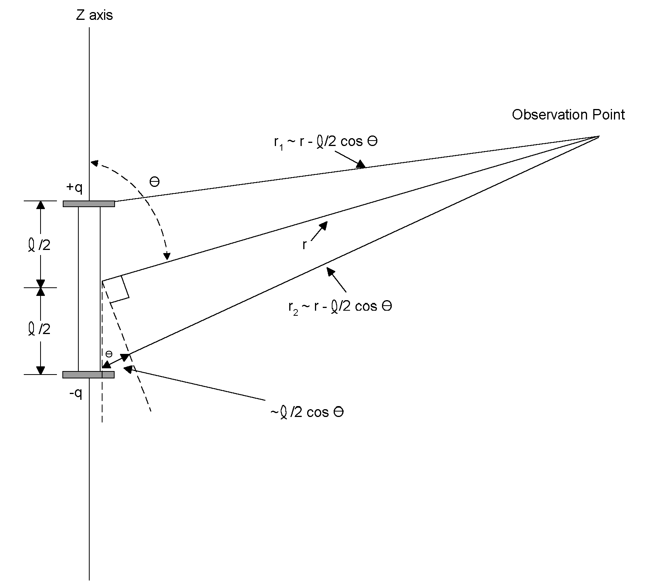
Figure 4: The small wire element is assumed to have its charge concentrated on the plates at its ends. The voltage at an observation point is calculated from the electric field. Some simplifying geometric assumptions are used.

The voltage at an observation point can be computed knowing the distribution of charge (Equation 1(c).
$$\begin{aligned}\text{V=}\frac{1}{4πε_{0}}\underset{\text{n=1}}{\overset{N}{\sum{}}}\frac{ρ_{n}}{r_{n}}v_{n}ρ_{n}v_{n}=q_{n} \\ \text{V=}\frac{1}{4πε_{0}}\left(\frac{q}{r_{1}}−\frac{q}{r_{2}}\right) \\ q=\frac{I_{0}}{\text{jw}}e^{jωt} \\ V=\frac{I_{0}e^{jωt}}{jω4{\text{πε}}_{0}}\left(\frac{1}{r_{1}}−\frac{1}{r_{2}}\right)\end{aligned}$$

Once again, we will account for propagation time by using retarded currents.
$$V=\frac{I∗}{jω4{\text{πε}}_{0}}\left(\frac{1}{r_{1}}−\frac{1}{r_{2}}\right)$$

By assuming that r >> l, l >>d, r₁ = r - (l/2) cos θ, r₂ = r + (l/2) cos θ and λ >> l, we can show that this equation is equal to the following (see Appendix A for derivation):

$$\text{V=}\frac{I_{0}ℓ}{4πε_{0}c}e^{j(ω\text{t-}βr)}\text{cos}θ\left(\frac{1}{r}+\frac{c}{jωr^{2}}\right)$$

We are almost ready to compute the magnetic and electric fields. However, we will find it convenient to use spherical coordinates instead of Cartesian coordinates. The transformation between coordinate systems is illustrated in Figure 5.

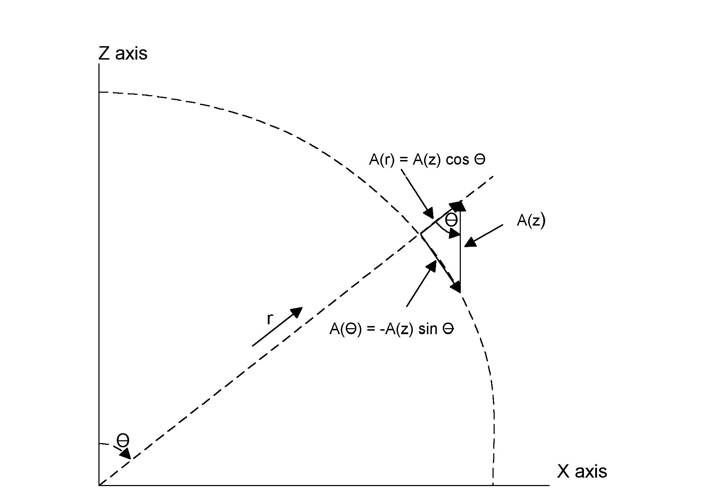
Figure 5: Conversion from Cartesian to spherical coordinates in the x, z plane is illustrated.

Expressing the vector potential in spherical coordinates we have:
$$\begin{aligned}A_{z}=\frac{μ_{0}I^{}ℓ}{4πr} \\ \\ A_{r}=A_{z}\text{cos}θ \\ A_{θ}\text{=-}A_{z}\text{sin}θ \\ A_{φ}\text{=0}\end{aligned}$$

To find B, and hence the magnetic field H=B/μ₀, we take the curl of A. In a previous chapter, we derived the curl operation in Cartesian coordinates. We will dispense with a similar derivation in spherical coordinates and just state the formula for curl in spherical coordinates here. Where, as in this case, A_{φ}=0, ∂A_{θ}/∂φ=0 and ∂A_{r}/∂φ=0:

$$\text{Curl of A in Spherical Coordinates }=∇×\text{A=}B_{φ}=\frac{1}{r}\left(\frac{∂(rA_{θ})}{∂r}−\frac{∂A_{r}}{∂θ}\right)$$

Solving for the term ∂(rA_{θ)}/∂r:
$$\begin{aligned}{\text{rA}}_{θ}\text{=-}\frac{μ_{0}ℓ}{4π}I_{0}{\text{ e}}^{jωt}e^{−jβr}\text{sin}θ \\ \frac{∂(rA_{θ})}{∂r}\text{=-}\frac{μ_{0}ℓ}{4π}I_{0}e^{jωt}\text{sin}θ\frac{∂(e^{\text{-j}βr})}{∂r}\text{= j }β\frac{μ_{0}ℓ}{4π}I^{}\text{sin}θ\end{aligned}$$

Solving for the term ∂A_{r}/∂θ:
$$\frac{∂A_{r}}{∂θ}\text{=-}\frac{μ_{0}ℓ}{4πr}I^{}\text{sin}θ$$

The curl of A is therefore:

$$\begin{aligned}∇×\text{A=}B_{φ}=\frac{1}{r}\left(\text{j }β\frac{μ_{0}ℓ}{4π}I^{}\text{sin}θ+\frac{μ_{0}ℓ}{4πr}{\text{ I}}^{}\text{sin}θ\right) \\ B_{φ}=\frac{μ_{0}ℓ}{4π}I^{}\text{sin}θ\left(\frac{\text{j }β}{r}+\frac{1}{r^{2}}\right) \\ H_{φ}=\frac{ℓ}{4π}I^{}\text{sin}θ\left(\frac{\text{j }β}{r}+\frac{1}{r^{2}}\right)\end{aligned}$$

That solves for the magnetic field. To find the electric field, we use Equation 1(a).

$$\text{E=-}Δ\text{V-}\frac{\text{dA}}{\text{dt}}$$

As with the curl operation, we introduced the gradient operation in an earlier chapter and derived it in Cartesian coordinates. As above, we will dispense with the derivation here and just state the formula for the gradient in spherical coordinates. Where, as here, ∂V/∂φ=0, the gradient of the voltage expressed in spherical coordinates is:

$$\begin{aligned}ΔV={ΔV}_{r}+{ΔV}_{θ} \\ {ΔV}_{r}=\frac{∂V}{∂r} \\ {ΔV}_{θ}=\frac{1}{r}\frac{∂V}{∂θ}\end{aligned}$$

Solving for the electric field in the r direction:

$$\begin{aligned}E_{r}\text{=-}{ΔV}_{r}−\frac{{\text{dA}}_{r}}{\text{dt}} \\ {ΔV}_{r}=\frac{∂V}{∂r} \\ \frac{∂V}{∂r}=\frac{∂}{∂r}\left(\frac{ℓ}{4πε_{0}c}I_{0}e^{j(ω\text{t-}βr)}\text{cos}θ\left(\frac{1}{r}+\frac{c}{jωr^{2}}\right)\right)\end{aligned}$$

In Appendix B we show that this is equal to:

$$\frac{∂V}{∂r}\text{=-}\frac{ℓ}{4πε_{0}c}I^{}\text{cos}θ\left(\frac{jβ}{r}+\frac{2}{r^{2}}+\frac{\text{2c}}{jωr^{3}}\right)$$

Likewise:
$$\frac{{\text{dA}}_{r}}{\text{dt}}=\frac{d}{\text{dt}}\left(\frac{μ_{0}ℓ}{4πr}I_{0}e^{j(ω\text{t-}βr)}\text{cos}θ\right)=\frac{jωμ_{0}ℓ}{4πr}I^{}\text{cos}θ=\frac{μ_{0}ℓ}{4π}\frac{jω}{r}I^{}\text{cos}θ$$

But we know that since 1/c²=μ₀ε₀:

$$\frac{μ_{0}ℓ}{4π}=\frac{μ_{0}ℓε_{0}}{4πε_{0}}=\frac{ℓ}{4πε_{0}c^{2}}$$

So:
$$\begin{aligned}\frac{dA_{r}}{\text{dt}}=\frac{ℓ}{4πε_{0}c}\left(\frac{jω}{\text{cr}}\right)I^{}\text{cos}θ=\frac{ℓ}{4πε_{0}c}\left(\frac{jβ}{r}\right)I^{}\text{cos}θ \\ \text{Since }\frac{ω}{c}=\frac{2πf}{fλ}=\frac{2π}{λ}=β\end{aligned}$$

Therefore:
$$\begin{aligned}E_{r}=\frac{ℓ}{4πε_{0}c}I^{}\text{cos}θ\left(\frac{jβ}{r}+\frac{2}{r^{2}}+\frac{\text{2c}}{jωr^{3}}\right)−\frac{ℓ}{4πε_{0}c}I^{}\text{cos}θ\left(\frac{jβ}{r}\right) \\ \frac{ℓ}{2πε_{0}}I^{}\text{cos}θ\left(\frac{1}{{\text{cr}}^{2}}+\frac{1}{jωr^{3}}\right)\end{aligned}$$

For E_{θ}:

$$\begin{aligned}E_{θ}\text{=-}{ΔV}_{θ}−\frac{dA_{θ}}{\text{dt}} \\ {ΔV}_{θ}=\frac{1}{r}(\frac{dV}{dθ}) \\ \frac{dV}{dθ}=\frac{d}{dθ}\left(\frac{ℓ}{4πε_{0}c}I^{}\text{cos}θ\left(\frac{1}{r}+\frac{c}{jωr^{2}}\right)\right)\text{=-}\frac{ℓ}{4πε_{0}c}I^{}\text{sin}θ\left(\frac{1}{r}+\frac{c}{jωr^{2}}\right) \\ \frac{dA_{θ}}{\text{dt}}=\frac{d}{\text{dt}}\left(−\frac{μ_{0}ℓ}{4πr}I_{0}e^{jωt}e^{−βr}\text{sin}θ\right)\text{=-}\frac{jωμ_{0}ℓ}{4πr}I_{0}e^{jωt}e^{−βr}\text{sin}θ\frac{jωℓμ_{0}ε_{0}}{4πrε_{0}}I^{} \\ \text{=-}\frac{ℓ}{4πε_{0}}I^{}\text{sin}θ\left(\frac{jω}{c^{2}r}\right)\end{aligned}$$

Therefore:

$$\begin{aligned}E_{θ}=\frac{1}{r}\left[\frac{ℓ}{4πε_{0}c}I^{}\text{sin}θ\left(\frac{1}{r}+\frac{c}{jωr^{2}}\right)\right]\text{+ }\frac{ℓ}{4πε_{0}}I^{}\text{sin}θ\left(\frac{jω}{c^{2}r}\right) \\ E_{θ}=\frac{ℓ}{4πε_{0}}I^{}\text{sin}θ\left(\frac{jω}{c^{2}r}+\frac{1}{{\text{cr}}^{2}}+\frac{1}{jωr^{3}}\right)\end{aligned}$$

We now can definitively state the solution to Maxwell’s Equations for the short current element in Figure 1:
$$\begin{aligned}H_{φ}=\frac{1}{4π}I^{}ℓ\text{sin}θ\left(\frac{jω}{\text{cr}}+\frac{1}{r^{2}}\right) \\ E_{r}=\frac{1}{2πε_{0}}I^{}ℓ\text{cos}θ\left(\frac{1}{{\text{cr}}^{2}}+\frac{1}{jωr^{3}}\right) \\ E_{θ}=\frac{1}{4πε_{0}}I^{}ℓ\text{sin}θ\left(\frac{jω}{c^{2}r}+\frac{1}{{\text{cr}}^{2}}+\frac{1}{jωr^{3}}\right)\end{aligned}$$

These three equations may seem a jumble, but they can be dissected readily to reveal the underlying physics of radiation from a wire element. Take the expression for the magnetic field:

$$\begin{aligned}H_{φ}\text{= }(\frac{1}{4π}) (I^{}ℓ) \text{sin}θ (\frac{jω}{\text{cr}}\text{+ }\frac{1}{r^{2}}) \\ ↑ ↑ ↑ ↑ ↑ \\ \text{constant } \text{current moment } \text{radiation }\text{Far Field Near Field} \\ (\text{retarded}) \text{pattern } \text{component component}\end{aligned}$$

Four fundamental elements make up the expression: a constant, a current element adjusted for propagation (that is, retarded), a pattern term, and two terms which denote the fall off of the field with distance. One of these terms is proportional to 1/r, the other to 1/r² . The first denotes the “far field” component of the magnetic field, and the latter the “near field” component. We define the far field as follows:
$$\begin{aligned}\frac{jω}{\text{cr}}\text{>>}\frac{1}{r^{2}} \\ r\text{>>}\frac{c}{ω} \\ \text{c=f}λ ω\text{=2}πf \\ r\text{>>}\frac{λ}{2π}\end{aligned}$$

At a distance much greater than λ/2π (far field), the magnetic field can be expressed as:

$$H_{φ}=\frac{1}{4π}\left(I^{}ℓ\right)\text{sin}θ \left(\frac{jω}{\text{cr}}\right)$$

In the near field, where r<< λ/2π:

$$H_{φ}=\frac{1}{4π}\left(I^{}ℓ\right)\text{sin}θ \left(\frac{1}{r^{2}}\right)$$

The electric far field is defined using the same criteria as the magnetic far field, that is the far field is defined as existing where r>>λ/2π . Indeed, in the far field the radial electric field, E_{r ,} can be ignored and the electric field considered equal to:

$$E_{θ}=\frac{1}{4πε_{0}}I^{}ℓ\text{sin}θ\left(\frac{jω}{c^{2}r}\right)$$

In the near electric field:
$$\begin{aligned}E_{r}=\frac{1}{2πε_{0}}I^{}ℓ\text{cos}θ\left(\frac{1}{jωr^{3}}\right) \\ E_{θ}=\frac{1}{4πε_{0}}I^{}ℓ\text{sin}θ\left(\frac{1}{jωr^{3}}\right)\end{aligned}$$

Much of our interest will focus on the far fields. Once again, these are:

$$\begin{aligned}H_{φ}=\frac{1}{4π}I^{}ℓ\text{sin}θ\left(\frac{jω}{\text{cr}}\right) \\ E_{θ}=\frac{1}{4πε_{0}}I^{}ℓ\text{sin}θ\left(\frac{jω}{c^{2}r}\right)\end{aligned}$$

Note the following:

1. The magnetic and electric fields are oriented 90 degrees from each other in space, and
2. The fields are in time phase.

We have seen this combination of magnetic and electric fields before. These equations describe a plane wave. The direction of movement is determined by the cross-product of the two fields:

$$P=E×H$$

The vector P is known as the Poynting vector. The electric field E is in units of V/m, and the magnetic field H in A/m. Their product is in units of W/m², representing the energy per unit area being carried outward by the wave.

The ratio of two fields is in units of ohms and is equal to:

$$\frac{E}{H}=\frac{1}{ε_{0}c}=\frac{\sqrt{μ_{0}ε_{0}}}{ε_{0}}=\sqrt{\frac{μ_{0}}{ε_{0}}}\text{=377 }Ω$$

The value 377 ohms is known as the free space impedance.

In the near field:

$$\begin{aligned}H_{φ}=\frac{1}{4π}I^{}ℓ\text{sin}θ\left(\frac{1}{r^{2}}\right) \\ E_{r}=\frac{1}{2πε_{0}}I^{}ℓ\text{cos}θ\left(\frac{1}{jωr^{3}}\right) \\ E_{θ}=\frac{1}{4πε_{0}}I^{}ℓ\text{sin}θ\left(\frac{1}{jωr^{3}}\right)\end{aligned}$$

The near electric and magnetic fields are not in time phase. For example, at θ=90 degrees,

$$\begin{aligned}H_{φ}=\frac{1}{4π}I^{}ℓ\left(\frac{1}{r^{2}}\right) \\ E_{θ}=\frac{1}{4πε_{0}}I^{}ℓ\left(\frac{1}{jωr^{3}}\right) \\ \text{Where }I^{}=I_{0}e^{jωt}e^{−βr}\text{ and }β=\frac{2π}{λ}=\frac{ω}{c}\end{aligned}$$

First, we note that the propagation term e^{-βr} can be ignored in the near field. Then, expanding e^{jωt} :

$$\begin{aligned}\begin{aligned}H_{φ}=\frac{1}{4π}I^{}ℓ\left(\frac{1}{r^{2}}\right)=\frac{1}{4π}I_{0}ℓe^{jωt}\left(\frac{1}{r^{2}}\right)=\frac{1}{4π}I_{0}ℓ(\text{cos}ωtωt\left(\frac{1}{r^{2}}\right)\end{aligned}E_{θ}=\frac{1}{4πε_{0}}I^{}ℓ\left(\frac{1}{jωr^{3}}\right)=\frac{1}{4πε_{0}}I_{0}ℓe^{jωt}\left(\frac{1}{jωr^{3}}\right)=\frac{1}{4πε_{0}}I_{0}ℓ(\text{cos}ωt \\ ωt\left(\frac{1}{jωr^{3}}\right)\text{Re}[H_{φ}]=\frac{1}{4π}I_{0}ℓ\text{cos}(ωt\left(\frac{1}{r^{2}}\right)\text{Re}[E_{θ}]=\frac{1}{4πε_{0}}I_{0}ℓ\text{sin}(ωt\left(\frac{1}{ωr^{3}}\right)\end{aligned}$$

The two fields are out of phase in time, just as V and I are out of phase in a reactive circuit. No power is dissipated into space through the action of the near fields. Energy is just temporarily stored in the magnetic and electric near fields just as energy is temporarily stored in the capacitors and inductors of a reactive circuit.

In our next chapter, we will apply our solutions for the short wire element to real world antennas such as half wave dipoles. From then on, things will get easier as we let our computers do most of the work.

References:

1. Kraus, J., Electromagnetics, Fourth Edition, McGraw Hill, 1992.

Appendix A

We start with these formulas:

$$\begin{aligned}\text{V=}\frac{I^{}}{4πε_{0}}\left(\frac{q}{r_{1}}−\frac{q}{r_{2}}\right) \\ I^{}=I_{0}e^{j(ωt−βr)}\end{aligned}$$

We note that:
$$\text{q=}\frac{I_{0}e^{j(ω\text{t-}βr)}}{jω}=\frac{I^{}}{jω}$$

By substitution:
$$\text{V=}\frac{1}{4πε_{0}}\left(\frac{I_{0}e^{j(ω\text{t-}βr_{1})}}{{jωr}_{1}} | | \frac{I_{0}e^{j(ω\text{t-}βr_{2})}}{{jωr}_{2}}\right)$$

From Figure 4 we note that where r>>l and λ>>r:

$$r_{1}\text{=r-}\frac{ℓ}{2}\text{cos}θ \text{and }{\text{ r}}_{2}\text{=r+}\frac{ℓ}{2}\text{cos}θ$$

So the voltage is equal to:
$$\text{V=}\frac{1}{\text{j4}\text{πω}ε_{0}}I_{0}e^{j(ω\text{t-}βr)}\left(\frac{e^{j(\frac{ℓβ}{2}\text{cos}θ)}}{\text{r-}\frac{ℓ}{2}\text{cos}θ}−\frac{e^{\text{-j}(\frac{ℓβ}{2}\text{cos}θ)}}{\text{r+}\frac{ℓ}{2}\text{cos}θ}\right)$$

Let:
$$\frac{ℓβ}{2}\text{cos}θ=γ$$

By substitution, and noting that r >> l, the last term is equal to:

$$\begin{aligned}\left(\frac{e^{j(\frac{ℓβ}{2}\text{cos}θ)}}{(\text{r-}\frac{ℓ}{2}\text{cos}θ)}−\frac{e^{\text{-j}(\frac{ℓβ}{2}\text{cos}θ)}}{(\text{r+}\frac{ℓ}{2}\text{cos}θ)}\right)=\left(\frac{e^{jγ}}{(\text{r-}\frac{γ}{β})}\frac{e^{\text{-j}γ}}{(\text{r+}\frac{γ}{β})}\right)=\frac{re^{jγ}+\frac{γ}{β}e^{jγ}\text{-r}e^{\text{-j}γ}+\frac{γ}{β}e^{\text{-j}γ}}{r^{2}−(\frac{γ}{β})^{2}} \\ \frac{r(e^{jγ}−e^{−jγ})+\frac{γ}{β}e^{jγ}e^{\text{-j}γ}}{r^{2}−(\frac{γ}{β})^{2}}\end{aligned}$$

We can further simplify this expression by noting that:

$$\frac{γ}{β}=\frac{\frac{ℓβ}{2}}{β}=\frac{ℓ}{2}\text{cos}θ$$

and since r >>l:
$$\frac{r(e^{jγ}−e^{−jγ})+\frac{γ}{β}e^{jγ}e^{\text{-j}γ}}{r^{2}−(\frac{γ}{β})^{2}}=\frac{\text{2jr }\text{sin}γ\text{+2}\frac{γ}{β}\text{cos}γ}{r^{2}}$$

However, since β=2π/λ:
$$\begin{aligned}γ=\frac{ℓβ}{2}\text{cos}θ=\frac{ℓπ}{λ}\text{cos}θ \\ \text{and since }λ\text{>>}ℓ\text{, }γ\text{<<}1\text{, }\text{so:} \\ \text{sin}γ≈γ \\ \text{cos}γ≈1\end{aligned}$$

We can state that the voltage is approximately equal to:

$$\begin{aligned}\text{V=}\frac{1}{\text{j4}\text{πω}ε_{0}}I_{0}e^{j(ω\text{t-}βr)}\left(\frac{\text{2jr}γ\text{+2}\frac{γ}{β}}{r^{2}}\right)=\frac{1}{\text{j4}\text{πω}ε_{0}}I_{0}e^{j(ω\text{t-}βr)}\left(\frac{\text{2jr}(\frac{ℓβ}{2}\text{cos}θ)\text{+2}(\frac{ℓ}{2}\text{cos}θ)}{r^{2}}\right) \\ \frac{1}{\text{j4}\text{πω}ε_{0}}I_{0}e^{j(ω\text{t-}βr)}\left(\frac{\text{jr}ℓβ\text{cos}θ+ℓ\text{cos}θ}{r^{2}}\right) \\ \frac{β}{4\text{πω}ε_{0}}I_{0}ℓe^{j(ω\text{t-}βr)}\text{cos}θ\left(\frac{1}{r}+\frac{1}{jβr^{2}}\right) \\ \frac{ω}{β}\text{=c, so:} \\ \text{V=}\frac{I_{0}ℓ}{4πε_{0}c}e^{j(ω\text{t-}βr)}\text{cos}θ\left(\frac{1}{r}+\frac{c}{jωr^{2}}\right)\end{aligned}$$

Appendix B

We start with the expression for the radial electric field, E_{r} :

$$\begin{aligned}E_{r}\text{=-}{ΔV}_{r}−\frac{{∂A}_{r}}{∂t} \\ {ΔV}_{r}=\frac{∂V}{∂r} \\ \frac{∂V}{∂r}=\frac{∂}{∂r}\left(\frac{ℓ}{4πε_{0}c}I_{0}e^{j(ω\text{t-}βr)}\text{cos}θ\left(\frac{1}{r}+\frac{c}{jωr^{2}}\right)\right)\end{aligned}$$

This partial derivative is equal to:

$$\frac{∂V}{∂r}=\frac{ℓ}{4πε_{0}c}I_{0}e^{jωt}\text{cos}θ\frac{∂}{∂r}\left(\frac{e^{\text{-j}βr}}{r}+\frac{e^{\text{-j}βr}c}{jωr^{2}}\right)$$

We note that:

$$\begin{aligned}\frac{∂}{∂r}(\frac{e^{\text{-j}βr}}{r})\text{=-}\frac{e^{\text{-j}βr}}{r^{2}}−\frac{jβe^{\text{-j}βr}}{r} \\ \frac{∂}{∂r}(\frac{e^{\text{-j}βr}c}{jωr^{2}})\text{=-}\frac{2e^{\text{-j}βr}c}{jωr^{3}}−\frac{jβe^{\text{-j}βr}c}{jωr^{2}}\text{=-}\frac{2e^{\text{-j}βr}c}{jωr^{3}}−\frac{e^{\text{-j}βr}}{r^{2}} \\ \frac{∂}{∂r}\left(\frac{e^{\text{-j}βr}}{r}+\frac{e^{\text{-j}βr}c}{jωr^{2}}\right)\text{=-}\frac{e^{\text{-j}βr}}{r^{2}}−\frac{jβe^{\text{-j}βr}}{r}−\frac{2e^{\text{-j}βr}c}{jωr^{3}}−\frac{e^{\text{-j}βr}}{r^{2}} \\ \text{=-}e^{\text{-j}βr}\left(\frac{jβ}{r}+\frac{2}{r^{2}}+\frac{\text{2c}}{jωr^{3}}\right)\end{aligned}$$

Plugging this result in yields:

$$\begin{aligned}\frac{∂V}{∂r}\text{=-}\frac{ℓ}{4πε_{0}c}I_{0}e^{j(ω\text{t-}βr)}\text{cos}θ\left(\frac{jβ}{r}+\frac{2}{r^{2}}+\frac{\text{2c}}{jωr^{3}}\right) \\ \text{=-}\frac{ℓ}{4πε_{0}c}I^{}\text{cos}θ\left(\frac{jβ}{r}+\frac{2}{r^{2}}+\frac{\text{2c}}{jωr^{3}}\right)\end{aligned}$$

