What this Cliff Face May Reveal about the Building of the Pyramids and the Origin of the Sphinx

By Glen Dash, Glen Dash Foundation for Archaeological Research

The limestone cliff face shown below may be the one of the most important places at Giza that no tourist ever visits. Not even many archaeologists know it is there. But as Mark Lehner has pointed out, it *is* important, as it is one of the few places to the south and east of the pyramids where the original surface of the plateau is preserved (Figures 1a, 1b and 2) [1]. It lies directly south of the eastern edge of the Great Pyramid and may have served as a distant marker to aid the ancient surveyors. It could have had a ceremonial purpose as well, since the sun set behind it on the winter solstice when viewed from the junction of the Khafre causeway and the Khafre Valley Temple. Finally, it is geologically linked with the Sphinx and may offer clues as to the original purpose of the great mound of rock from which the Sphinx’s head was eventually carved. It has no official name; we refer it as GCF1 for the modern survey control monument on its top.

[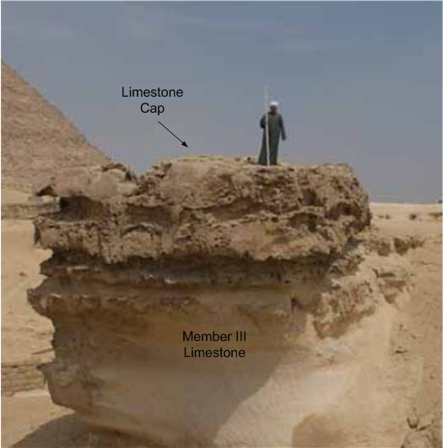](http://glendash.com/blog/wp-content/uploads/2014/08/GCF1-01-top.jpg)

**Figure 1a: GCF1 photographed from the south. (Photo by Mark Lehner)**

[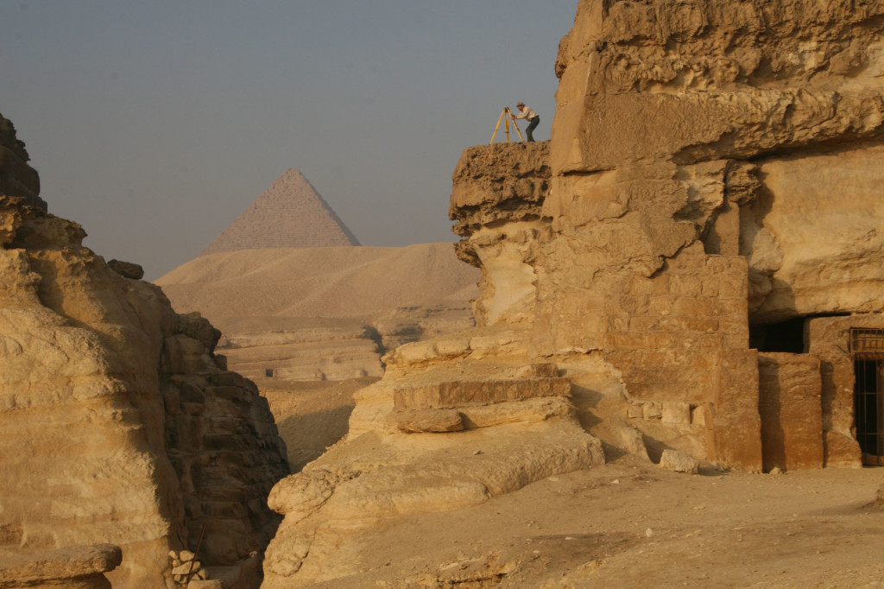](http://glendash.com/blog/wp-content/uploads/2014/08/GCF1-01-bottom.jpg)

**Figure 1b: GCF1 from the east. (Photo by Joan Dash)**

If you stand on GCF1 you see the history of quarrying at Giza all around you written in stone [2]. To the northwest is a quarry which the Egyptians used to build part of the Great Pyramid (Figure 3) [3]. To east and west are gigantic blocks of worked stone [4]. Their existence reveals that the Egyptians began the quarrying process here by cutting channels through the bedrock to form huge “quarry blocks” they later hewed down into individual stones (Figure 4). After the pyramids and temples were completed, the Egyptians fashioned many of the quarry blocks into tombs [5].

[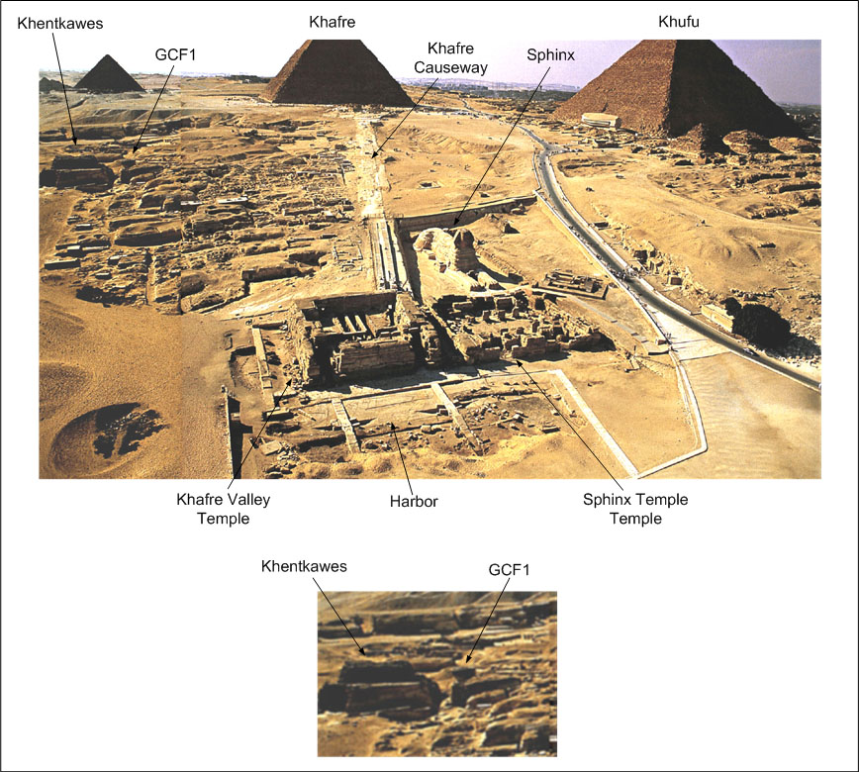](http://glendash.com/blog/wp-content/uploads/2014/08/GCF1-02.jpg)

**Figure 2: Top: The Sphinx, Sphinx Temple, Khafre Valley Temple, GCF1 and Khentkawes viewed from the east. Bottom: A close up of Khentkawes and GCF1. (Photo by Kenneth Garrett)**

*[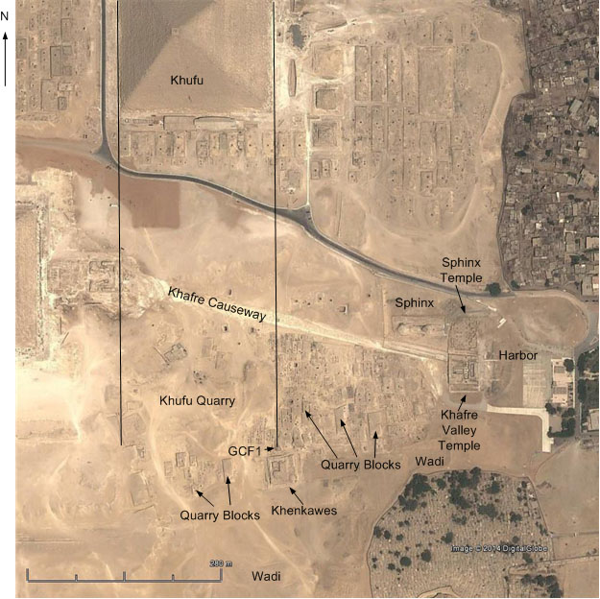](http://glendash.com/blog/wp-content/uploads/2014/08/GCF1-031.jpg)*

**Figure 3: GCF1 is aligned with the eastern edge of the Great Pyramid of Khufu. It stands at the eastern boundary of the Khufu Quarry and is surrounded by rectangular cuttings of worked stone known as “Quarry Blocks.” (Photo courtesy Google Earth)**

[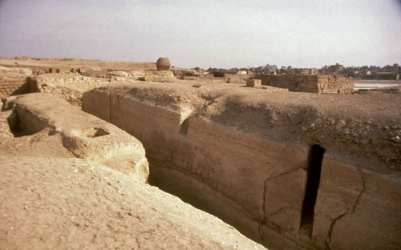](http://glendash.com/blog/wp-content/uploads/2014/08/GCF1-04.jpg)

**Figure 4: Quarry Blocks. As an early step in the quarrying process, the Egyptians cut channels into the limestone members creating massive rectangular blocks. (Photo by Mark Lehner**)

Viewed from the south, as in Figure 1, GCF1 looks like a pillar of stone. Approached from north, as in Figure 5, GCF1 appears to be a knoll of stepped bedrock that rises slightly higher than the surface around it. While the stone to its east and west was quarried away, the stone to the north was not, perhaps to permit access to its summit. At some point the knoll’s southern slope was cut away as well, creating a quarry block that was eventually fashioned into the tomb of Khentkawes (Figure 6).

[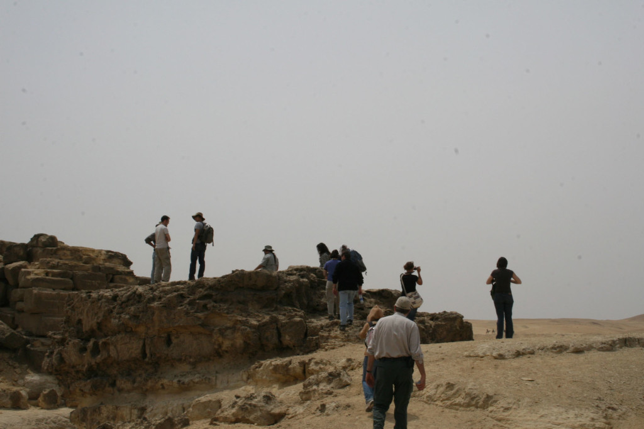](http://glendash.com/blog/wp-content/uploads/2014/08/GCF1-05.jpg)

**Figure 5: Approaching GCF1 from the north. (Photo by Joan Dash)**

[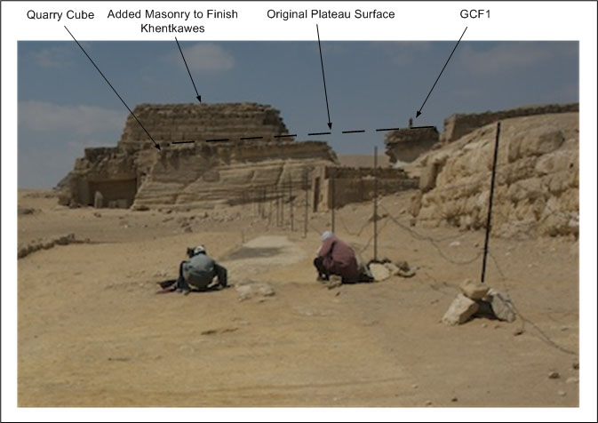](http://glendash.com/blog/wp-content/uploads/2014/08/GCF1-06.jpg)

**Figure 6: GCF1 was part of a high knoll which was quarried away on the east and west. A channel was cut on its south forming a quarry block which eventually became part of Khentkawes’ tomb. (Photo courtesy AERA)**

Why was the summit of GCF1 left intact? It may have been an observation point. By standing here an overseer could direct the quarrying operations all around him and monitor the movement of goods up the wadi from the harbor to the east.

GCF1’s survival is fortuitous in part because it preserves the geological history of this part of the plateau. Beneath its dark crown, we see uniform stone reminiscent of the head of the Sphinx. Indeed, GCF1 and the Sphinx are cut from the same geological layer, known as Member III (Figures 1 and 7).

In 1980 and 1981, K. Lal Gauri, working with Mark Lehner for the Sphinx Project of the American Research Center in Egypt, geologically mapped the Sphinx area. Gauri identified three distinct rock beds designated from bottom to top as Members I, II, and III [6]. A year later, Thomas Aigner expanded the study to cover the rest of the plateau [7]. To the north and west of the Sphinx, Aigner identified a bank of nummulitic packstone supporting the Great Pyramid (Figure 7). Nummulitic stone is named for the coin sized fossils (nummulites) that populate it. The nummulitic packstone here is hard, brittle and difficult to work. To the southeast of the Great Pyramid, the nummulitic packstone gives way to the more easily worked members. The Sphinx rests on Member I while its body is carved from Member II and its head and neck from Member III. The makeup of Member III stone makes it more resistant to weathering than Member II (Figure 8) [8]. That is why the Sphinx’s head is well preserved while its body is not. GFC1 exhibits bedding similar to that what find in the head and neck of the Sphinx (Figures 9a and 9b).

[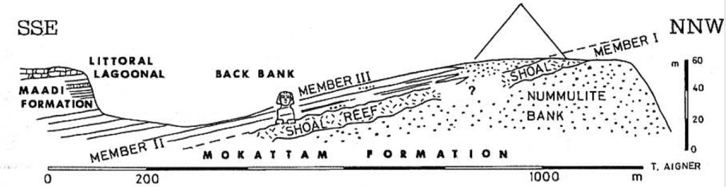](http://glendash.com/blog/wp-content/uploads/2014/08/GCF1-07.jpg)

**Figure 7: Thomas Aigners’ map of the geological makeup of the Giza Plateau. (Lehner 1985, 137)**

[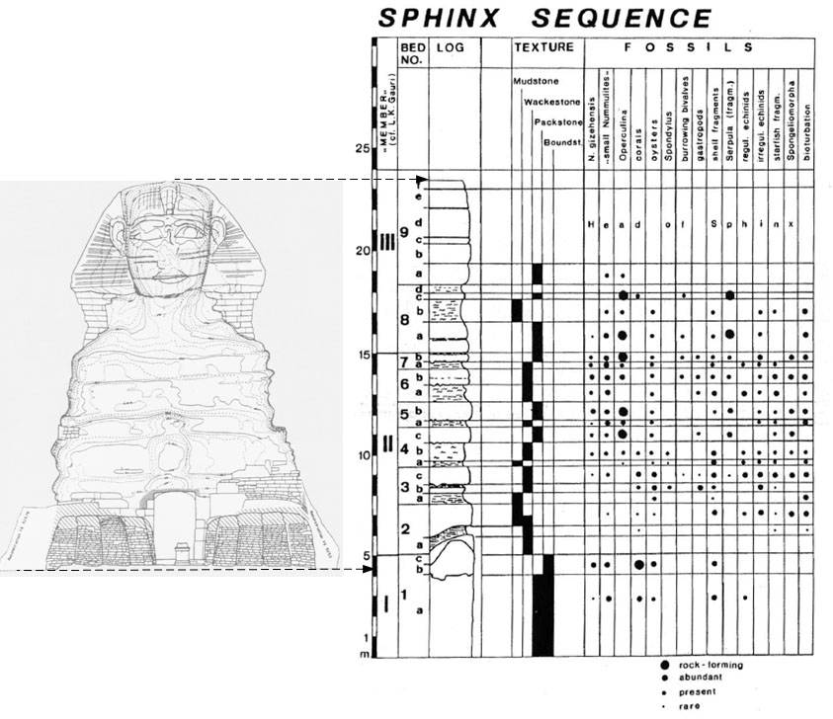](http://glendash.com/blog/wp-content/uploads/2014/08/GCF1-081.jpg)

**Figure 8: The bedding sequence making up the Sphinx. (Lehner 1985, 138 and Lehner 1997, 130)**

[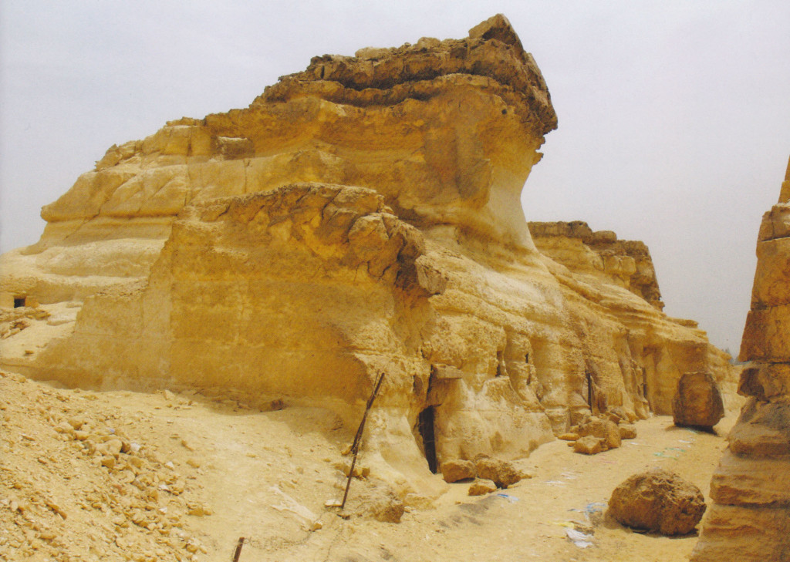](http://glendash.com/blog/wp-content/uploads/2014/08/GCF1-09-top.jpg)

**Figure 9a: GCF1 viewed from the south-southwest. (Photo by Mark Lehner)**

[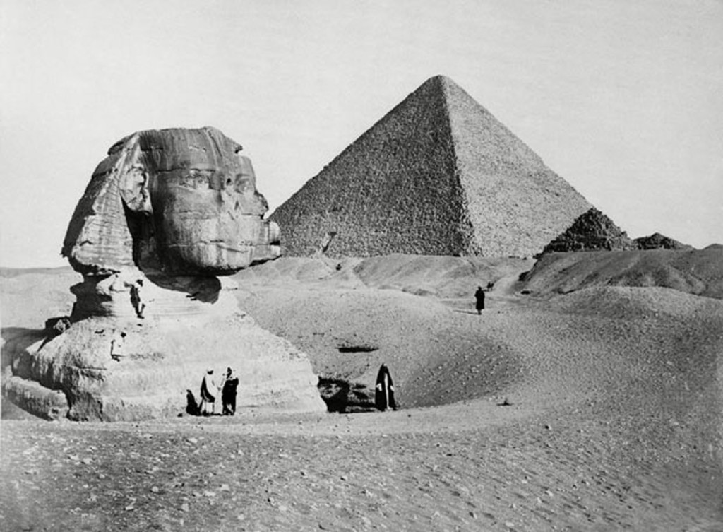](http://glendash.com/blog/wp-content/uploads/2014/08/GCF1-09-bottom.jpg)

**Figure 9b: Beneath the dark surface layer, GCF1 exhibits bedding layers similar to that in the head and neck of the Sphinx. (Photo by Henri Bechard)**

The Sphinx and GCF1 have more in common than just their geology. Like GCF1, the head of the Sphinx stands alone above an area originally covered by an expanse of Member III stone. Except for the area immediately around what became the head, all that Member III stone was presumably quarried away. What was left would have been an isolated block of limestone. Could the head of the Sphinx, prior to being carved into the likeness of a pharaoh, been an observation point like GCF1? It is possible, and overlooking the harbor, such a block of stone would have stood in an auspicious place. If true, the theory would bolster the traditional view that the Sphinx as we see it today was carved after the second pyramid was built when it was no longer needed as an observation point to direct traffic operations in the harbor below.

GCF1 also stands directly south of the eastern edge of the Great Pyramid. As such, it could have served as the southern end of a great reference line at Giza, one that extended from the northeast corner of the Great Pyramid to a point on GCF1 (Figure 3).

[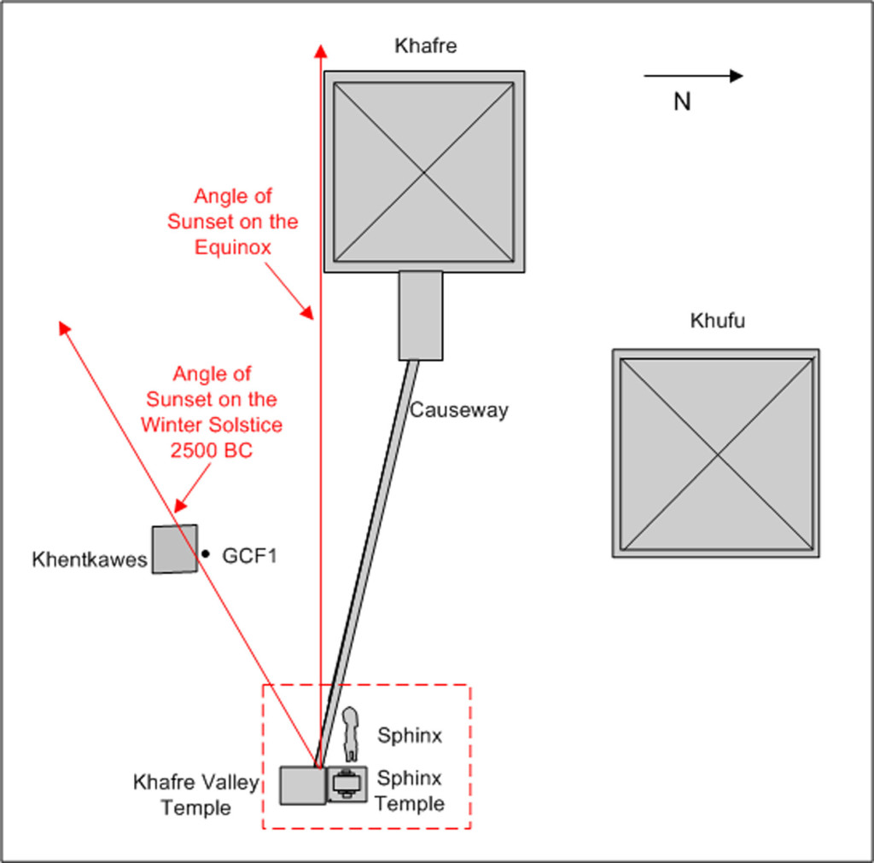](http://glendash.com/blog/wp-content/uploads/2014/08/GCF1-10.jpg)

**Figure 10: A priest standing atop the Khafre Valley Temple at its junction with the Khafre Causeway would have observed the sun setting on the winter solstice just beyond the mound formed by GCF1 and Khentkawes. From the same vantage point on the equinox, the setting sun would have grazed the south side of the Khafre Pyramid.**

The Egyptians could also have used GCF1 as a foresight to observe the sun on the winter solstice. As I described in a previous paper [9], a priest standing atop the Khafre Valley Temple at the point where it met the Khafre causeway would have seen the sun set behind the knoll capped by GCF1 on that day (Figure 10).

About the author: Glen Dash has been surveying in Egypt for more than ten years. He directs the Glen Dash Foundation for Archaeological Research. You can read more about his work at [*http://www.DashFoundation.org*](http://www.DashFoundation.org) .

**Notes:**

[1] Lehner 1991, 16

[2] Lehner 2008, 14-15

[3] Lehner 1985, 149

[4] Lehner 1985, 152

[5] Lehner 1985, 152

[6] Lehner 1985, 137

[7] Lehner 1985, 137

[8] Gauri et al 1995, 123-126

[9] Dash 2011, 7

**References:**

Dash, Glen, “The Solar Alignments at Giza,” Aeragram, 12 No. 2 (Fall 2011), 3-8.

Gauri, K. Lal, Sinai, John and Bandyopadhyay, Jayanta, "Geological Weathering and Its Implications on the Age of the Sphinx," Geoarchaeology: An International Journal, 10 No. 2 (1995), 119-133.

Lehner, Mark, "Giza. A Contextual Approach to the Pyramids," Archiv für Orientforschung, 32 (1985), 136-158.

Lehner, Mark, "Archaeology of an image: The Great Sphinx of Giza," (Ph.D. diss., University of Chicago, 1991).

Lehner, Mark, The Complete Pyramids, London: Thames and Hudson, 1997.

Lehner, Mark, “Giza: Overviews and Ground Truths,” Aeragram, 9 no. 2 (Fall 2008), 14-15.