**The Man Who Put the Mast Atop the Great Pyramid**

By Glen Dash, Glen Dash Foundation for Archaeological Research

*About the mast, visitors by the thousands ask their tour guides every year, “What is that?” and “Who put that there?”  Few get the right answers.*

Look at the Great Pyramid today and you will see something less than the ancient Egyptians saw 4,500 years ago. For one, the original white, gleaming limestone casing stones, more than 21 acres in all, are all but gone.  However, there is one thing that has been added, a mast on top.

[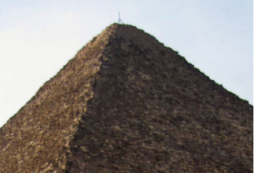](http://glendash.com/blog/wp-content/uploads/2013/12/photo2.png)

**Figure 1: The Great Pyramid and its mast.**

The man behind the mast was David Gill.  He was not an archaeologist but an astronomer.  And he was not in Egypt to survey the pyramids, but on his way back home from his observation of the Transit of Venus in 1874. [1]

A Transit of Venus occurs when Venus passes between the Earth and the Sun, appearing as a small dot moving along the Sun’s disk.  Transits are a rare occurrence.  In Venus’ case, transits occur generally in pairs about eight years apart every 243 years.  The last two transit pairs were in 1874 and 1882, and then in 2004 and 2012.

David Gill traveled to the island of Mauritius to observe the 1874 transit, and he was returning to Britain through Egypt when he was asked to participate in a survey of Egypt. [2] The initial stages of that work led Gill to Giza, where he met James Watson, then Director of the Detroit Observatory.  According to Gill’s biographer, “The two astronomers then set to work on an accurate measurement of the pyramid base, clearing out all the sand from the corner-stones.” [3]

[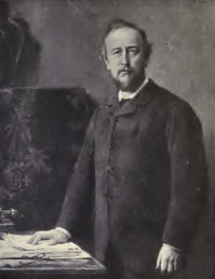](http://glendash.com/blog/wp-content/uploads/2013/12/David-Gill.jpg)

**Figure 2: Sir David Gill (Illustration from George Forbes, David Gill: Man and Astronomer, (London: John Murray, 1916), frontpiece)**

Gill reported on his work in a May 14, 1875 letter to Lord Lindsay, a British Astronomer and politician who was Gill’s employer:

“I have not much time to write for I only finished work late last night and have everything to prepare to start for Suez to-morrow with a special train to catch the steamer.

“I defer a full account of the work done till we meet, but I have measured a very accurate kilometre, established the latitude and longitude of the Great Pyramid, and measured the sides and height of the Great Pyramid to +/- 1 millim., and their exact azimuths by a triangulation.” [4]

Gill passed on his data to Flinders Petrie who analyzed it before making his own, historic measurements at Giza between December of 1880 and April of 1882.  It is from Petrie that we learn that Gill and his team set the mast upon the Pyramid. [5] But what was it for?

[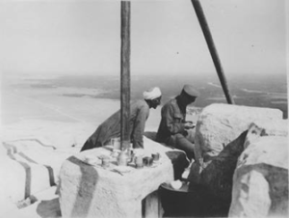](http://glendash.com/blog/wp-content/uploads/2013/12/photo3.png)

**Figure 3: A Great Pyramid tea party beneath the mast, circa 1920. (Source:  Kelsey Museum of Archaeology, University of Michigan,**

Neither Gill nor Petrie tell us, but we can make a reasonable guess. Gill states that he measured the height of the Great Pyramid. He might have done so by setting the tip of the mast at a height that represented Gill’s best guess at the height of the pyramid's missing peak. He could then measure the pyramid’s angle by placing his survey instrument at the base of the pyramid and focusing it on the top of the mast.  Knowing the pyramid’s size, he could then derive its height. [6]

So the man who put the mast upon the Great Pyramid was David Gill, who became Sir David Gill in 1900. [7] Its purpose was probably to facilitate the measurement of its height. Today it is weathered and no longer serves any useful purpose.  It does stand, however, as an enduring monument to the man who made the first modern measurements of the last surviving wonder of the ancient world.

**Notes:**

[1] George Forbes, *David Gill, Man and Astronomer,* (London: John Murray, 1916), 75.

[2] Forbes, 75.

[3] Forbes, 76.

[4] Forbes, 77.

[5] M. W. F. Flinders Petrie, *The Pyramids and Temples of Gizeh*, (London: Field & Tuer, 1883), 43.

[6] Glen Dash, “New Angles on the Great Pyramid,” *AERAGRAM*, 13 no. 2 (Fall 2012), 10.

[7] Wikipedia, “David Gill (astronomer),” <http://en.wikipedia.org/wiki/David_Gill_%28astronomer%29> , Accessed November 17, 2013.

About the author:  Glen Dash has been surveying in Egypt for more than ten years. He directs the Glen Dash Foundation for Archaeological Research.  You can read more about his work at [*http://www.DashFoundation.org*](http://www.DashFoundation.org).