The Great Pyramid Diagonals: Do They Point to a Hidden, Inner Platform Within the Pyramid?

By Glen Dash, Glen Dash Foundation for Archaeological Research

Of all the alignments associated with the Great Pyramid, the “pyramid diagonals” are among the most precise. The Great Pyramid’s diagonals are lines drawn between the outside corners of four “sockets” that ring the pyramid. (Figures 1 and 2) First discovered by Napoleon’s savants in 1801, the sockets original purpose is still unclear, but they do appear to mark the pyramid’s corners. (Petrie 1883, 37-39) The pyramid diagonals cross at the center of the pyramid, where they form a nearly perfect right angle. The probable error is less than one minute of arc, the width of two fingers viewed from across a football field. [1] How could the Egyptians have achieved such precision?

[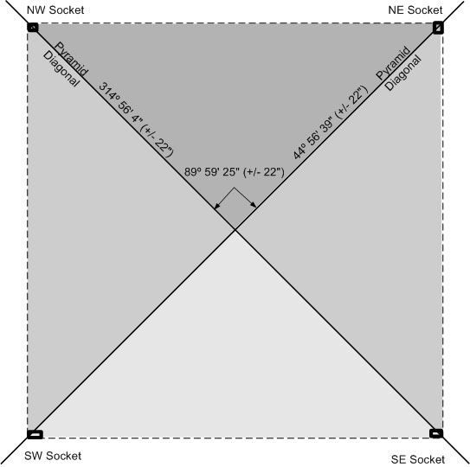](http://glendash.com/blog/wp-content/uploads/2014/11/GP-Diag-01.jpg)

**Figure 1: The Great Pyramid’s Diagonals. The diagonals intersect the outer corners of the sockets and form nearly a perfect right angle.**

[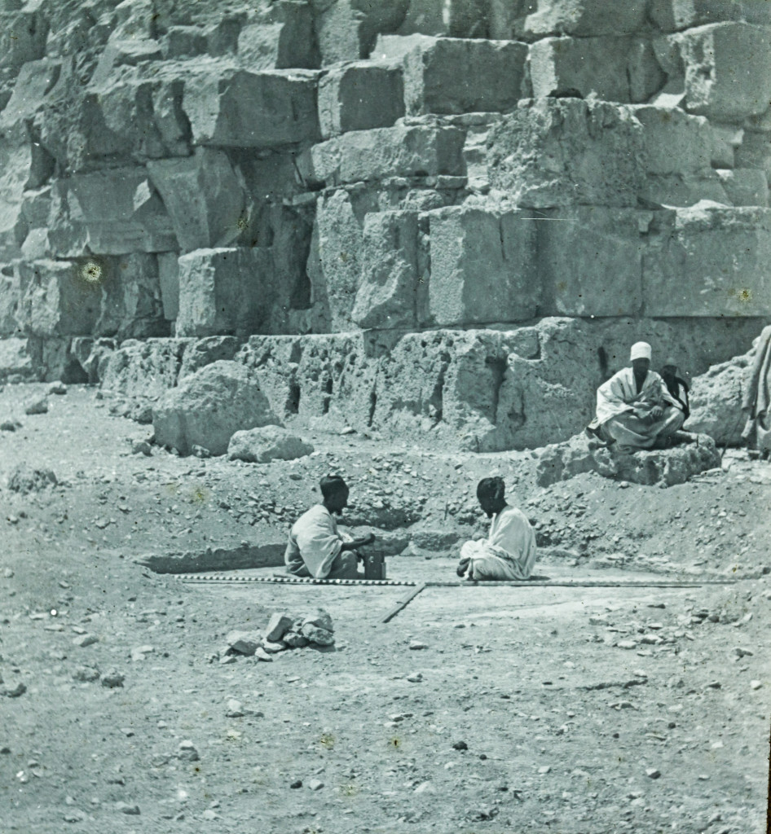](http://glendash.com/blog/wp-content/uploads/2014/11/NegNr-018100_PA3D.jpg)

**Figure 2: The Northeast Socket. This photo shows the socket as photographed by Piazzi Smyth in 1865. The pyramid’s casing, stripped away centuries ago, would once have covered a portion of the socket. Photo copyright Photoarchive 3D; courtesy of George Mutter and Bernard Fishman.**

We do not know for certain, since the Egyptians left us so few records. But one possibility is that the Egyptians, at the very outset of the project, leveled a surface around the center of what would become the pyramid and used that leveled surface as a stable platform to establish the direction of due north and to lay out the pyramid’s diagonals. (Figures 3 and 4) The Great Pyramid was built over a preexisting mound of bedrock which rose to a height of at least seven meters. We know that because the so called “service shaft” that connects the Grand Gallery with the descending passageway intercepts bedrock at a height of about seven meters above the pyramid’s base. (Maragioglio and Rinaldi 1965, 56)

[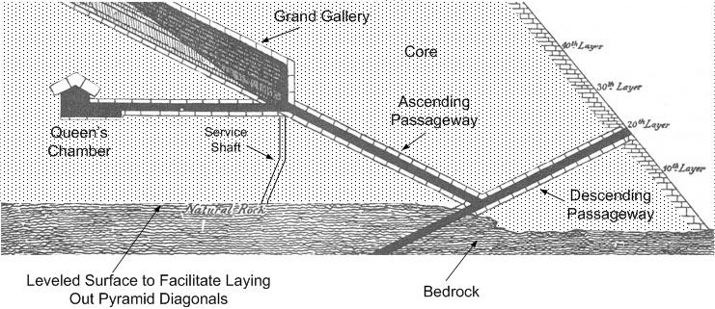](http://glendash.com/blog/wp-content/uploads/2014/11/GP-Diag-03.jpg)

**Figure 3: The bedrock within the Great Pyramid. The pyramid is built over a knoll of bedrock originally rising at least seven meters in height. This bedrock may have been leveled to provide a platform for determining the meridian and laying out the pyramid’s diagonals.**

If the Egyptians created this level platform, they could have first used it to estimate the meridian, or direction of due north, using either stellar or solar methods. (Dash 2013, 8-14; Dash 2014, 1-16) The next step, laying out the diagonals, could have been best accomplished by setting out squares to either side of the meridian. To do that, Egyptians could have begun by laying out four rods of exactly equal length in an approximate square. Then by laying two additional rods exactly equal in length to each other from the opposite corners, the Egyptians could have completed the square. It would have taken some experimentation to get the diagonal lengths exactly right, but when that was done the Egyptians should have been able to produce a near perfect square. As shown in Figure 4, the Egyptians might have laid four such squares, two to either side of the meridian line, and projected their lines to what would become the socket corners.

[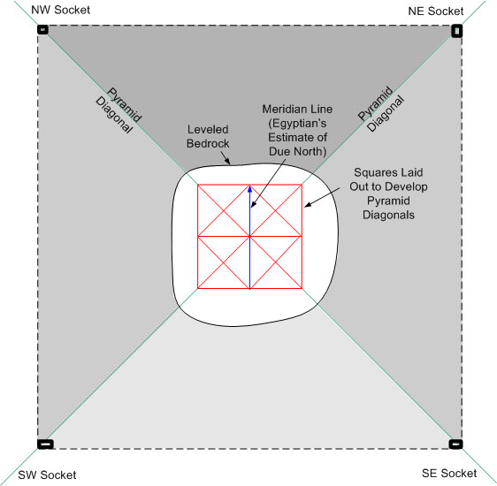](http://glendash.com/blog/wp-content/uploads/2014/11/GP-Diag-04.jpg)

**Figure 4: A platform within the pyramid? By leveling part of the bedrock knoll, the pyramid builders could have produced a reference platform for locating the meridian and laying out the diagonals.**

As the pyramid progressed, the platform would have become covered by masonry and would have disappeared from view. Because of that, we have no direct evidence of its existence. However, it is difficult to conceive of how the Egyptians could have achieved such precise diagonals without it.

Since, according to this theory, the meridian line bisected the diagonals, we can use the diagonals’ angles to recalculate the angle of the original meridian line. All we need to do is record the location of the socket corners, calculate the angles of the diagonals relative to due north, and then bisect the angle formed by them. Doing so yields a figure of was 3 minute and 38 seconds west of due north, plus or minus 22 seconds. According to my theory, that would have been the Egyptian’s estimate of the direction of due north when the Great Pyramid was commenced.

About the author: Glen Dash has been surveying in Egypt for more than ten years. He directs the Glen Dash Foundation for Archaeological Research. You can read more about his work at [*http://www.DashFoundation.org*](http://www.DashFoundation.org) .

**Notes**

[1] The socket corners are difficult to discern today. For their locations, we rely on Petrie (Petrie 1883, Plate X). While Petrie records their locations to 0.1 inch, he states that the lines between the socket corners cannot be located to better than 0.5 inch (Petrie 1883, 40). A tolerance of 0.5 inch produces an uncertainty (“probable error”) of 22 seconds of arc. See Figure 1. There are 60 arc minutes to a degree and 60 arc seconds to a minute. Petrie defines probable error as have a 50% confidence. (Petrie 1883, xvi).

**References**

Dash, Glen, “[How the Pyramid Builders May Have Found Their True North](http://dashfoundation.com/downloads/archaeology/as-published/AG14_1_True_North_singles.pdf),” Areagram, Vol. 14 No. 1 (Spring 2013), 8-14.

Dash Glen, “Did the Egyptians Use the Sun to Align the Pyramids?” [http://glendash.com/archaeology/working-papers.html](http://dashfoundation.com/archaeology/working-papers.html), Accessed October 1, 2014.

Maragioglio, V. and Rinaldi, C., L’Architettura Delle Piramidi Menfite, Parte IV, Rapallo: Tipografia Canessa, 1965.

Petrie, W. M. Flinders, The Pyramids and Temples of Gizeh, (London: Field and Tuer, 1883).