**How the Pyramid Builders May Have Found Their True North Part II: Extending the Line**

By Glen Dash, Glen Dash Foundation for Archaeological Research

In recent years various teams have field tested at least three methods the ancient Egyptians may have used to find true north, the “simultaneous transit method” [1], the “pole star method” [2] and the “solar gnomon method” [3]. Using any of these methods, the Egyptians could have located the meridian, the line that connects the observer to the North Pole, to within a few minutes of arc using only wood, rope, copper and stone. However, all three methods are, by themselves, incomplete. They do yield two points on the ground in a cardinal direction, but the points are only a few meters apart. How could the Egyptians have *extended the line* a hundred of meters or more, the distance needed to build a pyramid, while preserving its accuracy?

[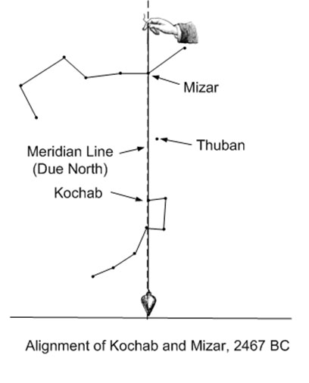](http://glendash.com/blog/wp-content/uploads/2014/06/Simultaneous-Transit.jpg)

**Figure 1: Determining true north using the simultaneous transit method. According to a theory by Kate Spence, at the time the Great Pyramid was built, Mizar and Kochab straddled the pole. By holding up a plumb line and waiting for both stars to transit behind it, they could approximately determine true north.**

The “simultaneous transit method” is discussed in detail in [1] and is illustrated in fig. 1. Kate Spence of the University of Cambridge, who proposed the theory, noted that two bright stars, Kochab in the Little Dipper and Mizar in the Big Dipper, straddled the celestial pole in the Egyptian Fourth Dynasty, the time when the Great Pyramid was built. In fact, in 2467 BC a chord drawn through the two stars would have passed directly through the celestial pole, pointing the way to true north [4]. In that year, an observer could have held up a plumb line and waited for the two stars to transit behind it. At that moment, the line between the observers’ pupil and the plumb line would have been true north.

The “pole star method” is illustrated in figs. 2 and 3. In the Fourth Dynasty, the pole star was Thuban in the constellation Draco. In fig. 2, an observer sits behind a bench, looking through a movable sight towards the pole star. To the north is a tall plumb line suspended from a masonry wall. The observer tracks the pole star, moving the sight along the bench until the star disappears behind the plumb line as viewed through the center of the sight. As shown in fig. 3, the observer continues to observe the star until it moves to its maximum east and west elongations, marking both positions on the bench. Using a straight edge, the observer then marks a point on the bench midway between the other two. The line between that point and the plumb line is true north.

[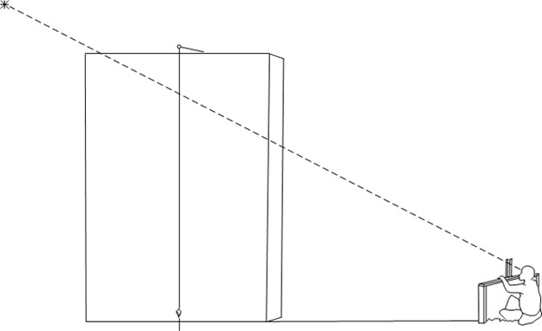](http://glendash.com/blog/wp-content/uploads/2014/06/Petrie-Method.jpg)

**Figure 2: Sighting a star using the pole star method. A masonry wall running approximately north-south supports a plumb line. A moveable sight is set on a bench and is moved to the left or right until the star disappears behind the plumb line as viewed through the center of the sight. At that moment the center of the sight, the plumb line and the star are aligned.**

[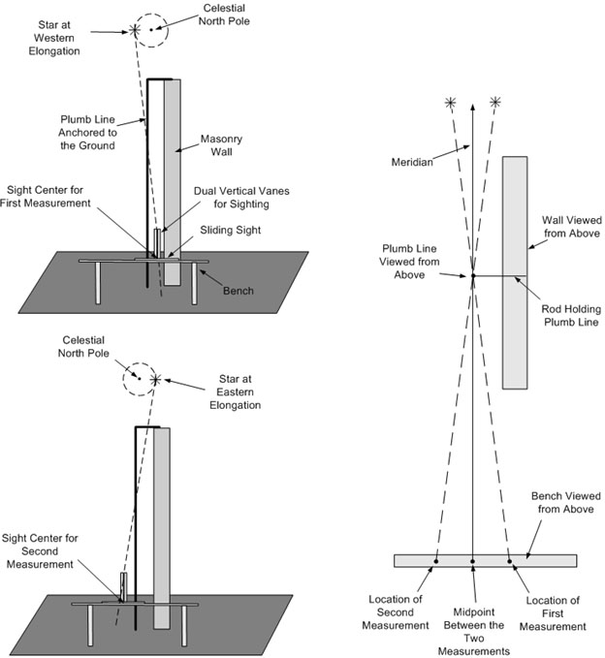](http://glendash.com/blog/wp-content/uploads/2014/06/Pole-Star-Method.jpg)

**Figure 3: Finding true north using the pole star method. The pole star, Polaris today and Thuban at the time of the Great Pyramid, is tracked using a plumb line and moveable sight. When the star reaches its maximum eastern and western elongations, those positions are marked on a bench. The line connecting the midpoint between those two markings and the plumb line is true north.**

The “solar gnomon method” is described in detail in [3]. It uses a vertical rod (a gnomon) to track the movement of the sun over the course of a day (fig. 4). At the end of the day, an observer takes a string and draws a circle around the base of the rod. The circle intercepts the arc produced by the gnomon’s shadow over the course of the day at two points. Those points run east-west. A line drawn perpendicular to them runs north-south.

[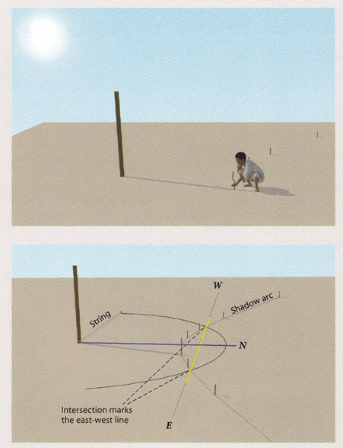](http://glendash.com/blog/wp-content/uploads/2014/06/Gnomon-Method.jpg)

**Figure 4: The solar gnomon method. An observer marks the location of the shadow produced by the vertical rod, the gnomon, over the course of the day. At the end of the day, a string is used to draw a circle around the base of the rod. The two points of intersection lie on a line running directly east-west. (Illustration by Wilma Wetterstrom)**

Whatever method they used, the Egyptians still needed to extend the line with high accuracy. Martin Isler proposed that they did this by using a variation on a ceremony known as “Stretching the Cord.” Stretching the Cord was part of temple foundation rites dating back at least to the reign of Khasekhemwy in the Second Dynasty (ca. 2770-2649 BCE). [5, 6] In its original form shown in fig. 5, the king stands opposite the goddess Seshat and each is holding onto a device which consists of two vertical poles wrapped with rope. We do not know the ceremony’s exact purpose. The King and the goddess may simply have been marking off a predefined distance -- a survey technique known as “chaining.” Others think the ceremony could have been used to set the angles or orientation of a pyramid or temple. [7]

[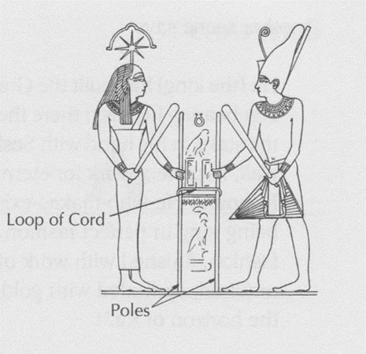](http://glendash.com/blog/wp-content/uploads/2014/06/Stretching-the-Cord.jpg)

**Figure 5: The “Stretching the Cord” ceremony. From the Temple of Edfu. (Isler 2001, fig.7-11)**

In Isler’s view, the ceremony could have been modified to explain how the Egyptians may have extended the line. [8] In his illustration shown here in fig. 6, Isler has the king standing at one end of a long loop with a priest or priestess in the role of Seshat at the other. The loop extends around two stakes which were set into the ground using the solar gnomon method. If the rope bends around either stake, then the priest or priestess moves to the left or right until the rope just touches both. At that point the stake held by the king, the two intermediate stakes and the stake held by the priest or priestess are aligned. In order for Isler’s method to work, however, the two stakes must be exactly the same diameter and exactly vertical. Even then, it may be impractical to extend the line with accuracy over long distances owing to the weight of the rope and the effects of wind.

[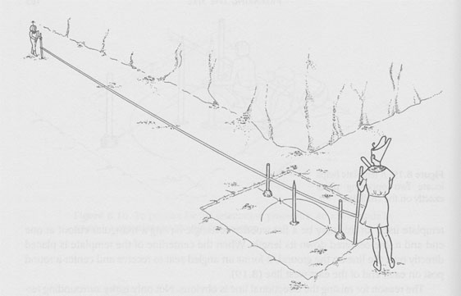](http://glendash.com/blog/wp-content/uploads/2014/06/Isler-Ext-1.jpg)

[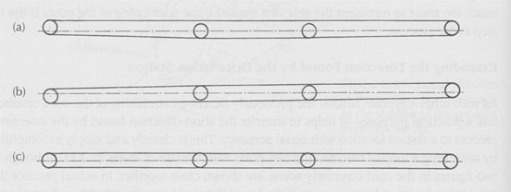](http://glendash.com/blog/wp-content/uploads/2014/06/Isler-Ext-2.jpg)

**Figure 6: Isler’s method for extending the line. A rope is looped around two stakes aligned with cardinal points. If the looped line just touches the sides of each stake, the endpoints of the loop are exactly aligned with the stakes. (Isler 2001, figs. 8.20 and 8.21)**

Here I suggest a different technique. First, determine two points on the ground in a cardinal direction using one of the above methods. Second, set a plumb line over one of the points and center a sight over the other (fig.7). Once that is done, leave the sight and plumb line fixed and at dusk or at night have an assistant walk into the field beyond the plumb line while holding a lamp. In essence, the lamp light serves as an “artificial star.” Direct the assistant to the left or right until the lamp light disappears behind plumb line as viewed through the center of the sight. At that point, the sight, the plumb line and the “far point” (the lamp light) are aligned.

[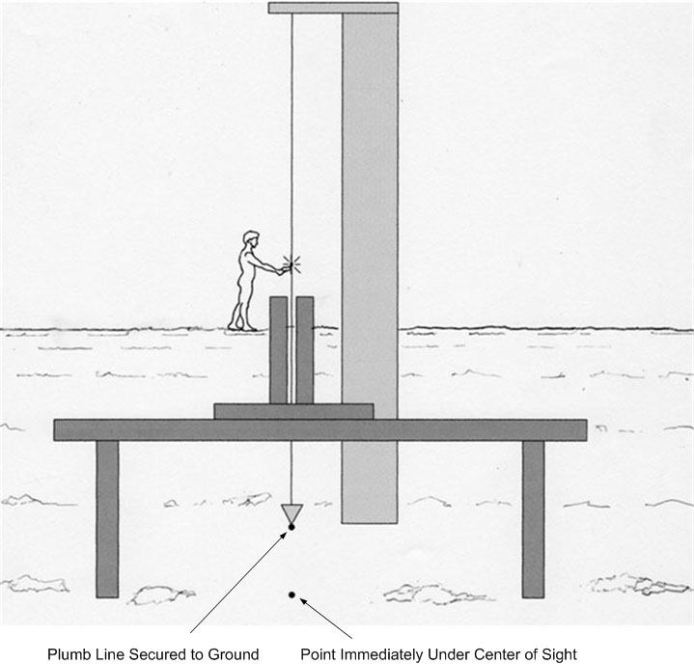](http://glendash.com/blog/wp-content/uploads/2014/06/Artificial-Star-01.jpg)

**Figure 7: Extending the line using an “artificial star.” The center of the sight and the plumb line are set over two previously determined cardinally aligned points. A person holding a lamp walks in the field beyond the plumb line. When the lamp light disappears behind the plumb line as viewed through the sight, the three points, the center of the sight, the plumb line and the lamp’s flame are aligned. (Illustration by Joan Dash)**

To enhance the method’s accuracy, the Egyptians could have placed the lamp in a box with a small hole facing the plumb line and sight, and set it on a bench built perpendicular to the sight line at the approximate location of the far point. They then could have moved the box from side to side along the bench until the light from the small hole disappeared behind the plumb line as viewed through the center of the sight.

The advantage of this “artificial star method” is that it is unaffected by distance or wind. The method can be used to align three points – the sight, plumb line and the far point – over practically any distance. Extending the line over the length of a pyramid should have been relatively easy. In fact, the Egyptians could have used the technique over kilometers. On a dark night, a candle can be seen over at a distance of a kilometer or more. [10]

We cannot say for sure how the Egyptians found true north or how they extended the line. Only scant records of their surveying techniques survive. What we can say is that they had the ability to find and extend a true north line with an accuracy of a few minutes of arc using only the materials they had.

*About the author: Glen Dash has been surveying in Egypt for more than ten years. He directs the Glen Dash Foundation for Archaeological Research. You can read more about his work at* <http://www.DashFoundation.org> *.*

**Notes**

[1] Spence 2000, 320-324; Rawlins and Pickering 2001, 699-700

[2] Dash 2012, 10-19

[3] Dash 2014, 1

[4] Dash 2012, 12

[5] Belmonte et al 2009, 201

[6] Lehner 1997, 8

[7] Belmonte et al 2009, 206

[8] Isler 2001, 185-187

[9] Kolbe 2008, 515-516

[10] Wolchover 2012, 1

**References**

Belmonte, Juan Antonio; Molinero, Miguel Angel and Miranda, Noemi, “Unveiling Seshat: New Insights into the Stretching of the Cord Ceremony,” *In Search of Cosmic Order: Selected Essays on Egyptian Archaeoastronomy*, Juan Antonio Belmonte and Mosalam Shaltout, eds., Cairo: Supreme Council of Antiquities Press, 2009, 197-212.

Dash, Glen, “New Angles on the Great Pyramid,” *AERAGRAM*, 13 No. 2 (Fall 2012), 10-19.

Dash, Glen, “Did the Egyptian Use the Sun to Align the Pyramids?” [http://www.DashFoundation.org/downloads/archaeology/working-papers/Solar True North.doc](http://www.DashFoundation.org/downloads/archaeology/working-papers/Solar%20True%20North.doc), Accessed June 9, 2014.

Isler, Martin, *Stick, Stones and Shadows: Building the Egyptian Pyramids*, Norman: University of Oklahoma Press, 2001.

Kolbe, Geoffrey, “A Test of the ‘Simultaneous Transit Method’,” *Journal for the History of Astronomy,* 39 (November 2008) 515-517.

Lehner, Mark, *The Complete Pyramids*, London: Thames and Hudson, 1997.

Petrie, W. M. Flinders, *The Pyramids and Temples of Gizeh***,** London: Field and Tuer, 1883.

Rawlins, Dennis and Pickering, Keith, “Astronomical orientation of the pyramids,” *Nature*, 412 (16 August 2001), 699-700.

Spence, Kate, “Ancient Egyptian chronology and the astronomical orientation of the pyramids,” *Nature*, 408 (16 November 2000), 320-324.

Wolchover, Natalie, “How Far Can the Human Eye see?” *Live Science*, 07 May 2012, <http://www.livescience.com/33895-human-eye.html>, Accessed June 9, 2014.