New Angles on the Great Pyramid

By Glen Dash

No monument in the world has given rise to more speculation about its meaning than the Great Pyramid of Khufu. It has been said to encode God’s unit of measurement (the “Pyramid Inch”), be a physical representation of the mathematical constant pi, and incorporate the Golden Section. Sir Isaac Newton thought it could be used to refine his theory of universal gravitation. All of these ideas, sensible or not, depended to one degree or another on the knowing the exact size and orientation of the Great Pyramid. It is surprising then to find that, to date, there has been no definitive work on the subject. The reason is due, in large part, to the condition we find the Pyramid in today. The original corners did not survive. The best we can do is to project their location from the fragmentary evidence that did survive. It has proven to be a challenge. Of the casing, only 55 meters of the original 920 meter baseline still exists.

Flinders Petrie, the father of Egyptian archaeology, measured the base of the Great Pyramid in 1880 and 1881. J. H. Cole, a surveyor with the Egyptian Ministry Finance, made additional measurements which he published in 1925. Joseph Dorner measured it in 1979 for his doctoral dissertation, but was unable to complete the work to his satisfaction due, in part, to equipment problems.

In 1984, Mark Lehner and David Goodman also measured the base of the Great Pyramid. That data, however, was set aside while Lehner undertook the decades long task of uncovering and mapping the workers’ cities. Now, for the first time, we publish this data and provide our analysis.

Pyramid Surveys: From Savants to the 1970’s

John Greaves, a Professor of Astronomy at Oxford, made one of the first attempts in modern times to precisely measure of the base of the Great Pyramid in 1638/9. However, he found the base covered in centuries old debris. The debris piles so interfered with his survey that they made accurate measurements all but impossible. Greaves estimated the base of the Great Pyramid to be 693 feet in length. He would prove to be off by more than 60.

Napoleon invaded Egypt in 1798 and brought with him his “savants,” 150 members of the “Commission of Arts and Sciences” to study and document sites throughout Egypt. One of those was Edme-Francois Jomard who assaulted the accumulated debris on the base of the Pyramid in Napoleonic style. A small army of Ottoman Turks cut through the overburden uncovering two “sockets” off northeast and northwest corners. (Figure 1) Jomard believed these sockets once held the very cornerstones of the Pyramid. To compute the Pyramid’s orientation and size, he thought, one only needed only to measure the relative positions of the socket’s outermost corners.

Flinders Petrie, who arrived at Giza in1880 to perform his measurements, disagreed. By analyzing the Pyramid’s angles, he determined that the true corners must have fallen somewhere inside the sockets. Petrie, at 27, had already gained recognition for his skills as a surveyor, even before winning lasting fame as an archaeologist.

By then, all four corners sockets had been found and exposed. Conveniently, the Royal Astronomer and surveyor David Gill had preceded Petire, and in 1874 had set bronze survey survey markers just inside the socket corners in 1874. (Figure 1) Petrie, and most every surveyor since, would use the Gill survey markers as control points.

Petrie found the north side of the Pyramid partially cleared of debris, revealing its ancient casing. The Pyramid’s casing stones consisted of white, smooth Tura limestone whose outer surface, Petrie estimated, was angled at a mean of 51 degrees and 52 minutes, plus or minus 2 minutes. (Figure 2) The casing once covered the entire Pyramid, a feat requiring more than twenty one acres of casing stones. Nearly all of it was carted away for building material long ago. “Platform stones” set into bedrock supported the casings. Petrie found the platform remarkably level.

At that time, however, most of the east, west and south sides of the Pyramid still remained covered in debris. Petrie cut through the debris to find a section of well preserved casing near the center of each side. He then chose one point on each side and measured their relative positions precisely.

Petrie then set out to calculate the size and orientation of the Pyramid by making a key assumption. He assumed that the corners of the Pyramid’s casing’s fell on the “pyramid diagonals” – lines that connected the four socket corners to their opposing corners. With that assumption and his measurements in hand, Petrie claimed to be able to calculate the length of the casing’s base on each side and their orientation relative to cardinal points using a complex geometrical argument. He found that each side was rotated slightly counterclockwise from cardinal points, as indicated by the minus sign in the table below.

Table 1: Petrie's Great Pyramid Measurements

Side | Length (m) | Angle
North | 230.363 | -3’ 20”
East | 230.320 | -3’ 57”
South | 230.365 | -3’ 41”
West | 230.342 | -3’ 54”
Average | 230.348 | -3’ 43”

The maximum difference between any two sides, said Petrie, was just 4.5 centimeters (about 1 ¾ inch). The corners of the casing, he said, formed nearly perfect right angles. The maximum deviation from a ninety degree angle at any corner was at the northeast, where it was 37” of arc, about one one-hundredth of one degree, or about the diameter of a dime viewed from across a football field.

However, as noted, Petrie measured just one point on each side. Establishing a line, of course, requires at least two points. In the Pyramid’s case, that would not be done until 1925 when J. H. Cole of the Computation Office of the Egyptian Ministry of Finance did so at the request of the German Archaeologist Ludwig Borchardt. Cole laboriously cut through debris to expose several more points on the casing on each side, chose the “best” two on each, and measured their angle. His measurements for the Great Pyramid were as follows:

Table 2: Cole's Measurements

Side | Length (m) | Angle
North | 230.353 | -2’ 28”
East | 230.391 | -5’ 30”
South | 230.454 | -1’ 57”
West | 230.357 | -2’ 30”
Average | 230.364 | -3’ 06”

The Pyramid was looking a little less perfect. The maximum difference between any two sides, according to Cole, was ten centimeters, about twice what Petrie had found. Its sides were also less square, with a deviation of about 3 ½ minutes of arc at the northeast corner, about six times what Petrie found. Cole did find Petrie correct in one respect though; the corners of the casing did seem to fall on the Pyramid diagonals.

The Egyptian Government eventually cleared the entire base of the Pyramid, but there would be no additional surveys until decades later. In 1979, Josef Dorner surveyed it as part of his doctoral dissertation at the University of Innsbruck. While he would not be able to complete his work, he was able to provide preliminary measurements. These were as follows:

Table 3: Dorner's Measurements

Side | Length (m) | Angle
North | 230.328 | -2’ 28”
East | 230.369 | -3’ 26”
South | 230.372 | -2’ 31”
West | 230.372 | -2’ 47”
Average | 230.360 | -2’ 48”

The maximum difference between any two sides, according to Dorner, was 4.4 centimeters. The worst of the right angles was 58” from square on the northeast, better than one sixtieth of one degree. While not as perfect a pyramid as Petrie had proposed, Dorner’s findings were more in line with Petrie than Cole.

Lehner’s Fallings

In 1984, Mark Lehner and David Goodman made a comprehensive survey of the base of the Pyramid. Goodman, a surveyor formerly with the California Department of Transportation, would later help to establish the survey grids we now use to map both the Giza Plateau and the Valley of the Kings. For this study, Goodman first laid a survey line along each side of the Pyramid between the bronze survey markers left by Gill. Lehner walked along the survey lines, identifying features he thought worthy of recording. When he found one, Goodman recorded Lehner’s point along the line electronically. Lehner then measured the offset between the line and the feature with a tape measure. Surveyors refer to these offset measures as “fallings.” At each station, Lehner carefully noted the condition of the edges of the casing and platform stones. Mapping those points where he found the top, outer edge of the platform stones or the lower edge of the casing stones well preserved, we can reconstruct the original lines of the Pyramid. While previous surveyors had concentrated only on the casing, Lehner measured the platform as well.

Analyzing the Lehner/Goodman Data

The first step in analyzing such data is to place it on a master grid. We will use the Giza Plateau Mapping Project (GPMP) control network which was established by Lehner and Goodman in 1984 and 1985. It assigns every point on the plateau an address, like houses on a city map. The origin of the map is at the center of the Great Pyramid, and everything is measured from that point, in units of meters. For example, Gill’s bronze survey marker off the northeast corner of the Pyramid is at 115.802 meters north of the center of the Pyramid, and 115.607 meters to its east. By convention, surveyors do not work with negative numbers, so instead of making the center of the Great Pyramid point (0, 0), Goodman and Lehner arbitrarily assigned it a location of (100000, 500000). That places the northeast Gill survey marker at “Northing” 100115.802 and “Easting” 500115.607. As designed, the GPMP system can be used to map features up to 100 km south of the Pyramid, and 500 km to its west, with unlimited range to its north and east.

Once converted to GPMP coordinates, we can use a standard statistical method known as linear regression analysis to “best-fit” lines to the Lehner/Goodman data. In Figure 3, we show best-fit lines for the casing and the platform on the west side of the Pyramid. Our linear regression analysis not only generates best-fit lines, but margins of error as well, known as confidence intervals.

We have generated best-fit lines and confidence intervals for the north and east sides as well. To derive corners, we need only to extrapolate these lines to see where they cross. Figure 4a shows the situation at the northwest corner. Here, two sets of best-fit lines for the casing, and two for the platform, meet. Each line is accompanied by confidence intervals. Based on our measurements and assumptions, there is a 95% probability that the original casing and platform edges fell within the regions bounded by the dotted lines. In the case of the casing, the error range, or “confidence area,” is 16 by 9 centimeters. In the case of the platform, it is 16 by 5 centimeters.

Is there a way to narrow this range further? We can assume, as did Petrie and Cole, that all four corners of the platform and casing fell on the Pyramid’s diagonals (Figure 4b). We know the locations of the Pyramid diagonals precisely. Since we only need the intersection of two lines to define a corner, and we are assuming that the casing and platform corners fell on the diagonal, we only need consider the intersection of either the northern casing and platform lines with the diagonal, or the intersection of the western casing and platform lines with the diagonal. The northern lines have narrower confidence intervals and thus are better defined. Therefore, we will locate the northwest platform and casing corners at the intersections of the northern lines with the diagonal. The regions bounding their intersections are their confidence areas.

Applying the same procedures at all four of the Pyramid’s corners, we can derive their locations. In the tables below we provide our best estimates for the locations of all four platform and casing corners and their confidence areas. The largest of the confidence areas is at the southeast, but even there we can locate the corner to within +/- 9.3 cm.

Table 4: Lehner/Goodman Casing Corners

Corner | Northing | Easting | Error Bounds (m)  (Confidence Areas)
NE | 100115.288 | 500115.034 | +/-.054
SE | 99885.006 | 500115.262 | +/-.093
SW | 99884.759 | 499884.954 | +/-.060
NW | 100115.095 | 499884.645 | +/-.050

Table 5: Lehner Goodman Platform Corners

Corner | Northing | Easting | Error Bounds (m)  (Confidence Areas)
NE | 100115.668 | 500115.414 | +/-.013
SE | 99884.484 | 500115.785 | +/-.031
SW | 99884.396 | 499884.592 | +/-.023
NW | 100115.522 | 499884.217 | +/-.026

We can use this data to calculate the length of the Pyramid’s sides and its angles. Here are the Lehner/Goodman estimates for the casing lengths compared with that of Petrie, Cole and Dorner:

Table 6: The Great Pyramid’s Casing Lengths: Lehner/Goodman, Petrie, Cole and Dorner (in meters)

Side | ← | Lehner/  Goodman | → | Petrie | Cole | Dorner
 | Min | Mean | Max
North | 230.286 | 230.389 | 230.493 | 230.363 | 230.253 | 230.328
East | 230.135 | 230.282 | 230.429 | 230.320 | 230.391 | 230.369
South | 230.155 | 230.309 | 230.462 | 230.365 | 230.454 | 230.372
West | 230.227 | 230.337 | 230.447 | 230.342 | 230.357 | 230.372
Average |  | 230.329 |  | 230.348 | 230.364 | 230.360

Petrie’s and Dorner’s measurements fit comfortably inside the Lehner/Goodman ranges. Lehner/Goodman and Petrie differ in the mean of all four sides by only 1.8 cm – three quarters of one inch. One of Cole’s measurements, however, falls outside the Lehner/Goodman ranges (in italics).

As for the angles:
Table 7: Angles of the Casing

Side | ← | Lehner/  Goodman | → | Petrie | Cole | Dorner
 | Min | Mean | Max
North | -1’ 19” | -2’ 52” | -4’ 25” | -3’ 20” | -2’ 28” | -2’ 28”
East | -1’ 12” | -3’ 24” | -5’ 36” | -3’ 57” | -5’ 30” | -3’ 26”
South | -1’ 24” | -3’ 41” | -5’ 58” | -3’ 41” | -1’ 57” | -2’ 31”
West | -2’ 58” | -4’ 37” | -6’ 14” | -3’ 54” | -2’ 30” | -2’ 47”
Average |  | -3’ 38” |  | -3’ 43” | -3’ 06” | -2’ 48”

All the measurement fall with the Lehner/Goodman ranges except for the Dorner and Cole measurements on the west side.

Recalling that Lehner also measured the platform, here are its lengths and angles as well:

Table 8: Lehner/Goodman Length and Angles of the Great Pyramid’s Platform

Side | ← | Length | → | ← | Angle | →
 | Min | Mean | Max | Min | Mean | Max
North | 231.157 | 231.196 | 231.236 | -1’ 35” | -2’ 10” | -2’ 45”
East | 231.140 | 231.184 | 231.229 | -4’ 51” | -5’ 31” | -6’ 11”
South | 231.138 | 231.193 | 231.248 | -29” | -1’ 18” | -2’ 07”
West | 231.076 | 231.126 | 231.176 | -4’50” | -5’ 34” | -6’ 18”
Average |  | 231.175 |  |  | -3’ 38”

The platform extends outward from the casing by an average of 42.3 cm on each side. The casing does not run quite parallel with the platform. Although this difference is too small to illustrate in our figures, it is still significant and helps us to understand how the Pyramid was built. It might suggest, for example, that the Pyramid’s builders were unsatisfied with the platform’s original lines and chose to square things up a bit up before finally dressing the casing down.

The South Side

In this analysis, we managed to compute the length and orientation of the base of the Great Pyramid without the benefit of data from its south side. We were able to do this because we assumed that the corners of both the casing and the platform fell on the socket diagonals. We had to do that because so little of south survives. There, the top, outer edge of the platform is nowhere to be found. As for the casing, at one point 122.2 meters east of the southwest Gill survey marker, Lehner found that the casing once met the platform at N99884.838 and E500006.828. Our model predicts that at that location the casing should have fallen at N99884.889 E500006.889 plus or minus 0.075 meters. The casing does indeed falls within the range out model predicts. It is the only usable data point on the casing we have been able to identify on the south side.

Implications for Khafre

The data may provide us some insight as to how the Khafre pyramid was built as well. In the table below, we list the angles of the Great Pyramid’s platform on its east and west side, along with the azimuth of its descending passageway. We compare that to the same data for the Khafre pyramid. The alignments are striking:

Table 9: Comparing the Alignments of Khufu and Khafre

 | East Side | West Side | Descending Passageway | Source
The Great Pyramid of Khufu | -5’ 31” +/- 40” | -5’ 34” +/- 44” | -5’ 49” | Lehner/Goodman, Petrie/Smyth
Khafre | -6’ 00” | -6’ 00” | -5’ 26” | Dorner, Petrie/Smyth

The alignment suggests that both pyramids may have been built to a common control line.

Conclusions

We gather our results in Figure 5. We have derived new estimates for the locations of the casing and platform corners and provided error bounds (confidence areas). We can fix the locations of the platform corners to within four centimeters, and the casing to within ten.

The Lehner/Goodman estimates for the casing corners are remarkably close to Petrie’s. The largest deviation between the two is on the northwest and is less than 4 centimeters (1.6 inches).

FIGURES

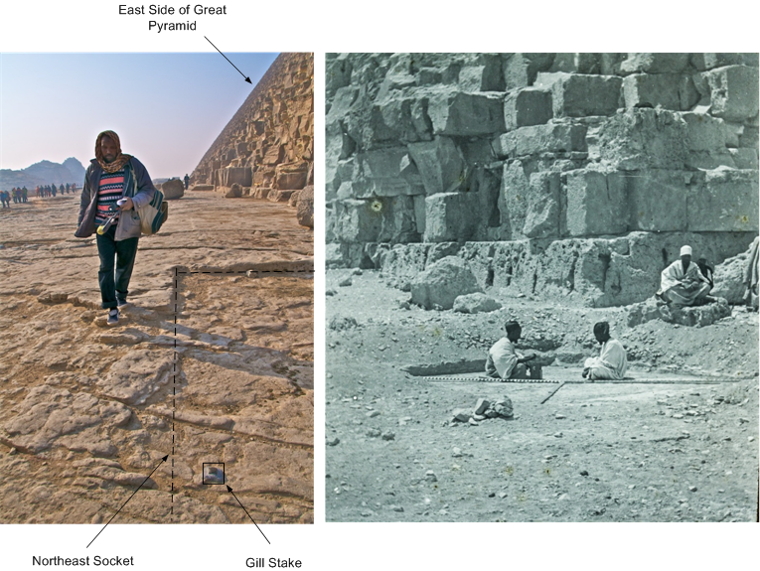

Figure 1: The Northeast Corner Socket. At left, AERA Surveyor Mohammed el-Bassett walks past the remains of the socket (dotted line). The same corner socket, as photographed by Piazzi Smyth in 1865, is at the right. (Copyright Photoarchive3D - Courtesy of George Mutter and Bernard Fishman.)

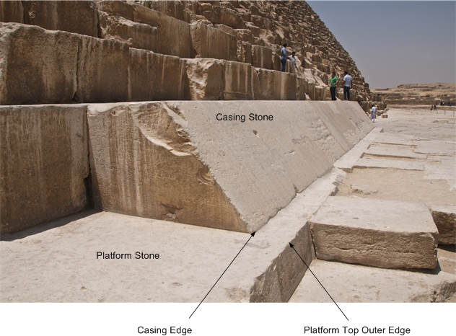

Figure 2: Casing and Platform Stones. The angled casing stones sit upon platform stones. The lower, outer edge of the casing and the top, outer edge of the platform provide the best places to measure the Pyramid’s lines.

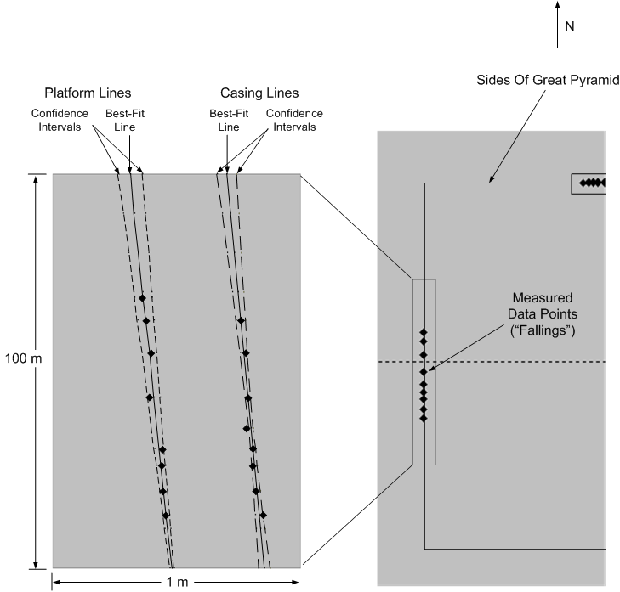

Figure 3: Lehner’s Fallings. Lehner mapped points near the middle of the east, west and north side of the Pyramid where he found well preserved edges. We derive best-fit lines and confidence intervals for these. (The horizontal scale is exaggerated here to emphasize the angle.) The original corners can be located by extrapolation.

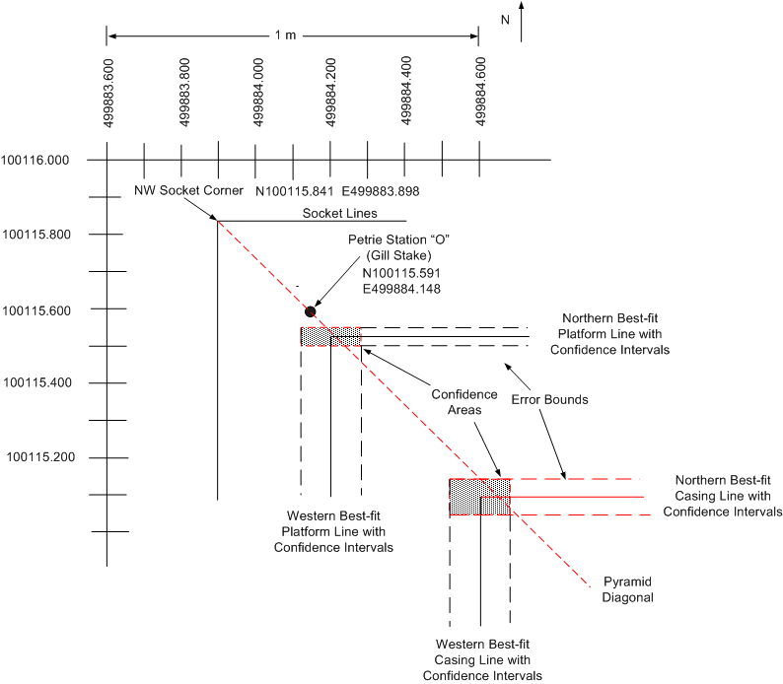

Figure 4a: The Northwest Corners. We can locate the corners from the intersection of the best-fit lines derived from the Lehner-Goodman data. Each line is surrounded by an error bound, also known as a confidence interval. (While the confidence intervals are, in fact, hyperbolic, they appear straight over short distances.) There is a 95% chance that the original corners fell within the “confidence areas.”

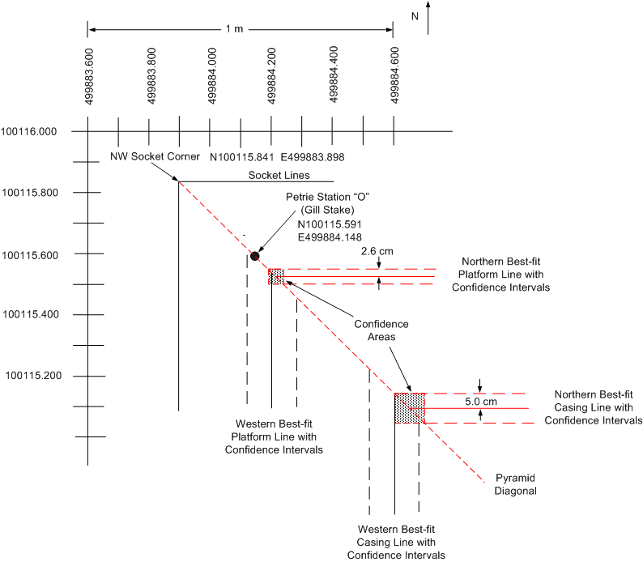

Figure 4b: Narrowing the Range. We can use the intersection of the Pyramid diagonal, which extends from the socket corner to the center of the Pyramid, and the northern best fit lines, to narrow the confidence areas. This helps us better locate the corners.

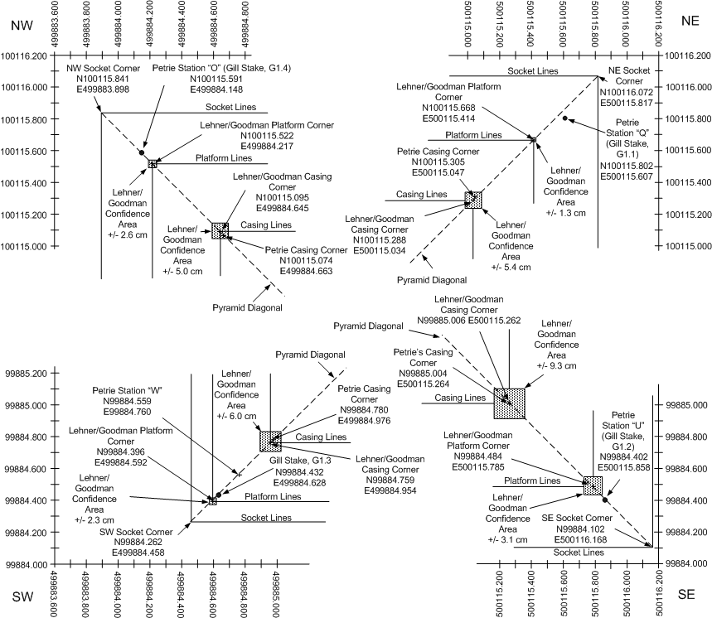

Figure 5: The Corners of the Great Pyramid.

ACKNOWLEDGEMENTS

The author wishes to thank the following people who helped in the preparation of this article. Jeff Stefanik, a professional surveyor with CME Associates of Woodstock, CT, helped us establish the protocol we used to complete our February, 2012 re-survey the Great Pyramid’s base. Dr. Robert Craig of Bird Conservation Research, Inc. of Putnam, CT provided us with valuable insight into the proper methods of statistical analysis to be used in evaluating a data set of this kind. Glenn Harrison of Fairfield, CT provided some of the statistical analysis and re-checked our calculations.

W. M. F. Petrie, The Pyramids and Temples of Gizeh, (London: Field and Tuer, 1883).
J. H. Cole, “Determination of the Exact Size and Orientation of the Great Pyramid of Giza,” (Cairo: Government Press, 1925).
J. Dorner, “Die Absteckung und astronomische Orientierung aegyptischer Pyramiden,” (Dissertation, Universitaet Innsbruck, 1981) and J. Dorner, “Das Basisviereck der Cheopspyramide,” Structure and Significance, Thoughts on Ancient Egyptian Architecture, P. Janosi, ed. (Vienna: Verlag der Oestrreichischen Akademie der Wissenschaften, 2005).
J. Greaves, Pyramidographia: or a Description of the Pyramids in Aegypt, (London: King’s Arms, 1736).
Tomkins 1971, 44.
Petrie 1883, 39.
The south side is too badly damaged to provide useful data for a statistical analysis. However, as we shall see, since we are assuming that the original casing and platform corners fell on the diagonals, we can proceed without that data.
Petrie and Maragioglio and Rinaldi placed the northern socket corners in exactly the same locations. Compare Petrie 1883 Plate X with V. Maragioglio and C. Rinaldi, L’Architettura Delle Piramidi Menfite Parte IV, (Rapallo, Tipografia Canessa, 1965), Plate 2.
Dorner initially set his azimuth by measuring the angle of the casing on the north side with a WILD meridian telescope. He found the north side running at an angle of -3’ 0”. However, he rejected his own measurement in favor of Cole’s: – 2’ 28”. Our analysis indicates he would have been better off not doing so. If he had accepted his own measurements, all his angles would change by -32” of arc. Not only would these revised angles fall within the Lehner/Goodman ranges, but they would be quite close to Petrie’s values as well.
There is no platform at Khafre. We use the angle of the base of its casing instead.

